**Practical no.3**

**Perform the following:  
3.1 Viewing all databases**

Show databases;

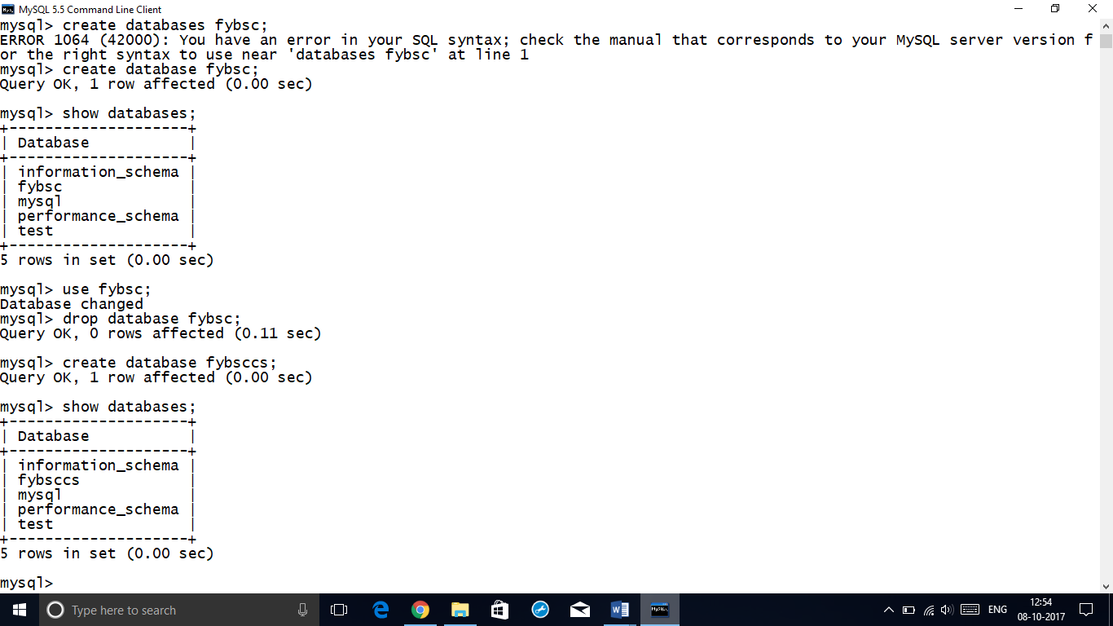

**3.2 Creating and Use a Database**

Create database fybsccs;

Database created

Use fybsccs

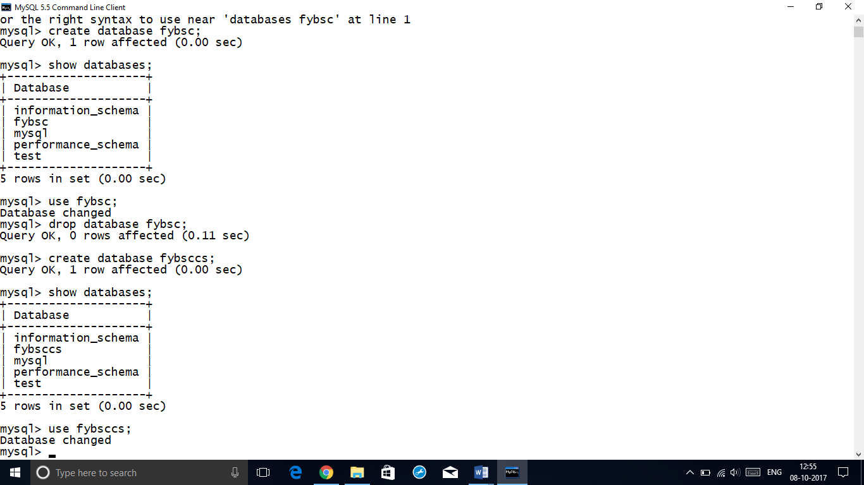

**3.3 Viewing all Tables in a Database**

Show tables in fybsccs

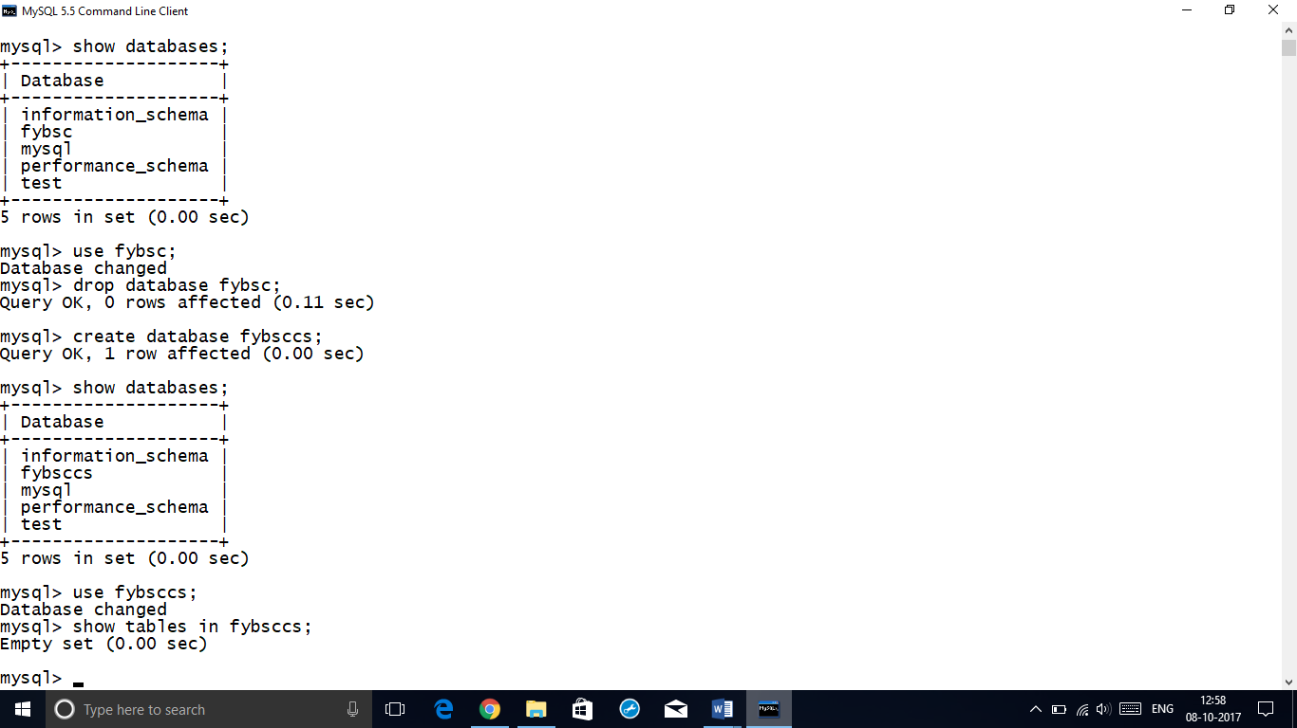 **3.4 Creating Tables (With and Without Constraints)**

3.4.1 Create the following table:

Employee(eid:tinyint,ename:char(25),phoneno(bigint))

Create table employee

(

eidtinyint,

enamechar(25),

phonenobigint

);

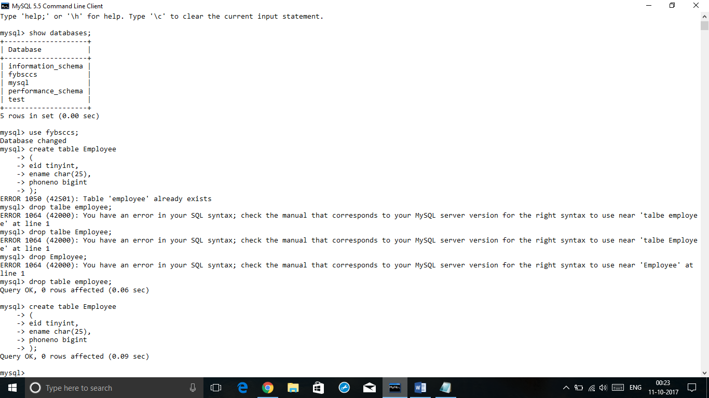

Department(did(tinyint),dname(char(5)))

Create table department

(

did tinyint,

dnamechar(5)

);

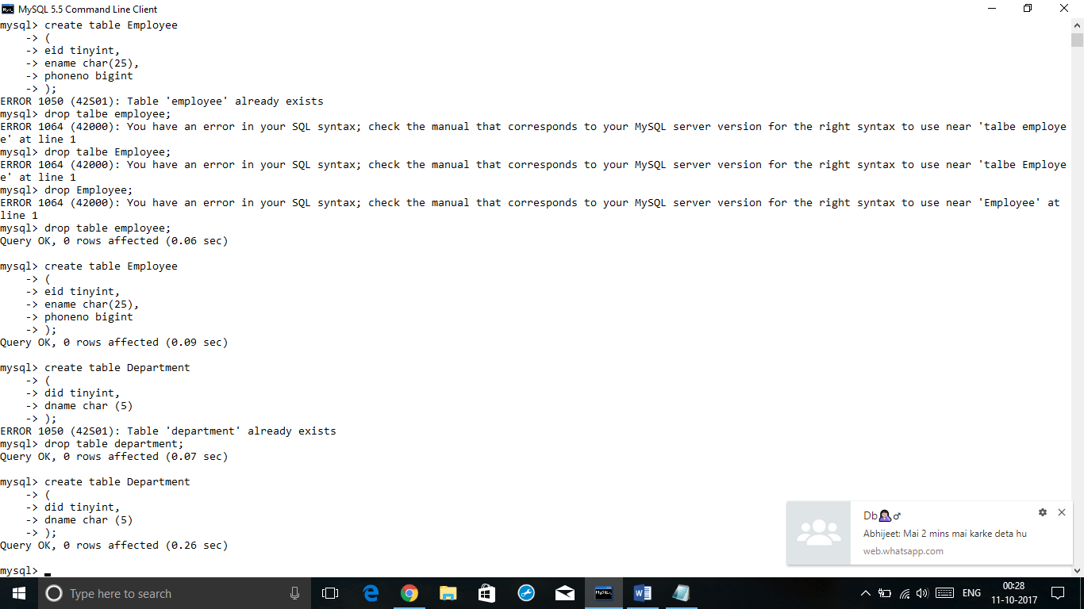

3.4.2 Create the following table and insert the given values into it:

Table name:**StudentMarks**

Where rollnotinyint primarykey ,

Name char(30)not null,

Foss,dbms,pyhon,co must be of decimal(5,2) datatype

|  |  |  |  |  |  |
| --- | --- | --- | --- | --- | --- |
| Rollno | Name | Foss | dbms | python | co |
| 1 | Ram | 60 | 89 | 67 | 56 |
| 2 | Shyam | 90 | 45 | 54 | 87 |
| 3 | Laxman | NULL | NULL | 78 | 40 |

Create table studentmarks

(

Rollno tinyint primary key,

Name char (30),

Foss decimal(5,2),

Dbmsdecimal(5,2),

Python decimal (5,2),

Co decimal (5,2)

);

* Insert into studentmarks values91,’ram’,60,89,67,56);

Insert into studentmarks values(2,’shyam’,90,45,54,87);

Insert into studentmarks values(3,’laxman’,NULL,NULL,78,40);

Values inserted

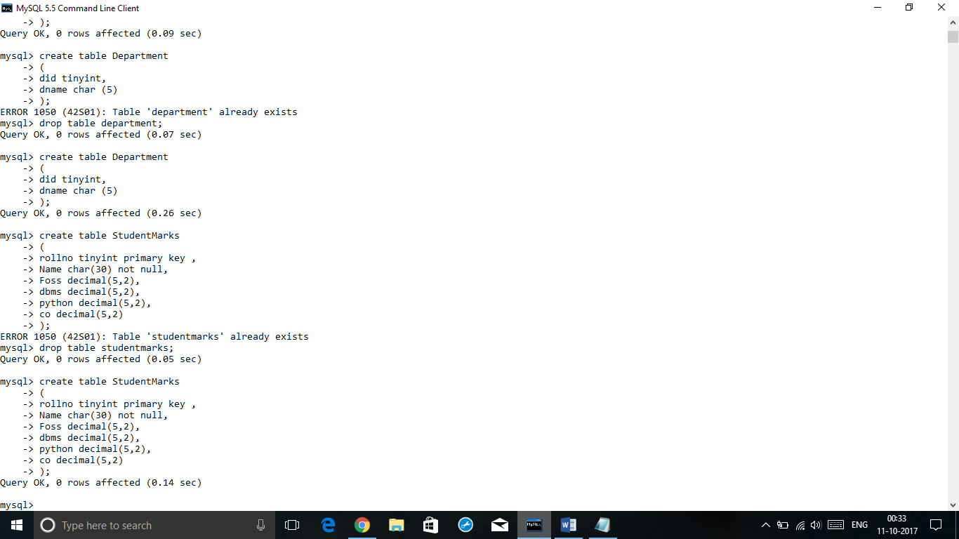

* + 1. Create table Student and Marks with the following columns, datatype and constraints:

**‘Student ‘ table:**

|  |  |  |
| --- | --- | --- |
| **COLUMN NAME** | **DATATYPE** | **CONSTRAINT** |
| Rollno | Tinyint | Primary key |
| Name | Char(20) | Not null |
| Address | Varchar(30) | Not null |
| Phoneno | Bigint | Not null |
| Age | tinyint | Not null, default 18 |
| Gender | Char(1) | Not null |
| Emailid | Varchar(20) | Unique |

Create table student

(

Rollnotinyint primary key,

Name char(20) not null,

Address varchar(30) not null,

Phonenobigint not null,

Age tinyint not null default 18,

Gender char(1) not null,

Emailed varchar(20) unique

);

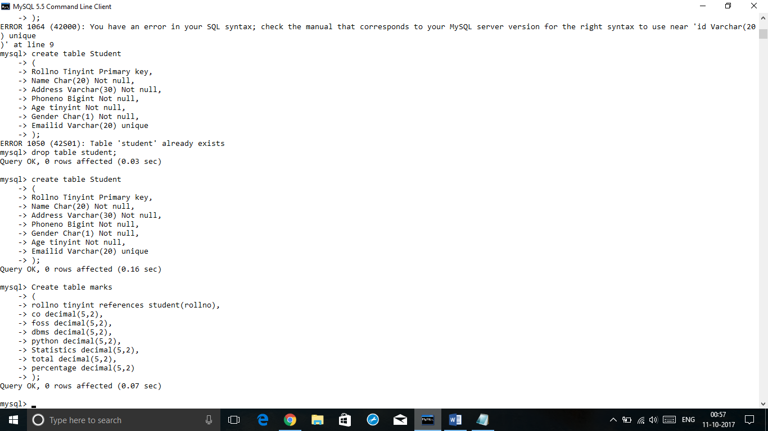

**Marks:**

|  |  |  |
| --- | --- | --- |
| **Colm name** | **Datatype** | **constraints** |
| Rollno | Tinyint | Foreign key, references Student(rollno) |
| Co | Decimal(5,2) | - |
| Foss | Decimal(5,2) | - |
| Dbms | Decimal(5,2) | - |
| Python | Decimal(5,2) | - |
| Statistics | Decimal(5,2) | - |
| Total | Decimal(5,2) |  |
| Percentage | Decimal(5,2) |  |

Create table marks

(

Rollnotinyint references student(rollno),

Co decimal(5,2),

Foss decimal(5,2),

Dbmsdecimal(5,2),

Python decimal(5,2),

Statistics decimal(5,2),

Total decimal(5,2),

Percentage decimal (5,2)

);



**3.5 Inserting/Updating/Deleting Records in a Table**

1. Insert records into 3.4.1 and 3.4.2 table

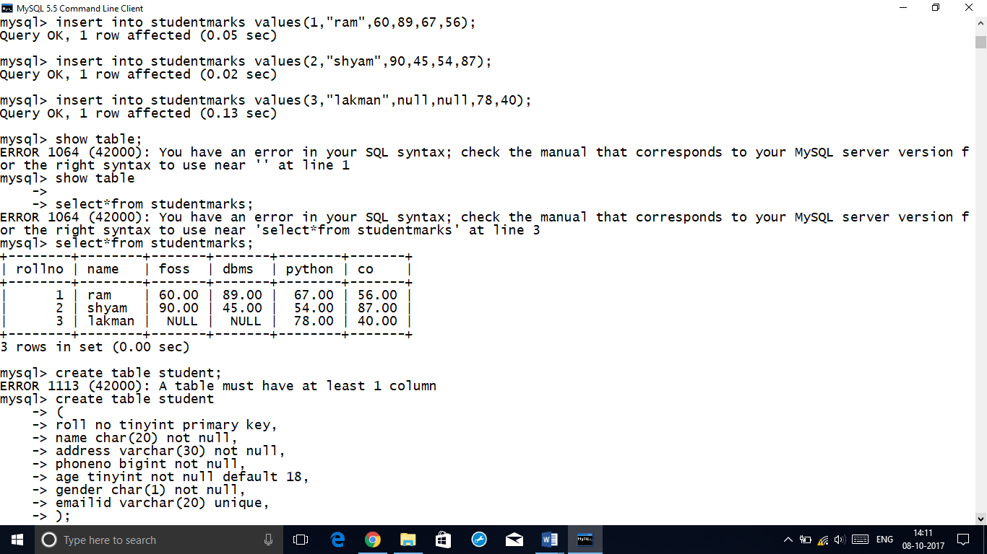

**Add a column ‘admissiondate’ date in studentmarks table**

Alter table studentmarks add admissiondate date;

select * from studentmarks;

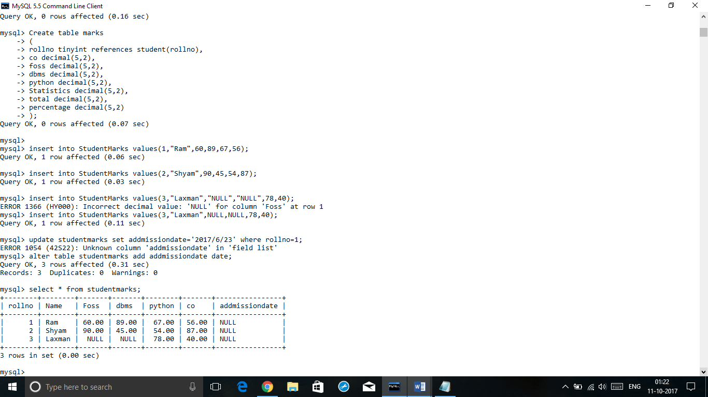

1. **Update table studentmarks by filling values into newly created added column ‘admissiondate’**

Update studentmarks set admissiondate=’2017/6/23’ where rollno=1 ;

select * from studentmarks;

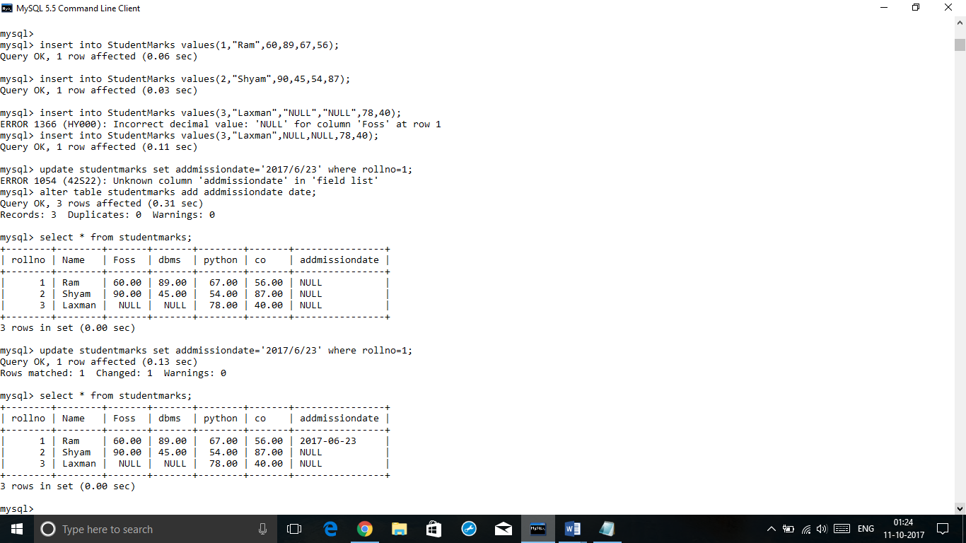

1. **Rename table Student to a new name ‘FycsStudents’**

Rename table student to fycsstudents;

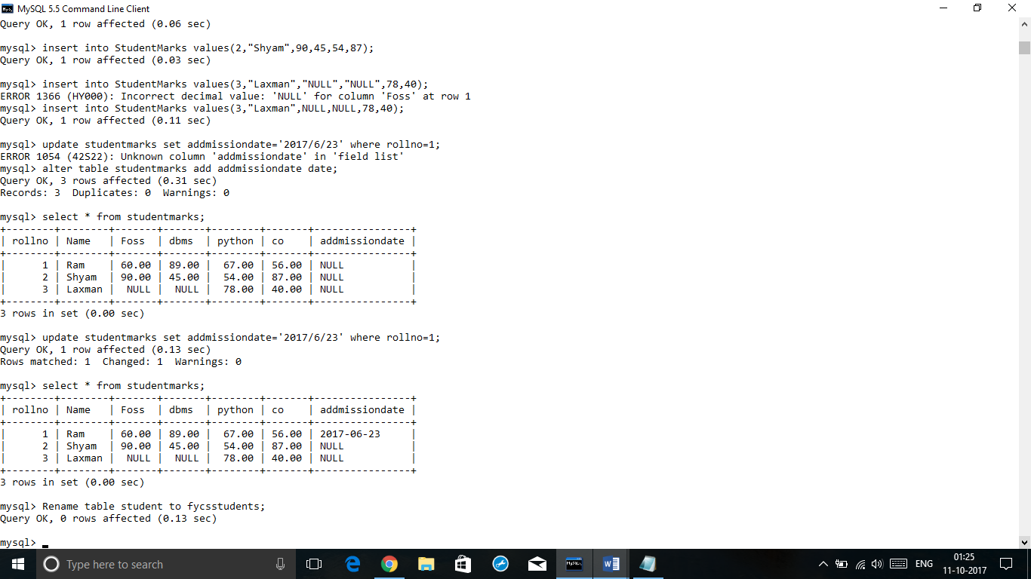

1. **Delete all records from FycsStudents table.**

Truncate table fycsstudents;

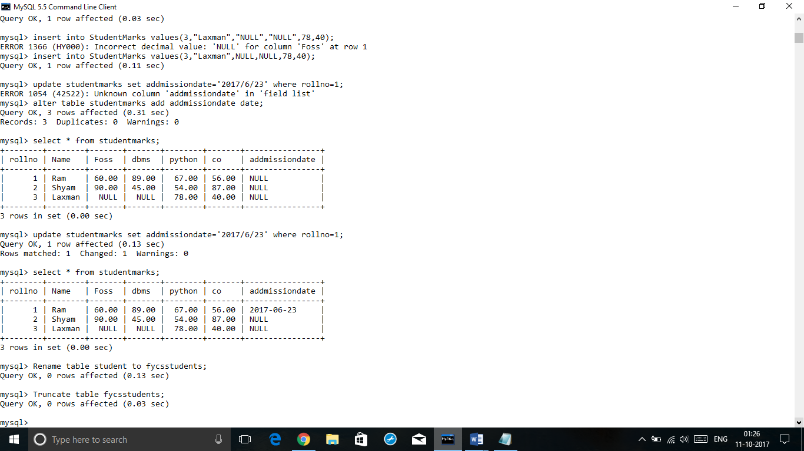

1. **Drop table FycsStudents**

Drop table fycsstudents;

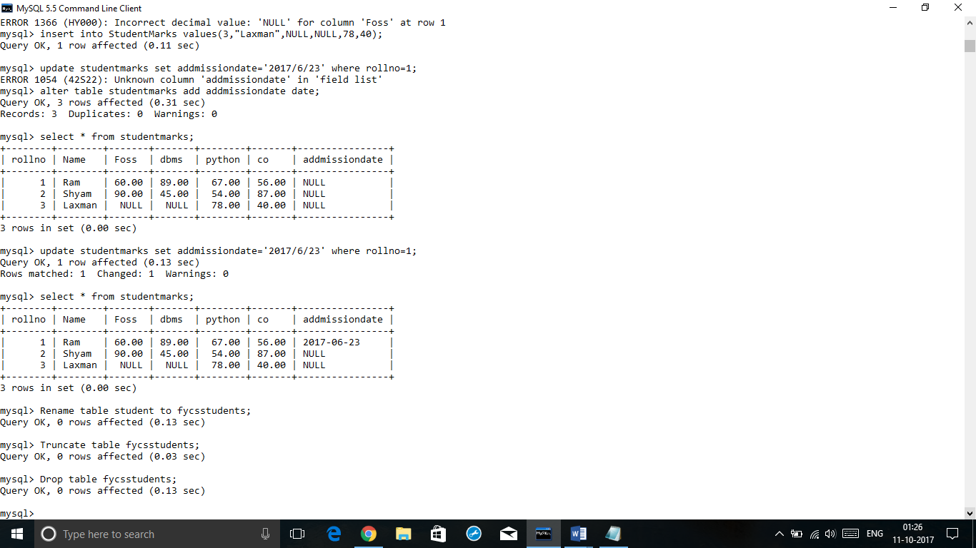

**3.5.1 Create a table query For following schema:**

**Employee ( e_id : integer , name : char(20) , DOB : date, addr : varchar(25) )**

Create table employee

(

e_idinteger ,

name varchar(20),

dob date,

addrvarchar(25)

);

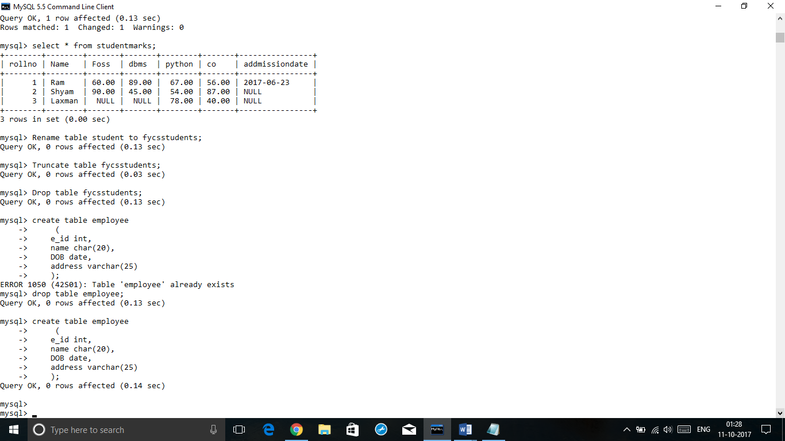

**E_ID NAME DOB ADDR**

------- --------------- -------------- ------------

1 sonali 25-JUN-95 23,RamNivas

2 priya 29-DEC-95 5,Shyam Nagar

3 jayshree 20-NOV-95 13,Park Avenue

4 priyanka 01-JUL-95 4,Sarvodya Nagar

5 ABC 20-JAN-80 45,pumphouse

insert into Employee values(1,’sonali’,’95-6-25’,’23,ram niwas’);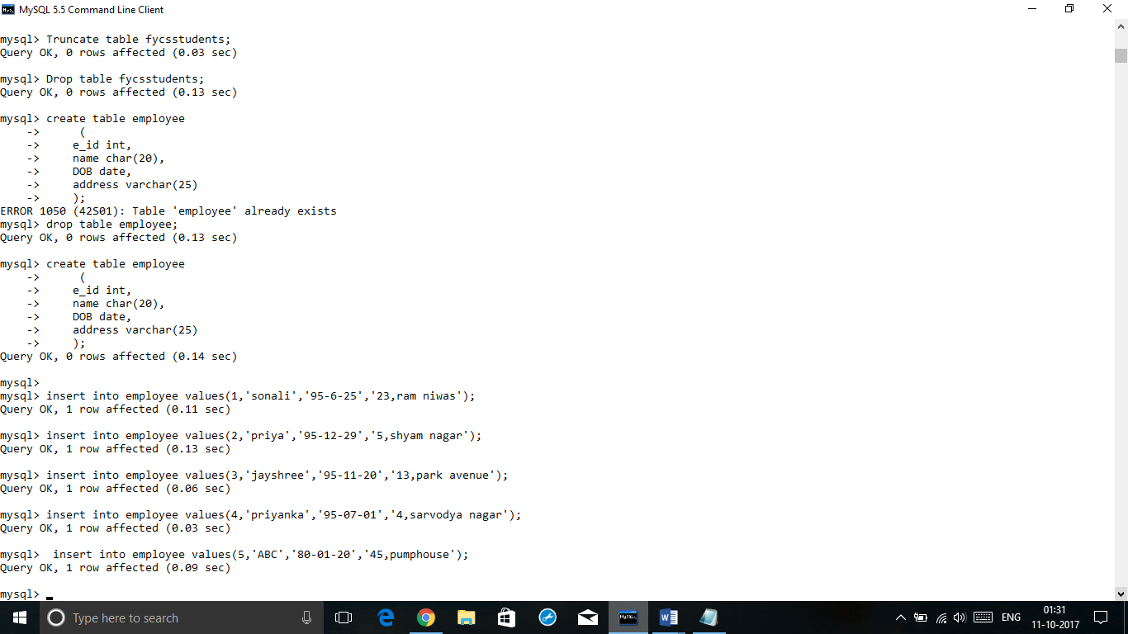

select*from employee;

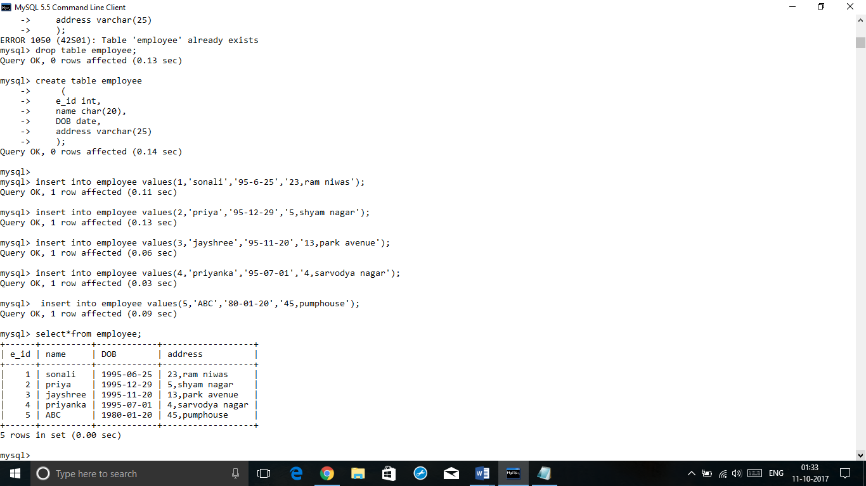

1. **change the data type of e_id to tinyint.**

Alter table employee modify column e_idtinyint;

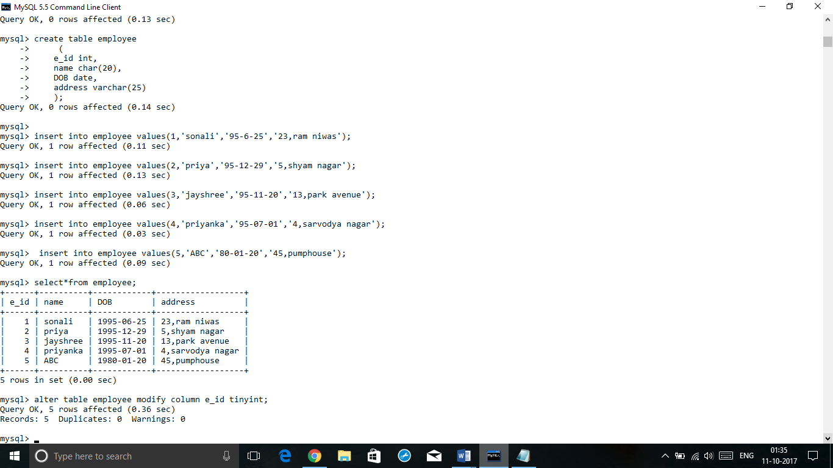

1. **add a new column salary - double into Employee table.**

Alter table employee

Add salary int;

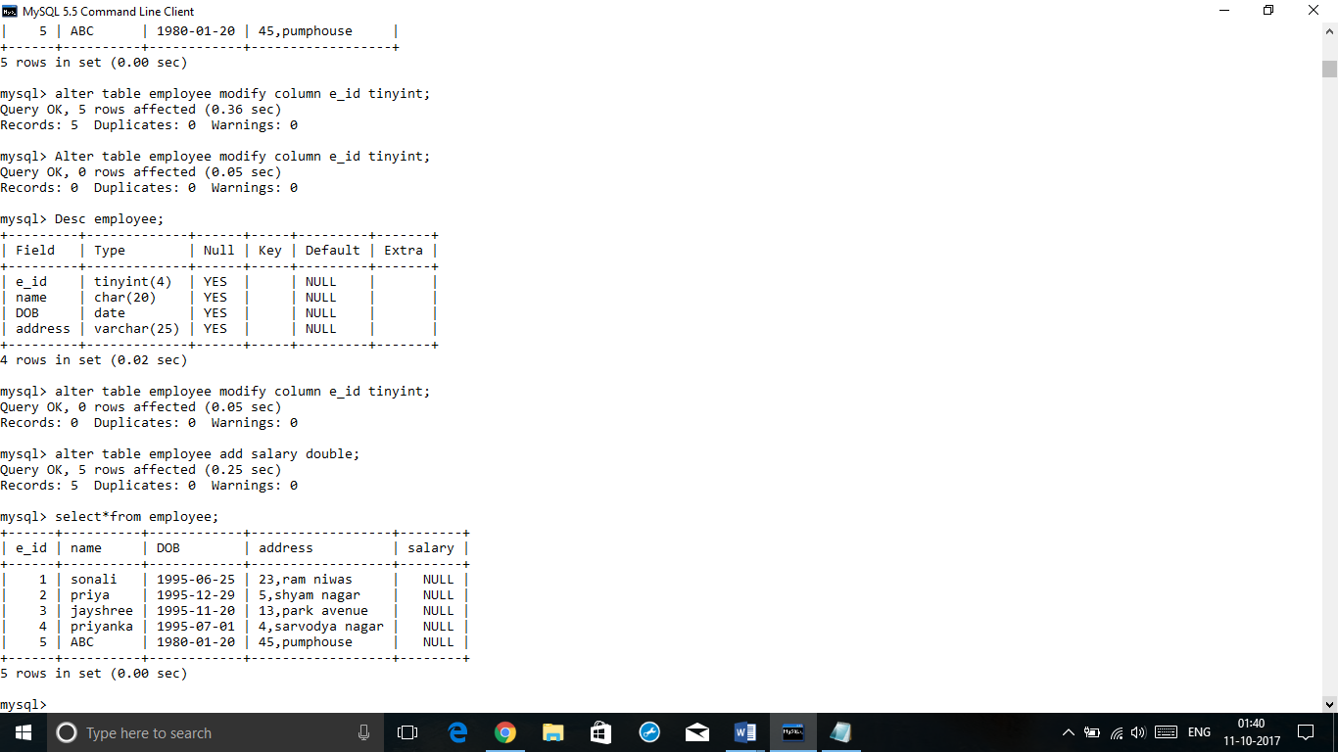

1. **add the new column phoneno-bigint into employee table.**

Alter table employee

Add phoneno bigint;

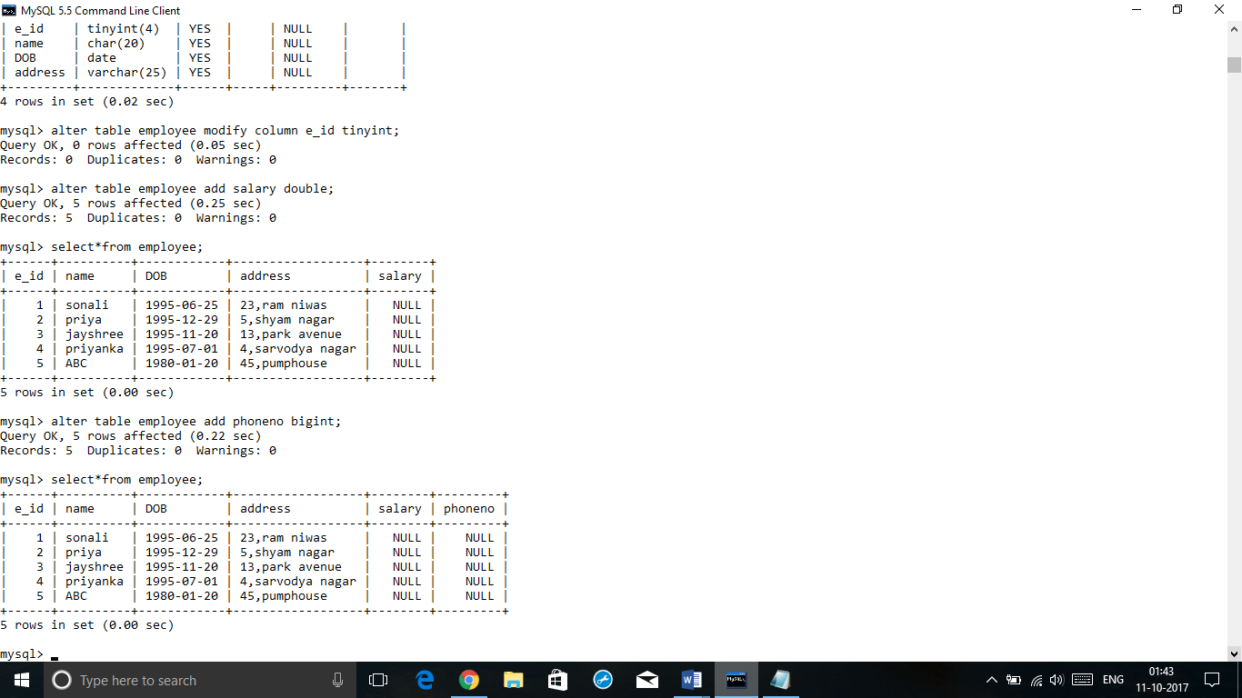

1. **Rename the e_id column to Emp-id.**

Alter table employee change e_id emp_id tinyint;

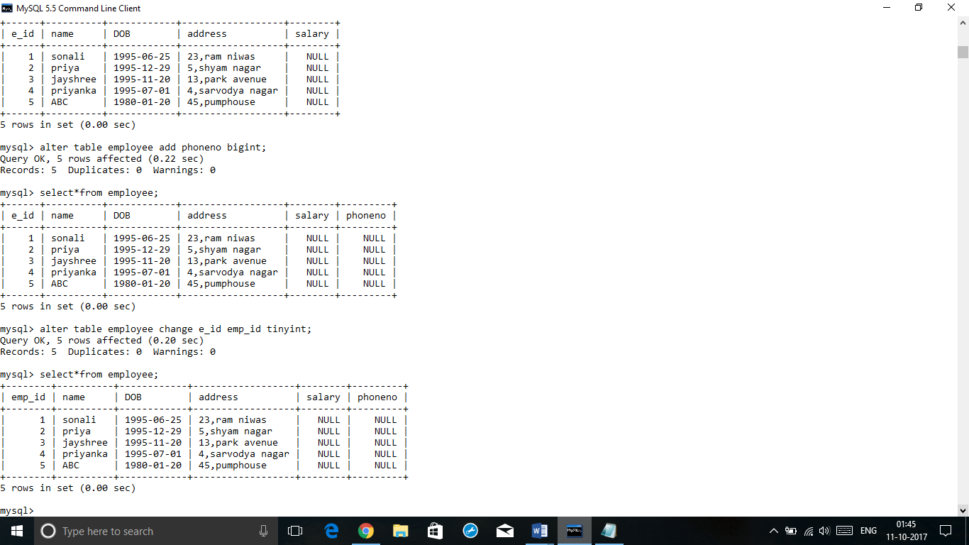

Desc employee;

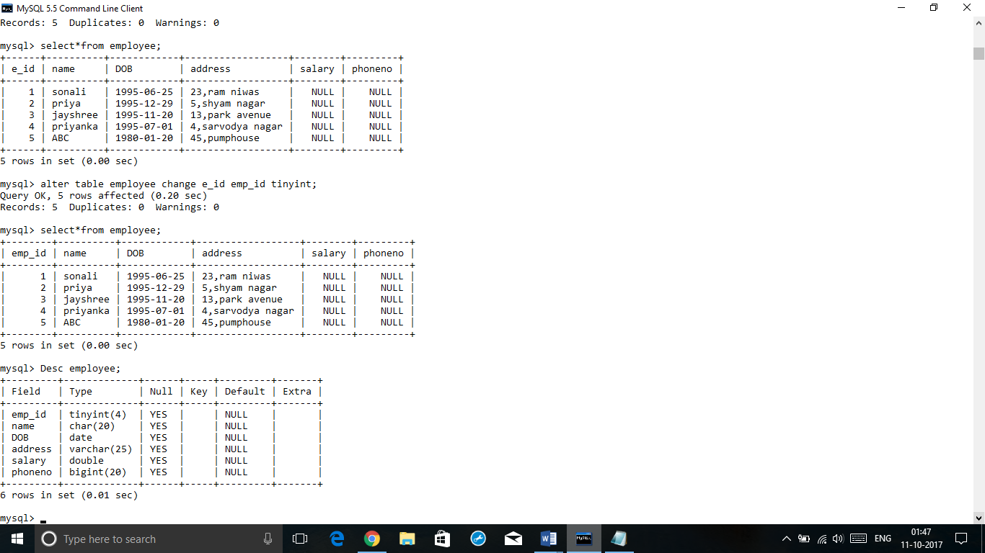

1. **DROP salary column from Employee table.**

Alter table employee

Drop salary int

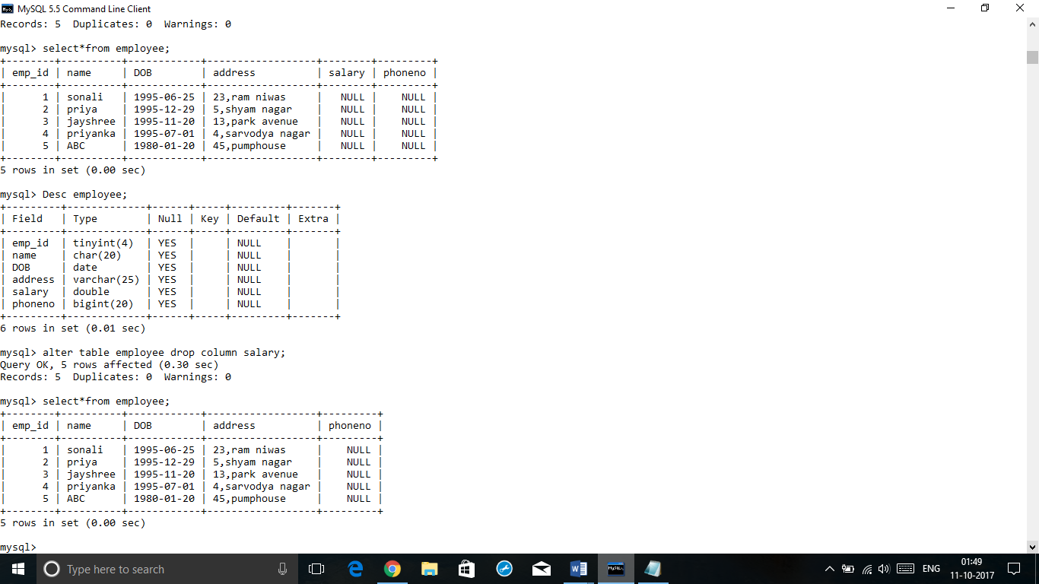

1. **Update name to ‘ABC’ where emp_id =5**

Update employee

Set name=ÁBC’

Where emp_id=5

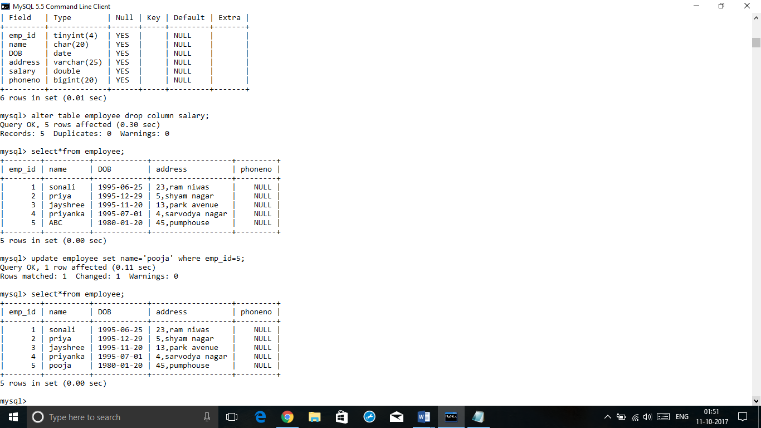

1. **update address to '34,Divya Gunj' where name =’priya’**

update employee

set address=’34.divya gunj’

where name=’priya

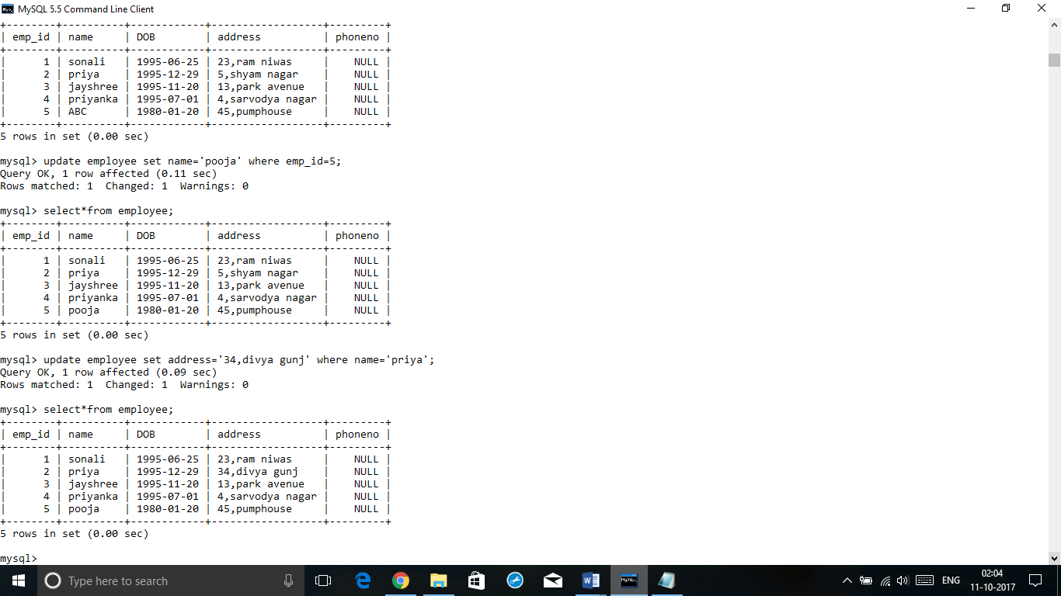

1. **delete record where emp_id=3**

delete from employee where emp_id=3

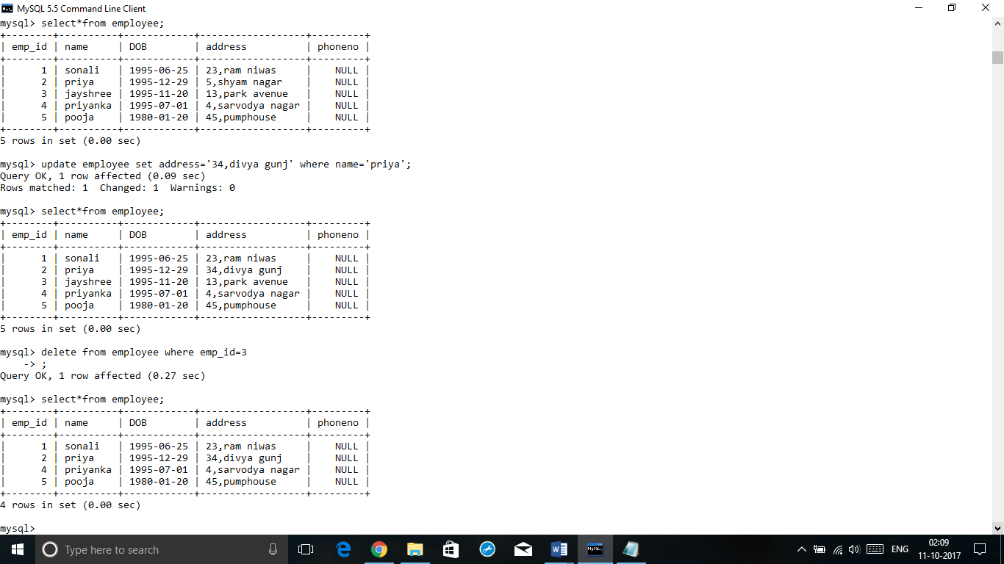

1. **Delete record from employee table where name=’riya’**

delete from employee where name=’riya’

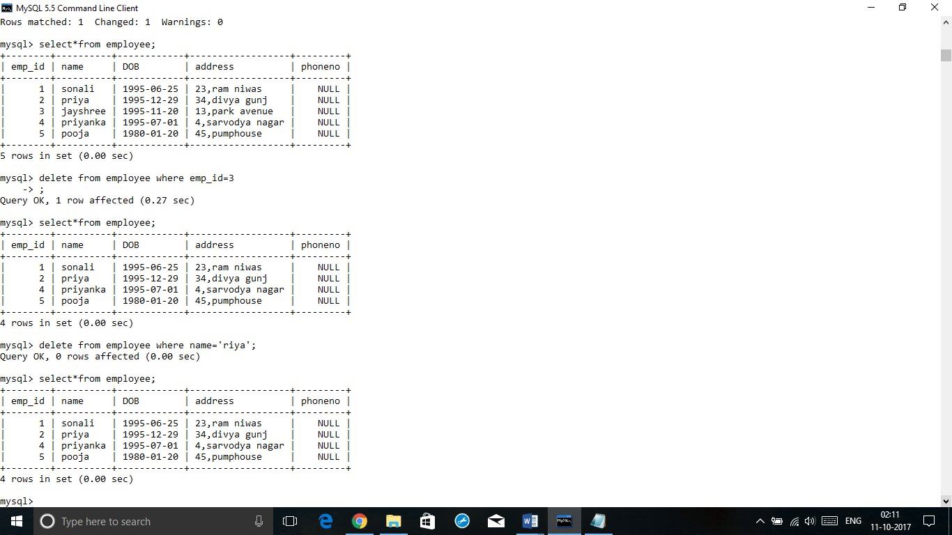

1. **Drop table Employee’**

Drop table employee;

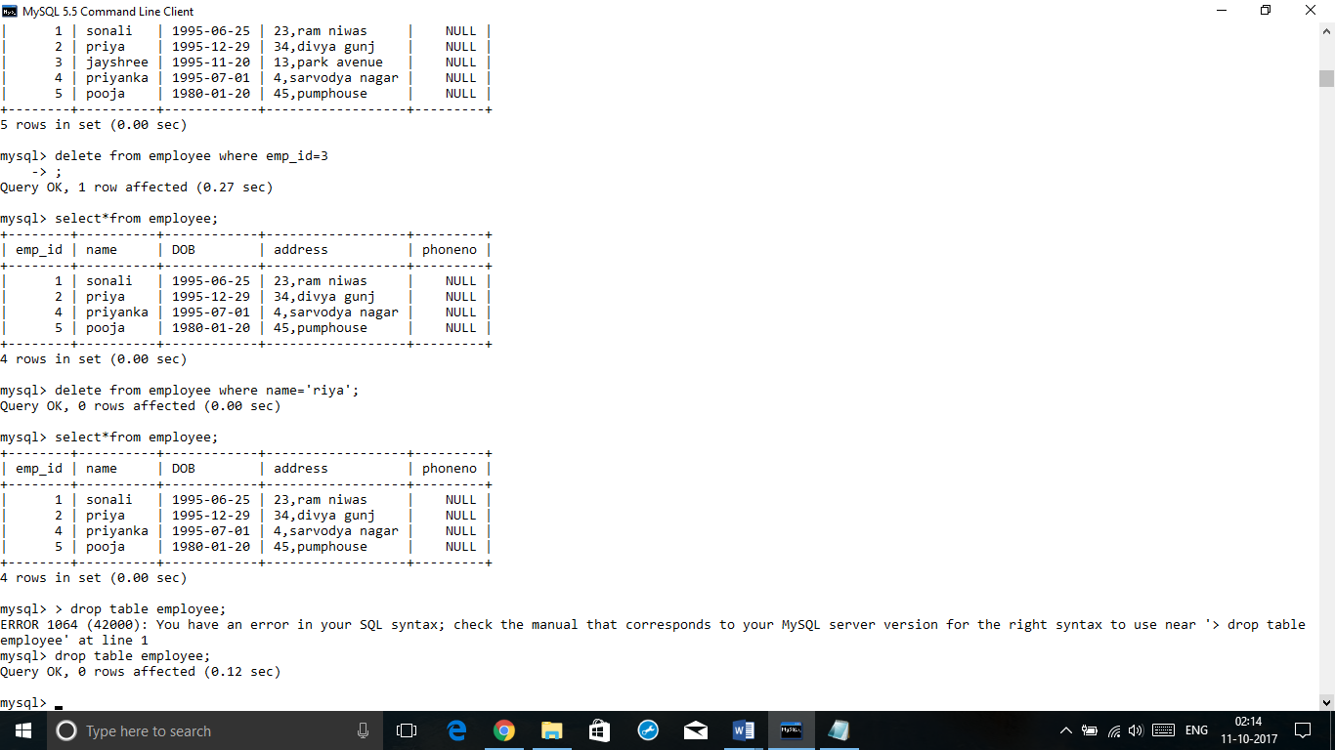

Practical No.4

**AIM: Altering/Dropping/Truncating/Renaming Tables**

1. **write the create table query for the below given Database schema.**

**Create table query:**

create table Employee

(eid tinyint,

ename char(25),

phoneno bigint

);

Table created

Desc employee;

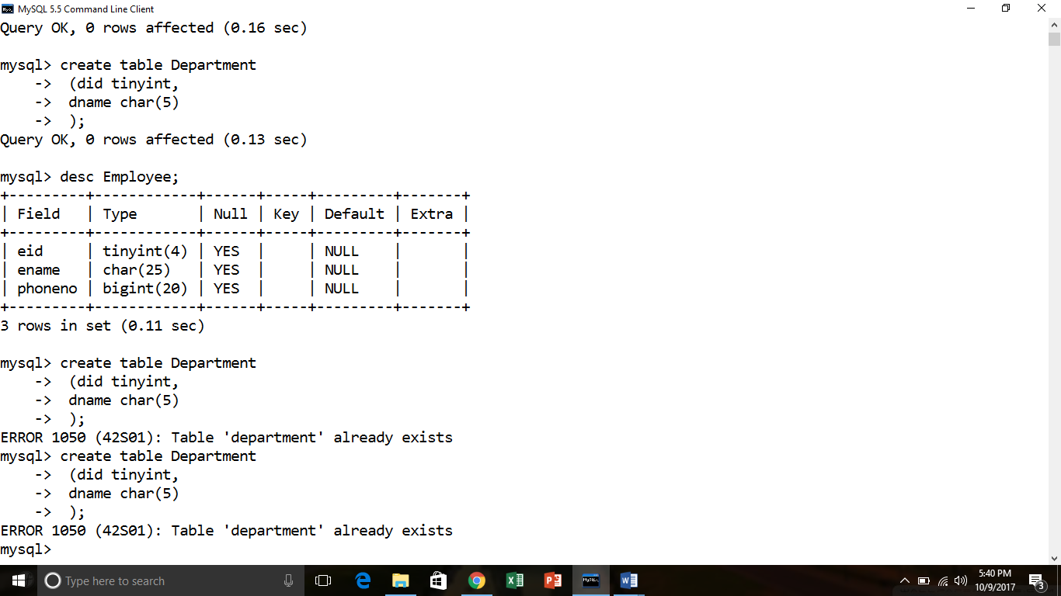

create table Department

(did tinyint,

dname char(5)

);

Table created

Desc department;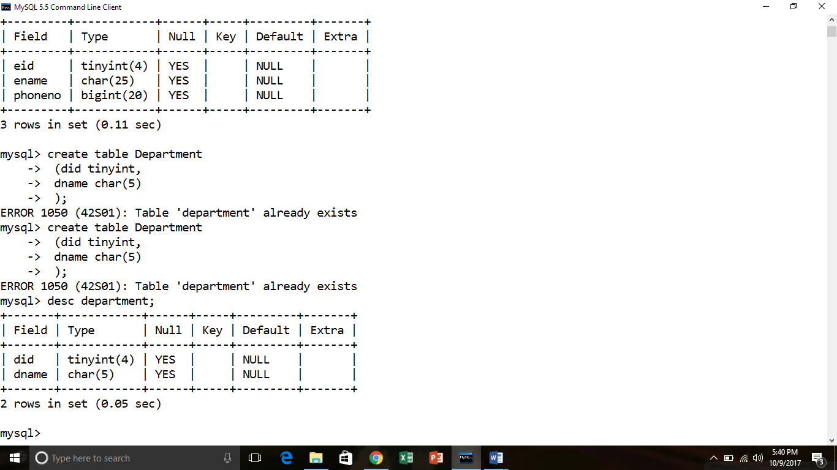

**QUERIES:**

1. **Add new column deptid(tinyint)in Employee table**

* Alter table employee add deptid tinyint;

Table altered

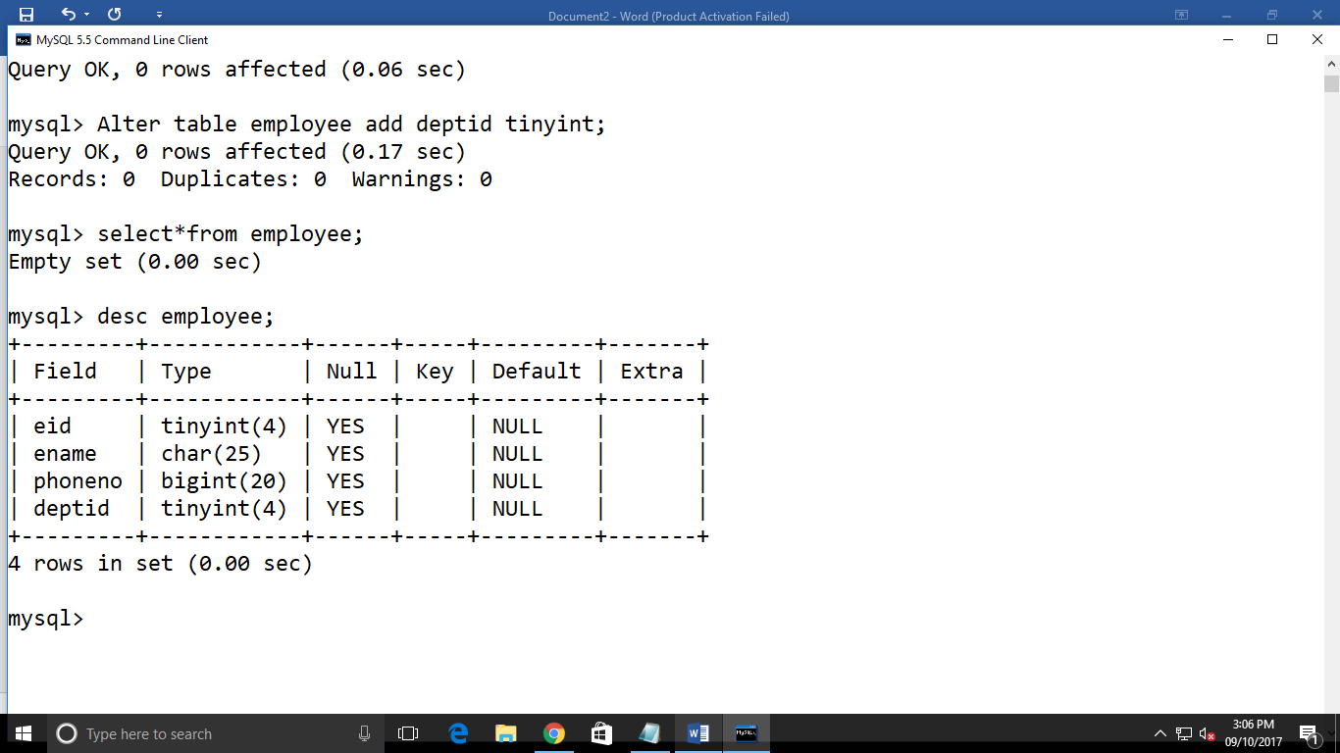

1. **Add new column manager_id(tinyint) in Department table**

* Alter table department add column manager_id tinyint;

Table altered

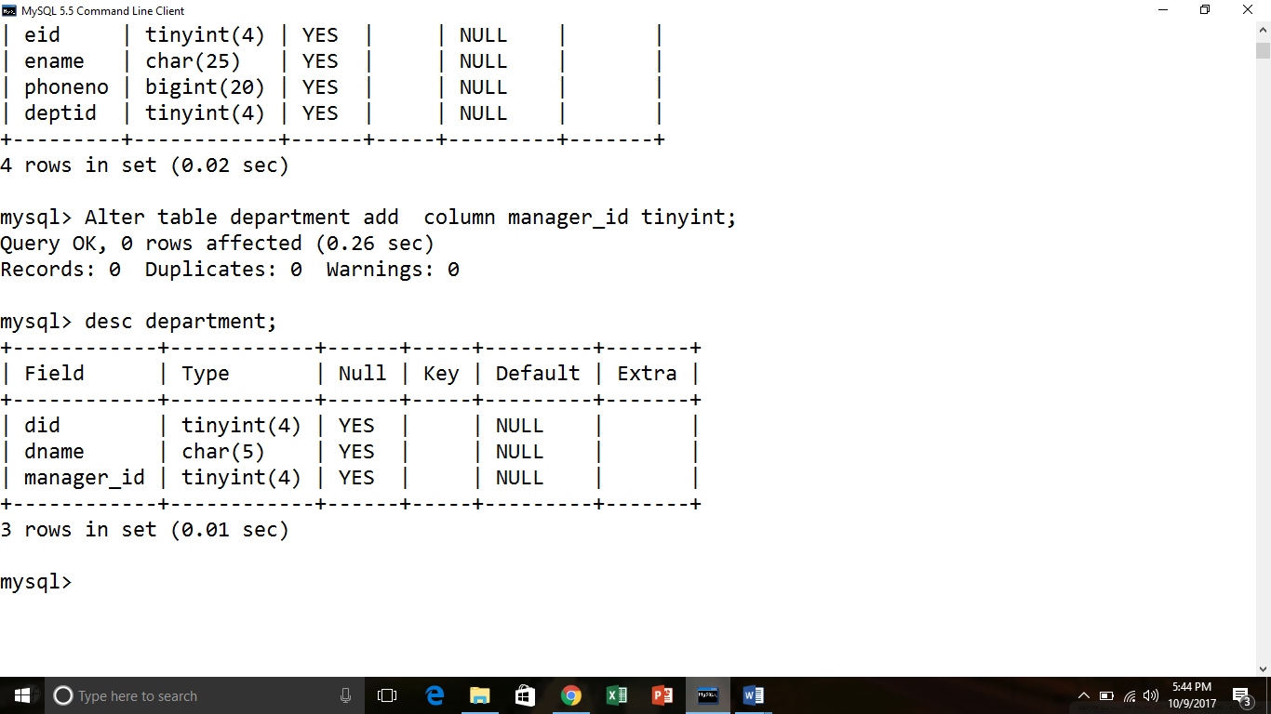

1. **Add primary key constraint on eid and did column of Employee and Department table respectively.**

* Alter table employee add primary key(eid);

Table altered

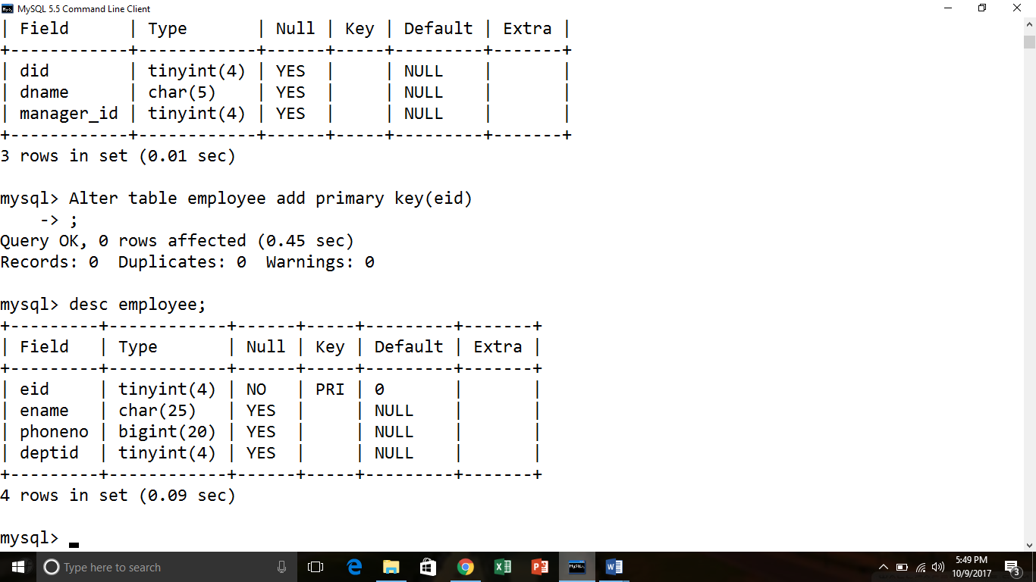

* Alter table department add primary key(did);

Table altered

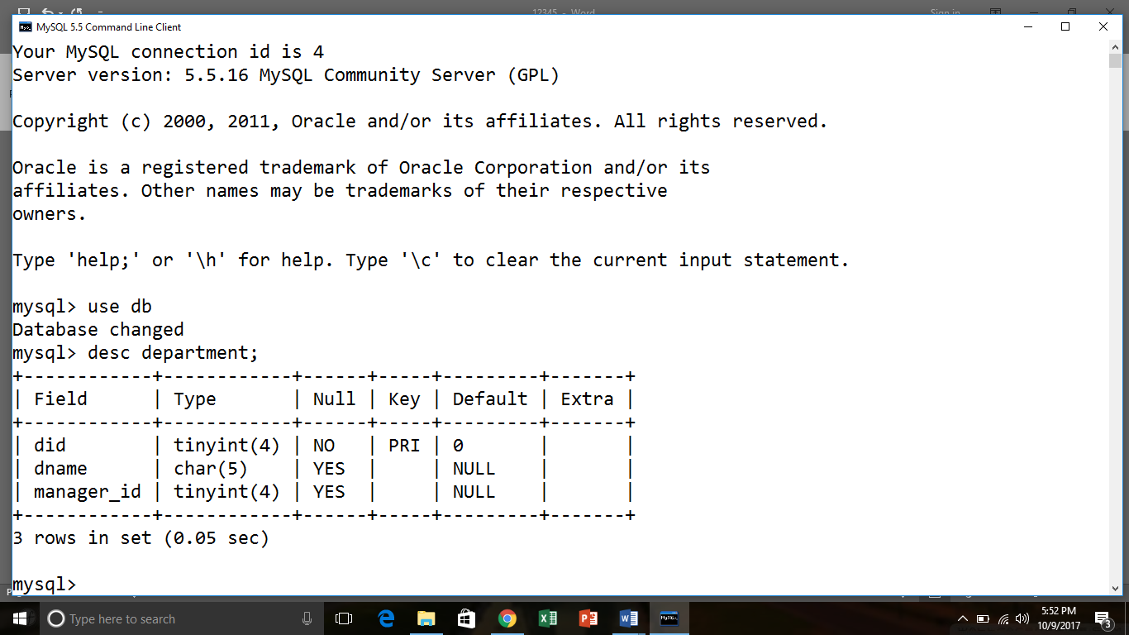

1. **Add foreign key constraint to deptid column of employee table and make it refer did column of department table.**

* Alter table employee add constraint foreign key(deptid) references department(did);

Table altered

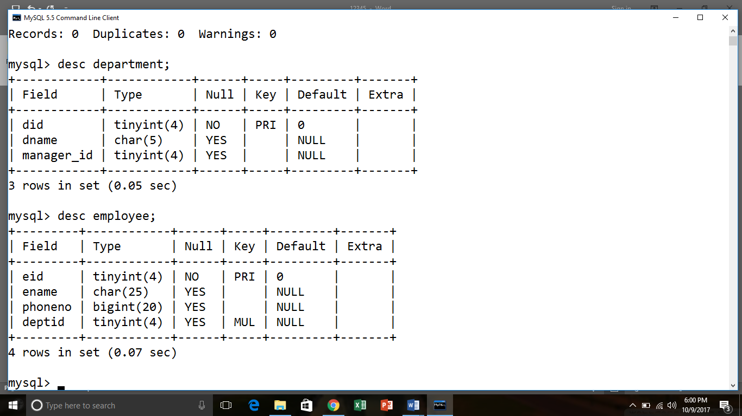

1. **Add foreign key constraint to manager_id column of department table and make it refer eid column of employee table.**

* Alter table department add constraint foreign key(manager_id) references employee(eid);

Table altered

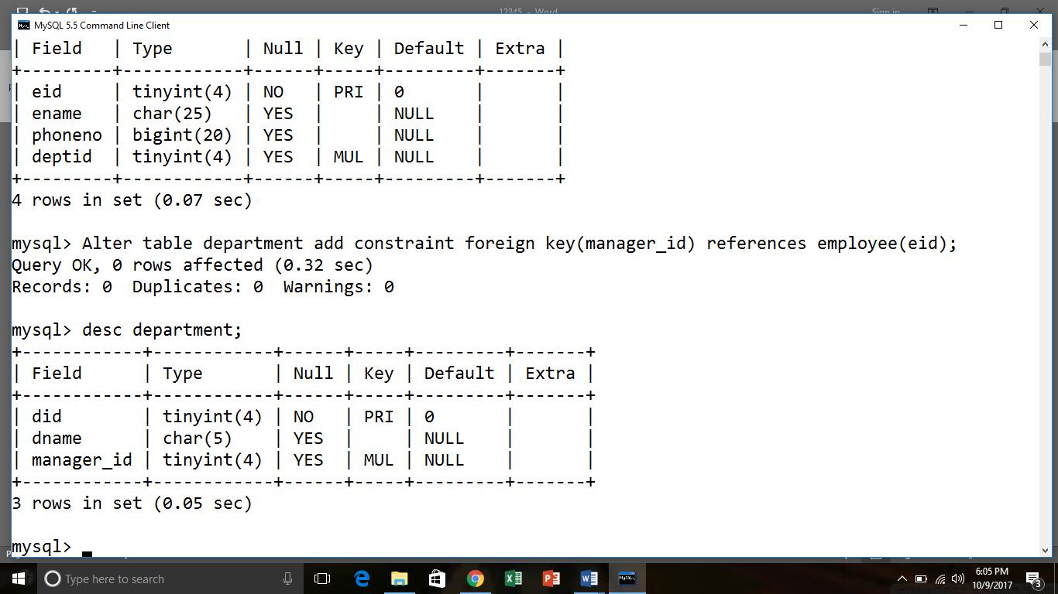

1. **Consider the below given Student table and perform the following alter operation:**

**Create table query:**

create table student

(rollno tinyint,

name char(30),

address varchar(30),

age tinyint

);

Table created

Desc student;

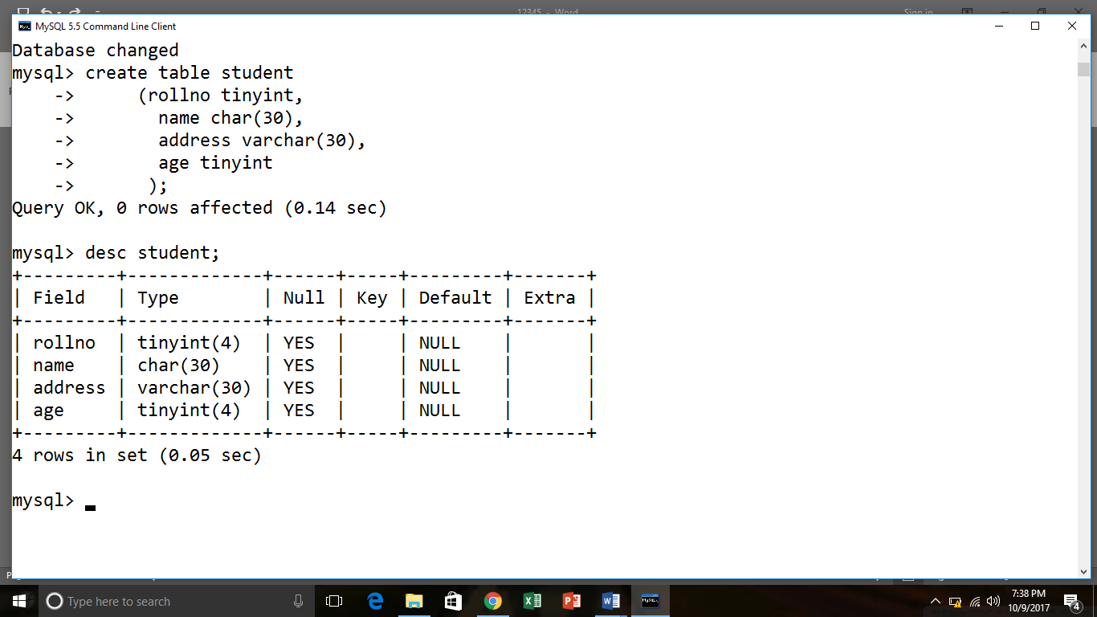

**QUERIES:**

**1. Add a new column ‘dept char(3)’in student table.**

* alter table student add dept char(3);

Table altered

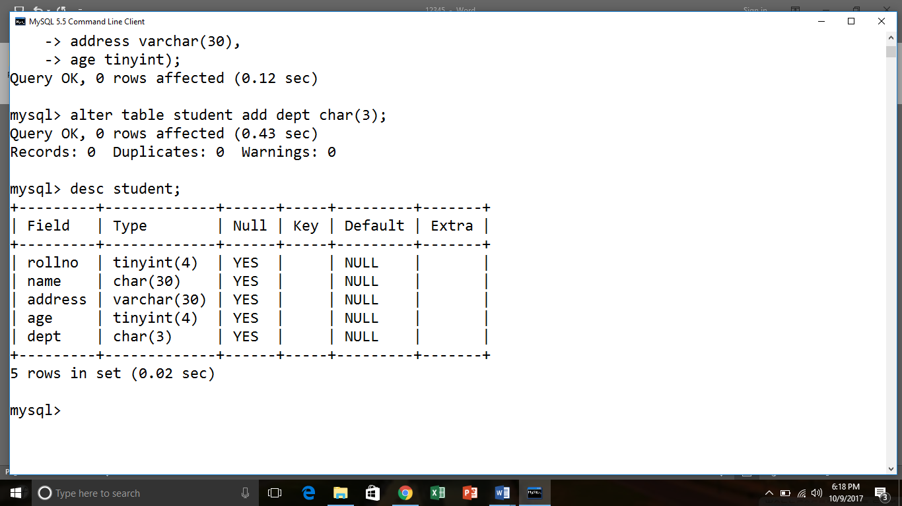

**2. Drop address column from student table**

* Alter table student drop column address;

Table altered

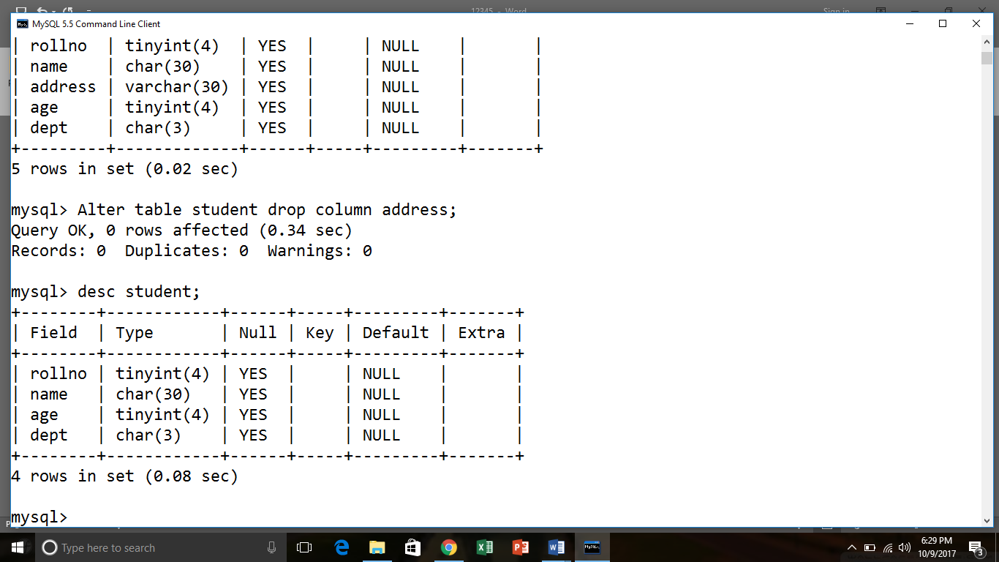

**3. Change the datatype for name column to name char(45)**

* Alter table student modify name char(45);

Table altered

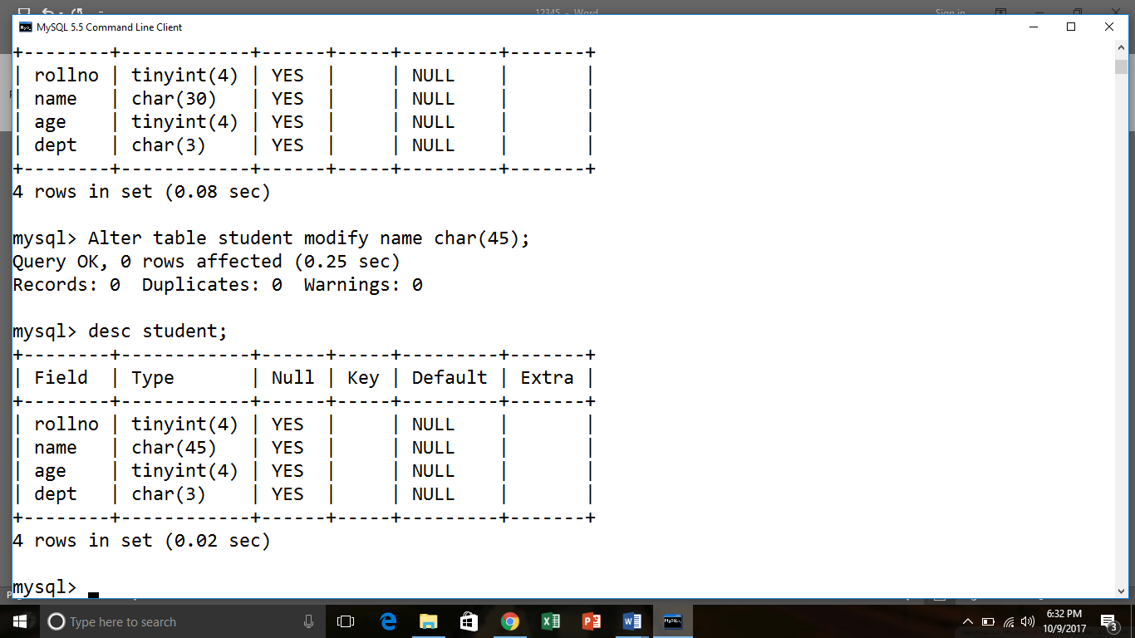

**4. Assign default value of 18 to age column**

* Alter table student modify age tinyint default 18;

Table altered

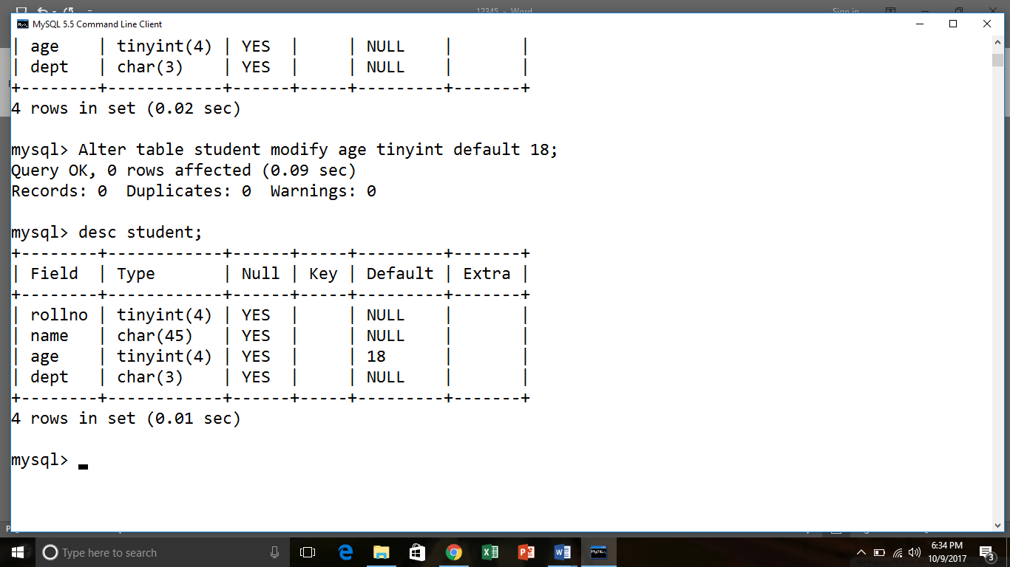

**5. Change the datatype for rollno to varchar(5)**

* Alter table student modify rollno varchar(5);

Table altered

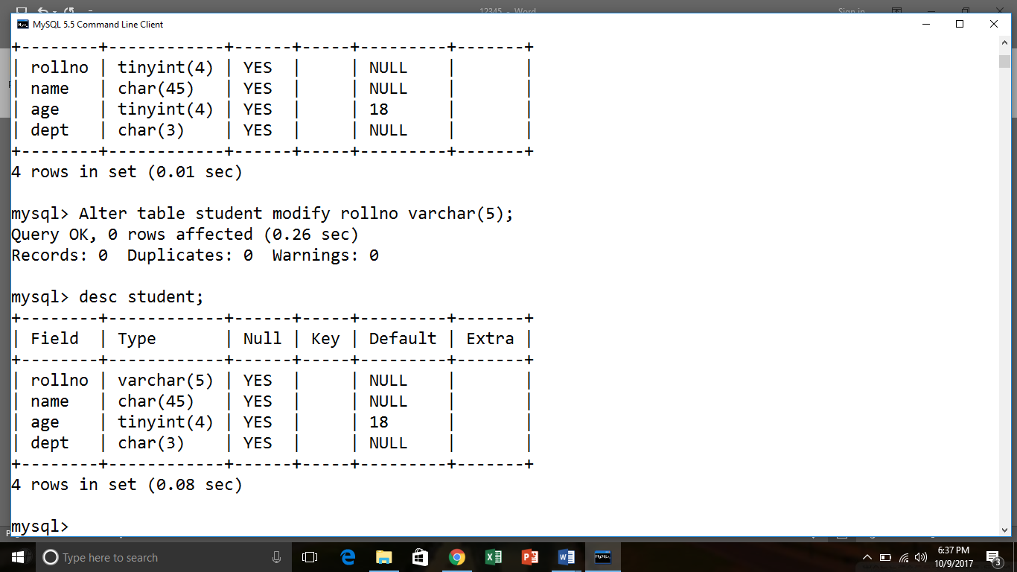

1. **Create a table query For following schema:**

**Employee (  e_id  : integer , name : char(20) , DOB : date, addr  : varchar(25) )**

**Create table query**

create table Employee28

(e_id integer PRIMARY KEY,

name char(20),

DOB date,

addr varchar(25)

);

Table created.

desc Employee28;

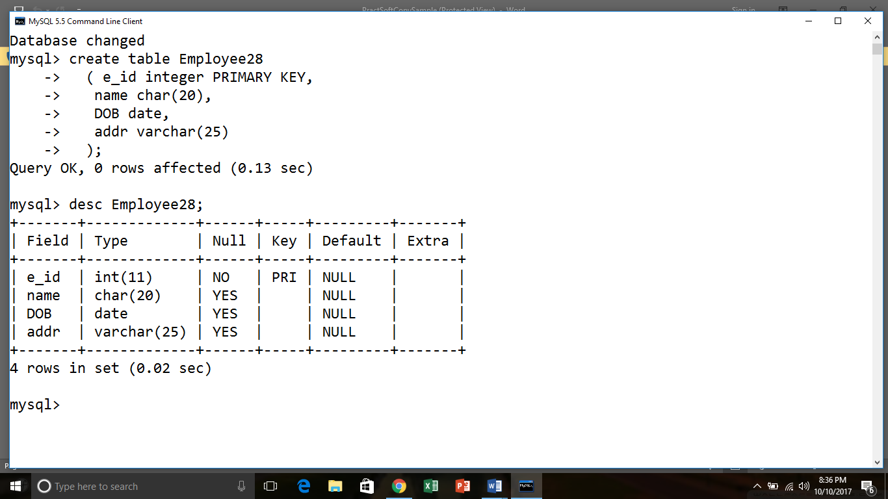

**Inserting values**

insert into employee28 values(1,'sonali','1995/6/25','23,Ram Nivas');

1 row created.

insert into employee28 values(2,'priya','1995/12/29','5,Shyam Nagar');

1 row created.

insert into employee28 values(3,'jayshree','1995/11/20','13,Park Avenue');

1 row created.

insert into employee28 values(4,'priyanka','1995/7/1','4,Sarvodya Nagar');

1 row created.

insert into employee28 values(5,'ABC','1980/1/20','45,pumphouse');

1 row created.

select * from employee28;

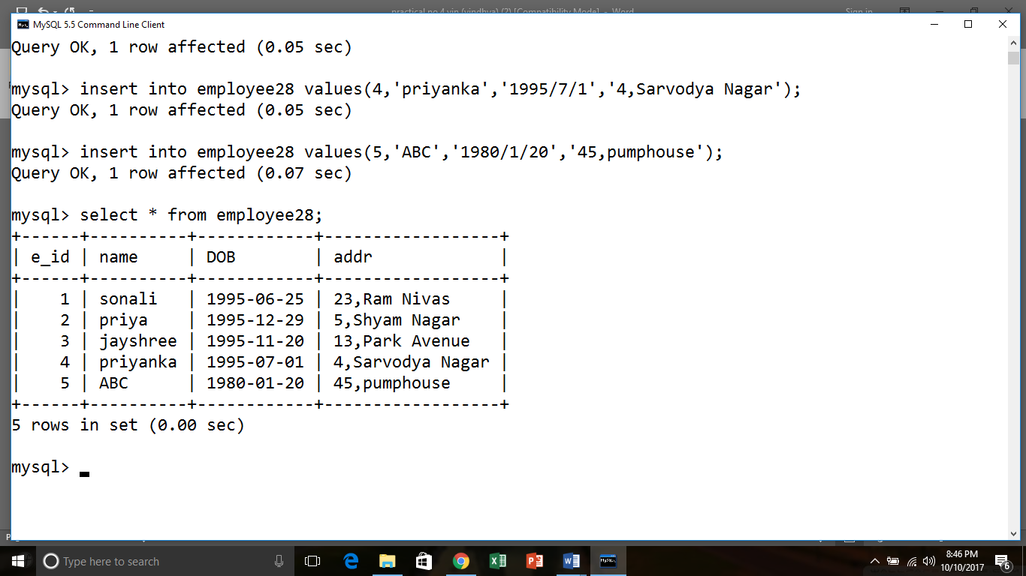

**QUERIES:**

**Q.1 change the data type of e_id to number.**

* Alter table employee28 modify e_id tinyint;

Table altered

Select * from employee28;

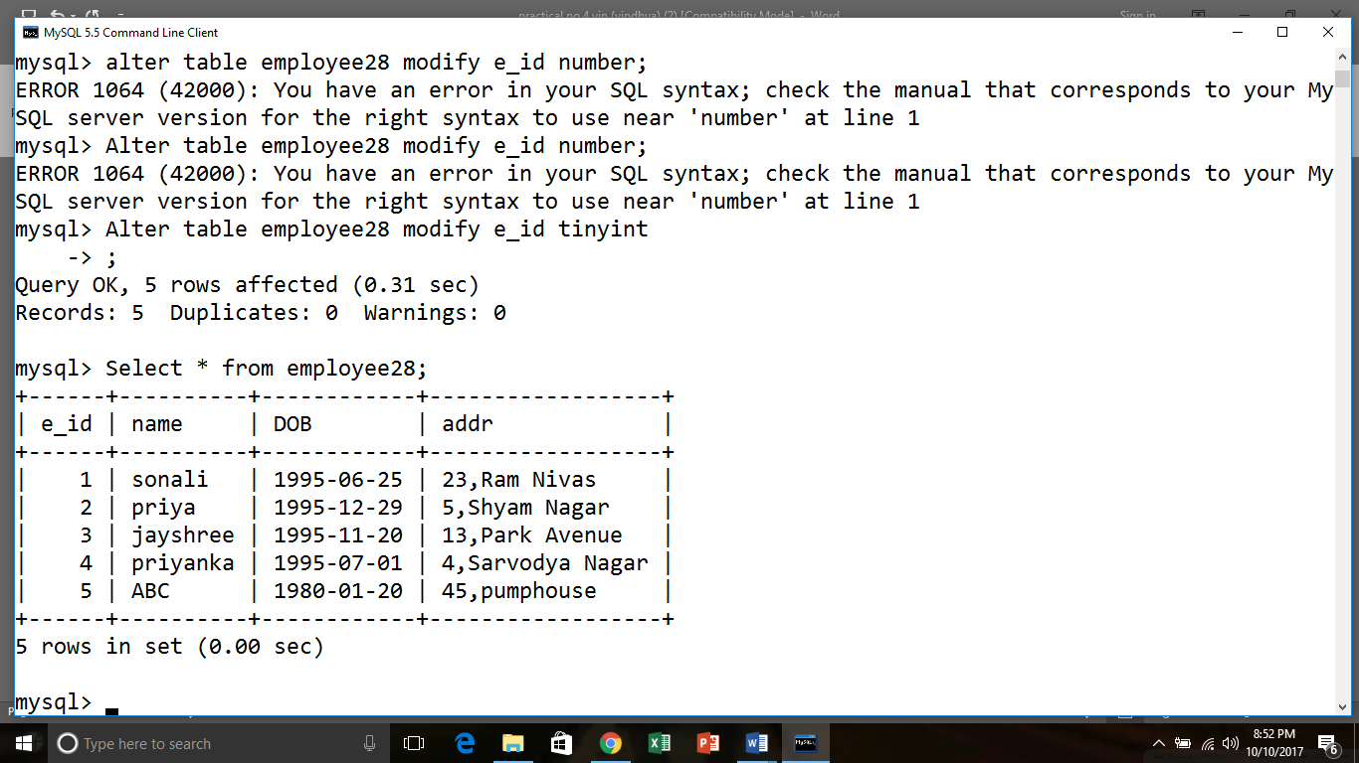

**Q.2 add a new column salary into Employee28 table.**

* alter table Employee28 add salary integer;

Table altered.

Select * from employee28;

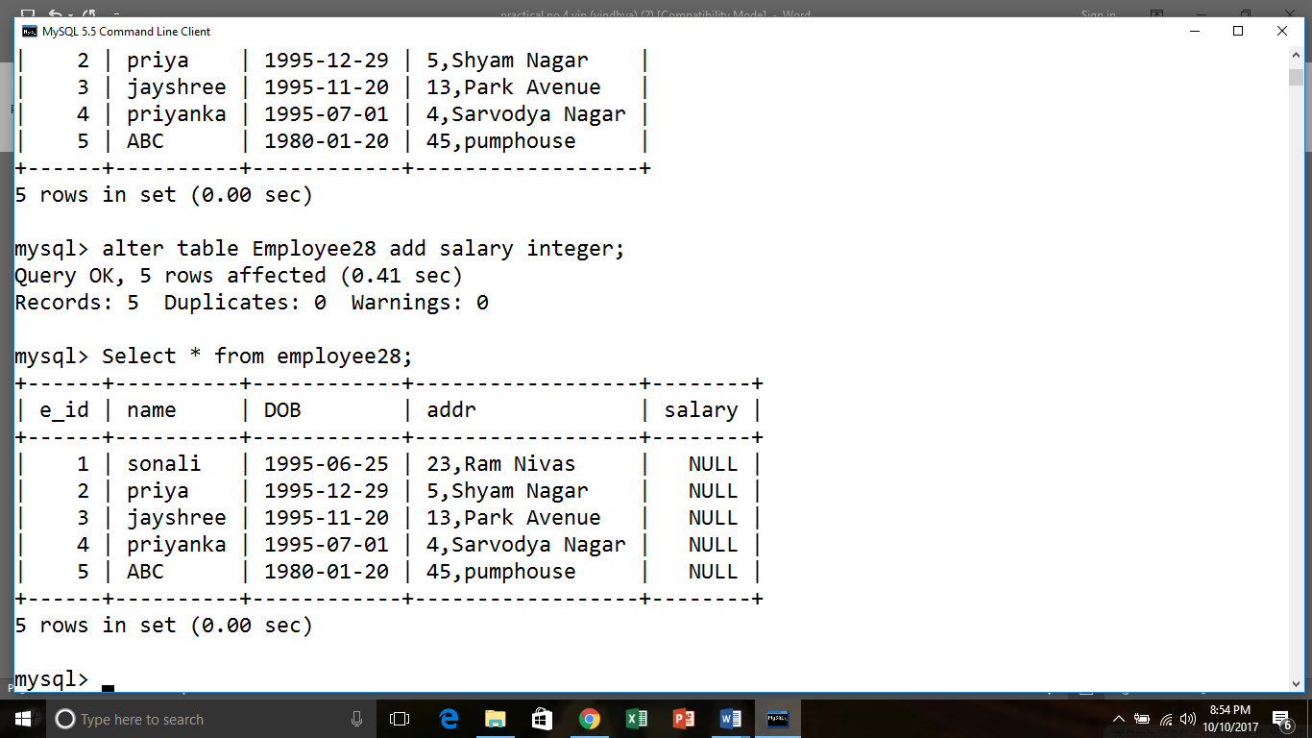

**Q.3 add the new column phone no into employee28 into Employee28 table.**

* alter table Employee28 add phone bigint;

Table altered.

desc Employee28

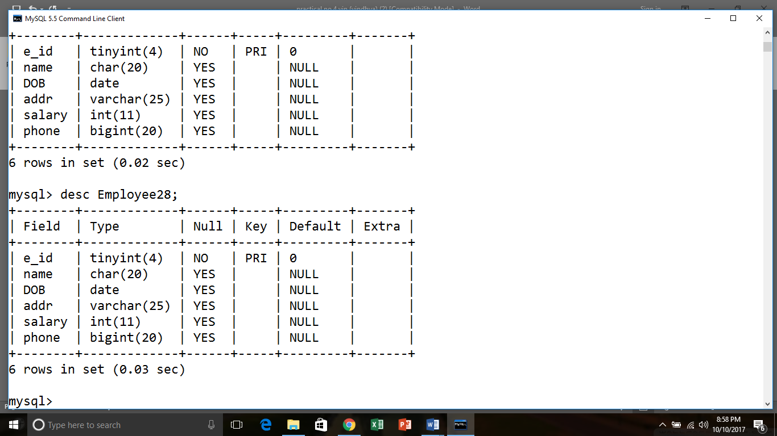

**Q.4Rename the e_id column to Empl-id.**

* ALTER TABLE employee28 CHANGE e_id empl_id tinyint(4);

Table altered.

desc Employee28;

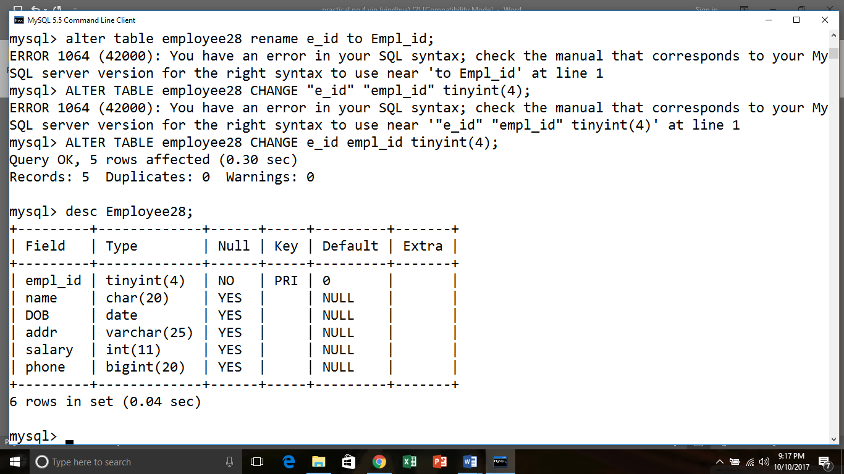

**Q.5  DROP salary column from Employee28 table.**

* alter table Employee28 drop  column salary ;

Table altered.

desc Employee28;

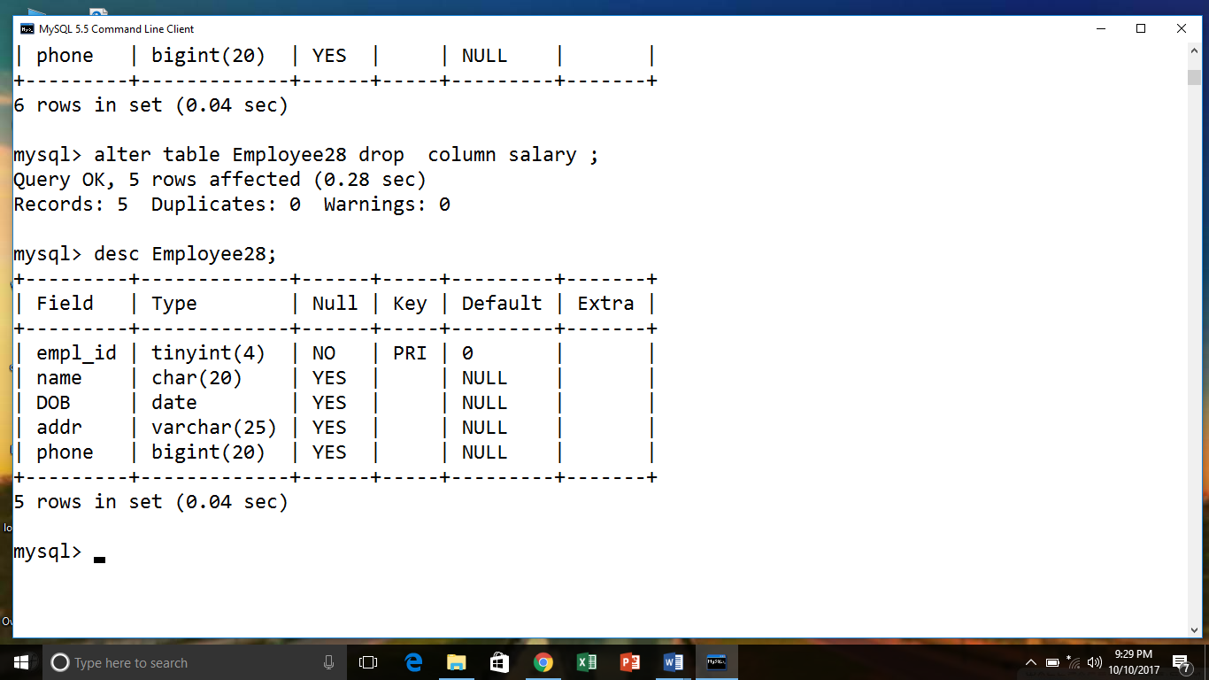

**Q.6 Update name where e_id =5**

* update employee28

SET name='Riya'

where empl_id=5;

1 row updated.

select * from employee28;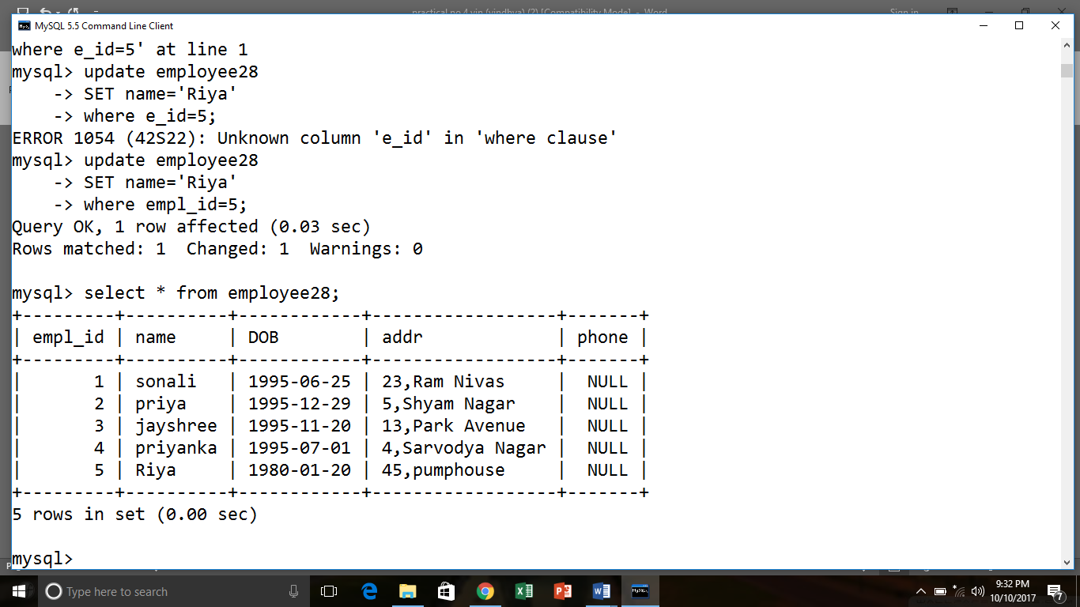

**Q.7 update  address where name =’priya’**

* update employee28

SET addr='34,Divya Gunj'

where name='priya';

1 row updated.

select * from employee28;

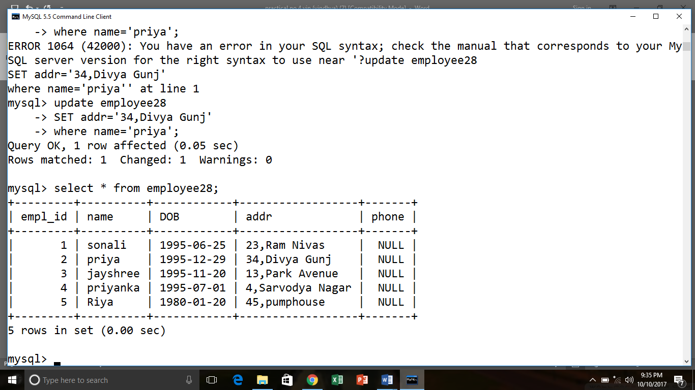

**Q.8) delete record e_id=3**

* delete from employee28

where empl_id=3;

1 row deleted.

select * from employee28;

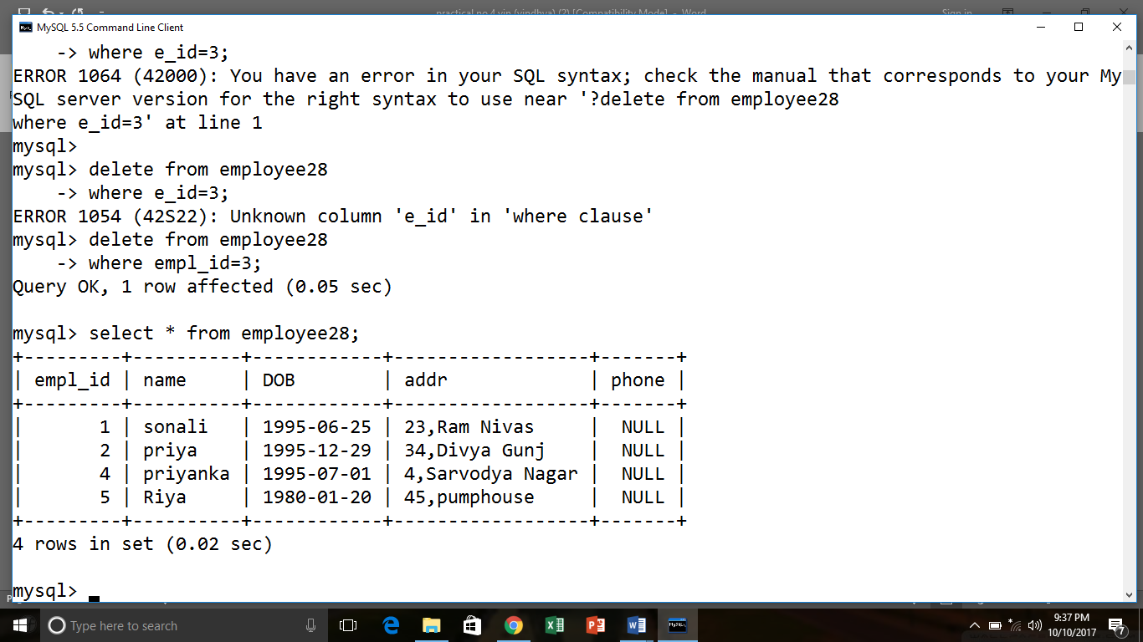

**Q.9Delete record from employee28 table where anme=riya.**

* delete from employee28

where name='Riya';

1 row deleted.

select * from employee28;

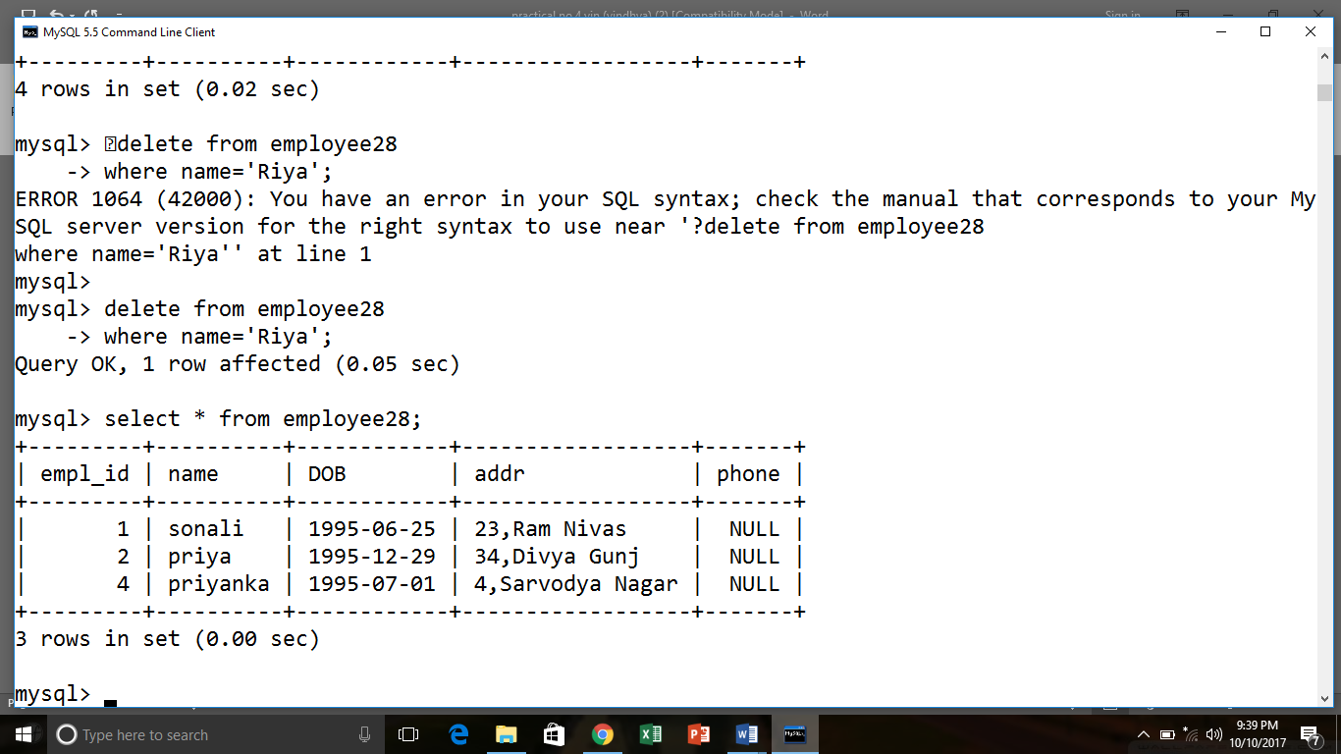

**Q.10 Drop table Employee28.**

* drop table Employee28;

Table dropped.

**PRACTICAL NO-5**

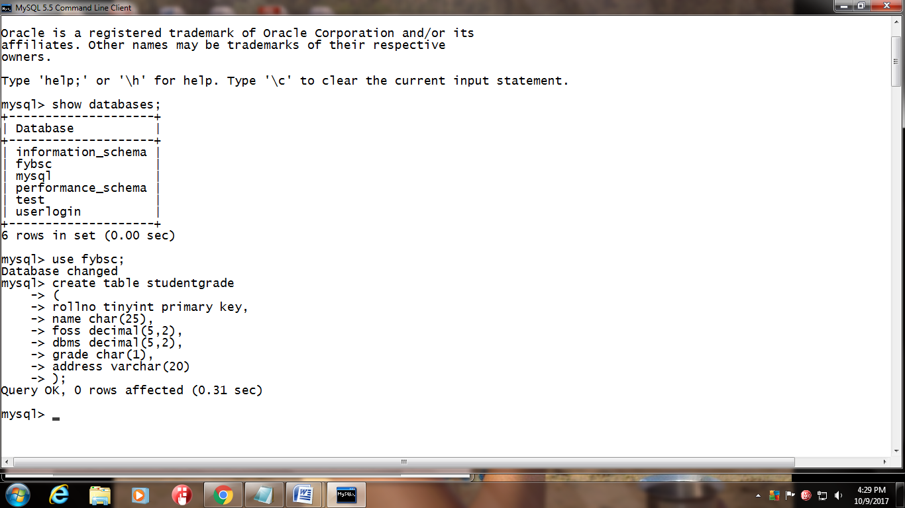

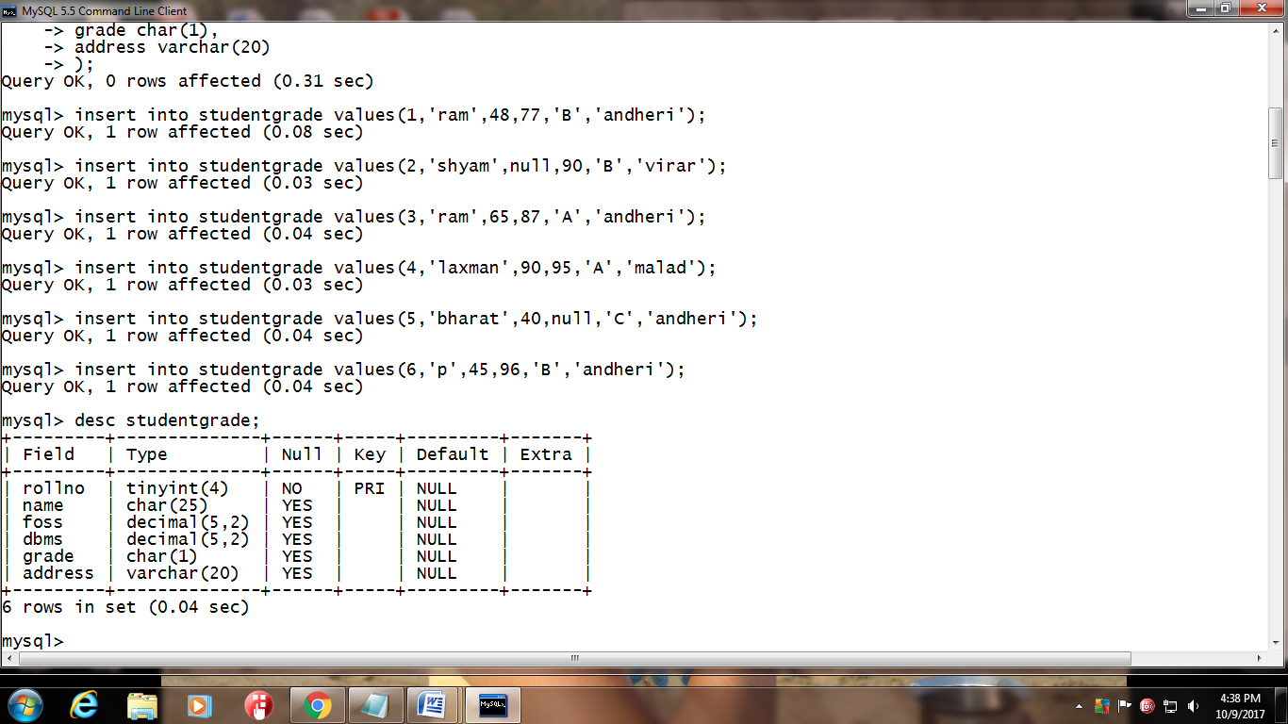

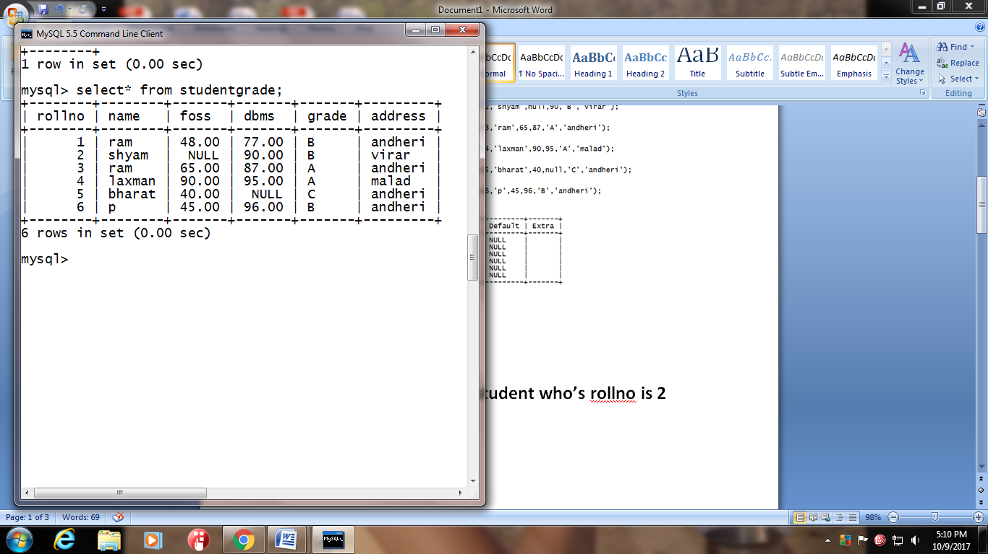

**Simple questions**

1. **Display the name of the student who’s roll no is 2**

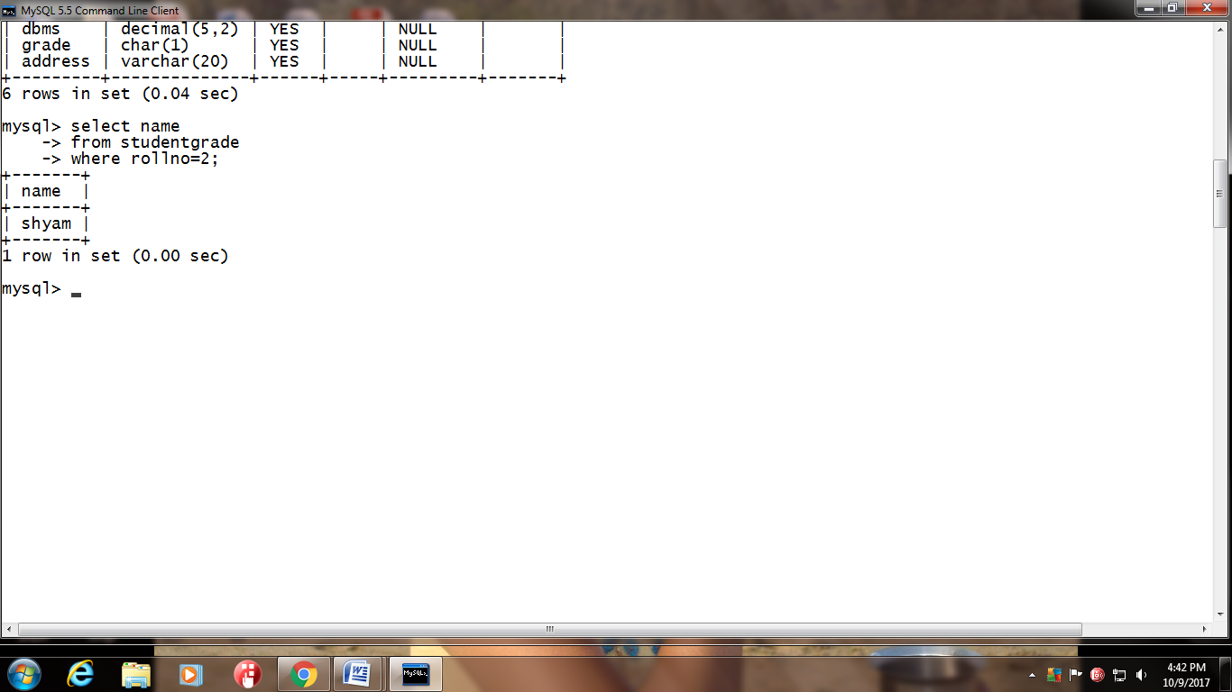

1. **Display the details of the student who’s name is ram**

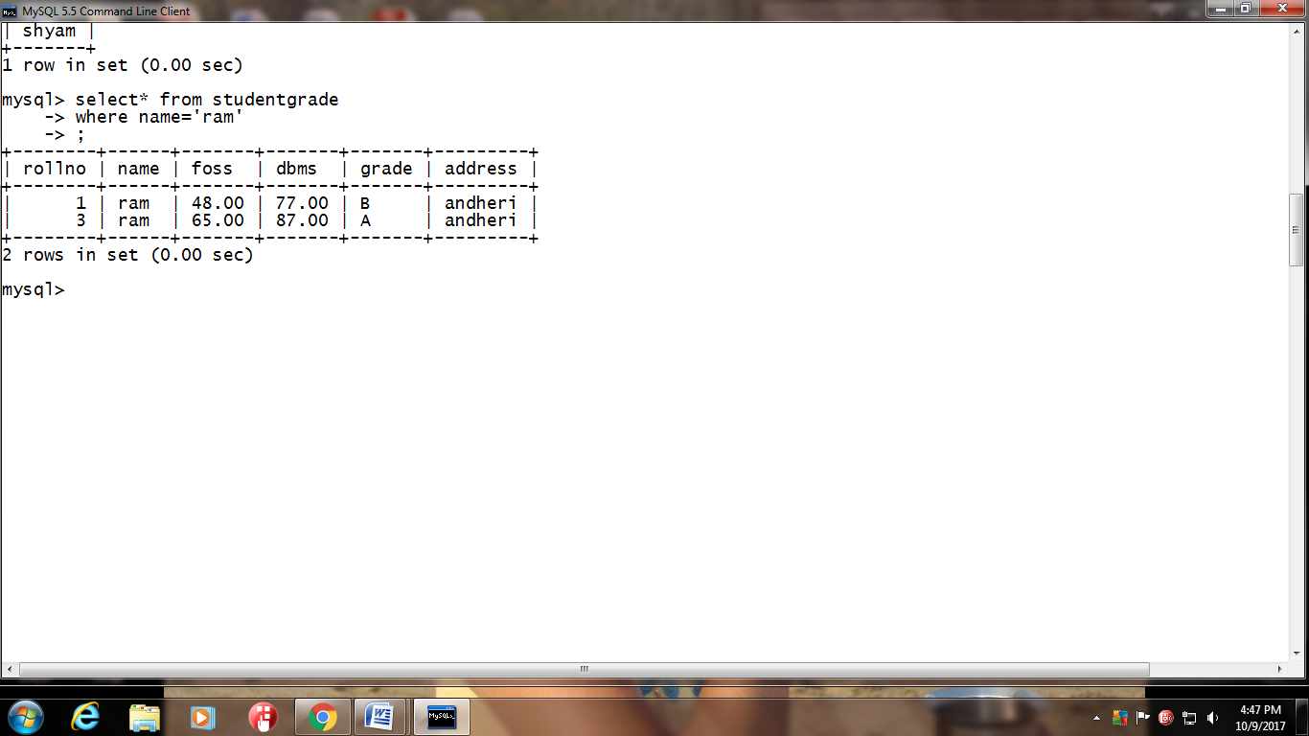

**3)Display the rollno and name of the student scoring more than 50 in dbms**

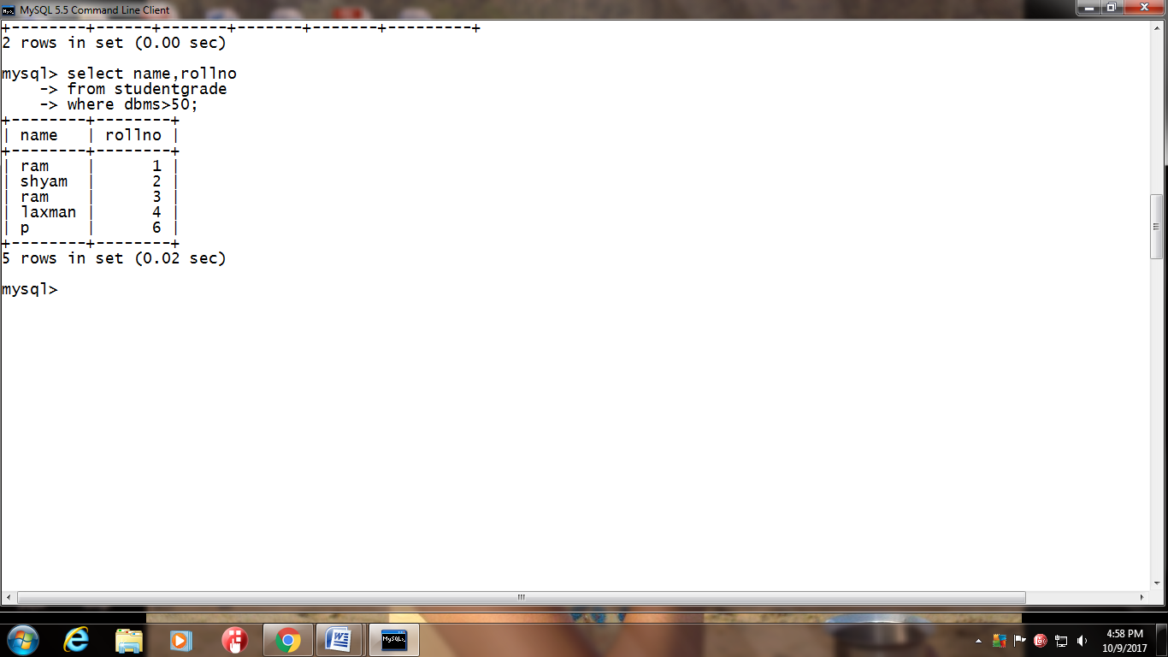

**4)Display the rollno and name of the student scoring more than 50 in dbms and foss**

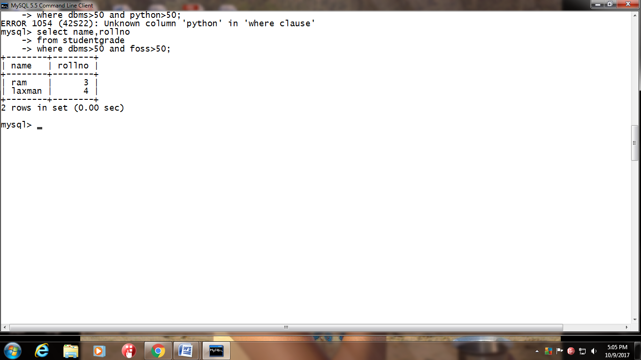

**5)Display the rollno of the student scoring less than or equal to 40 in foss**

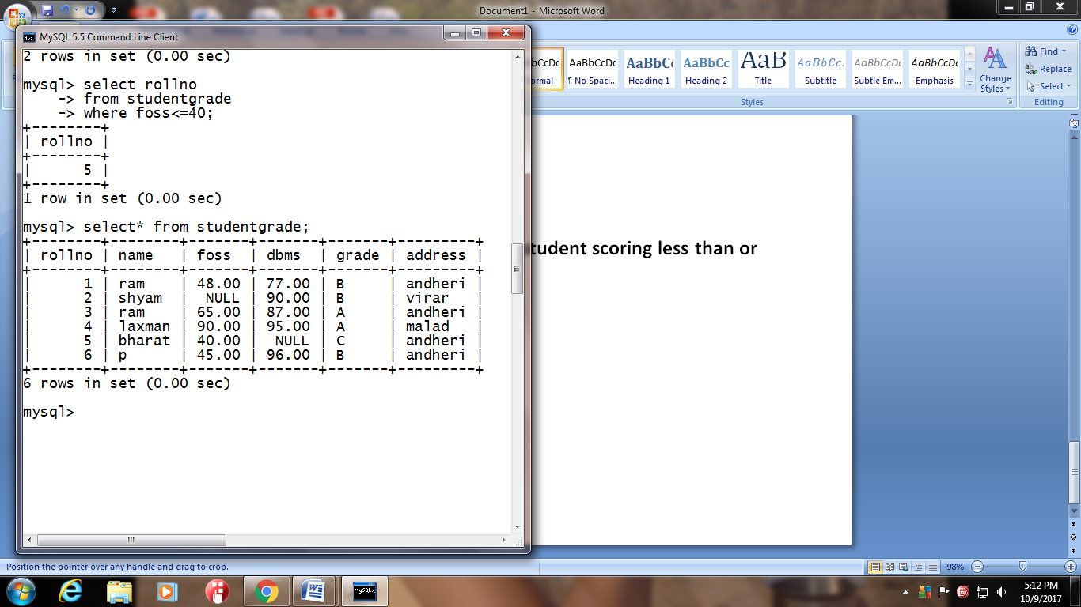

**6)Display the rollno,name and total marks (calculated column) scored by the students**

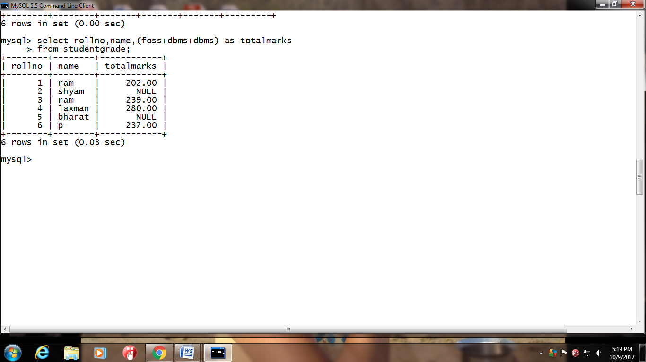

**7)Display the details of the student who’s name is not ram**

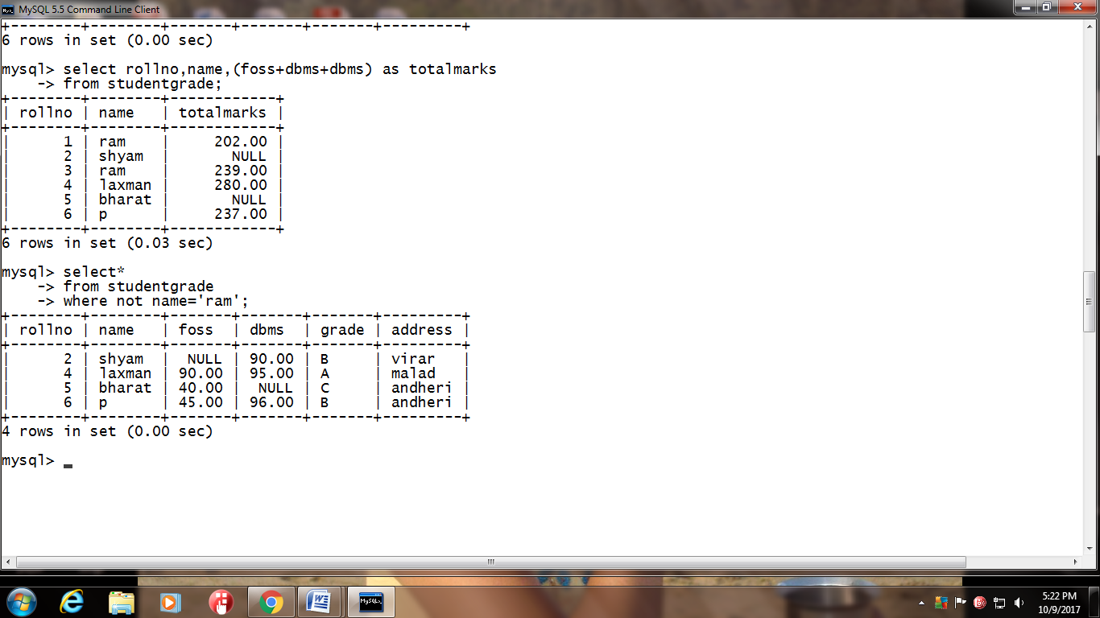

**8)Display the rollno of the student who’s rollno is not 1**

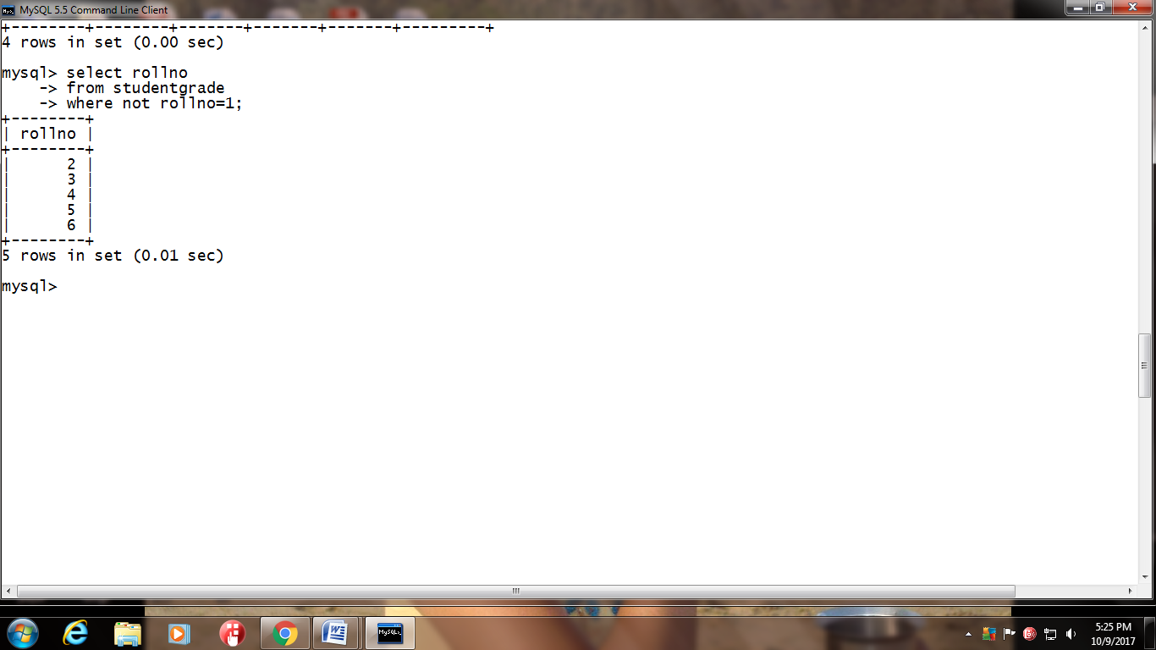

**9)Display the details of the student who’s marks in foss is greater than 50 and less than 90**

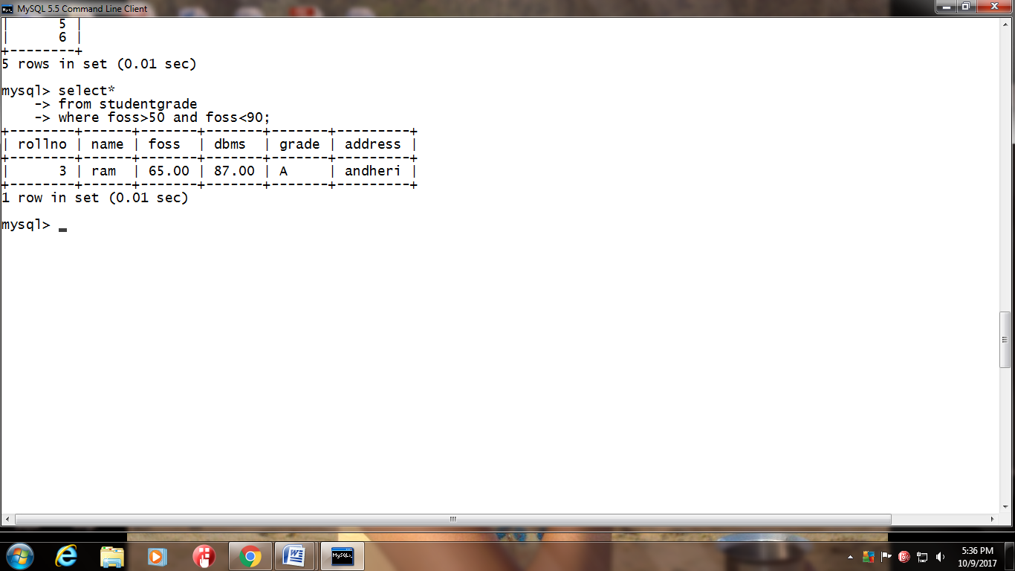

**10)Display the details of the student who’s marks in foss is greater than 40 and marks in dbms is less than 90**

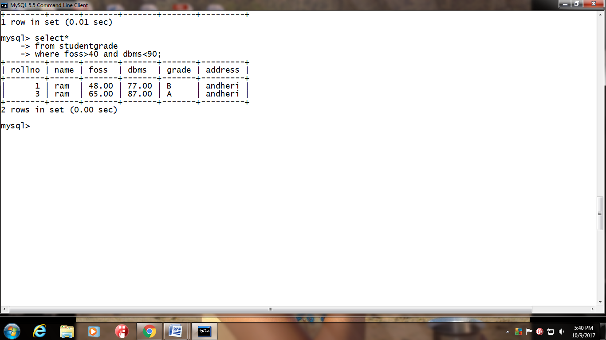

**13)Display the name of the student who’s rollno is either 1,2 or 3(use IN phrase)**

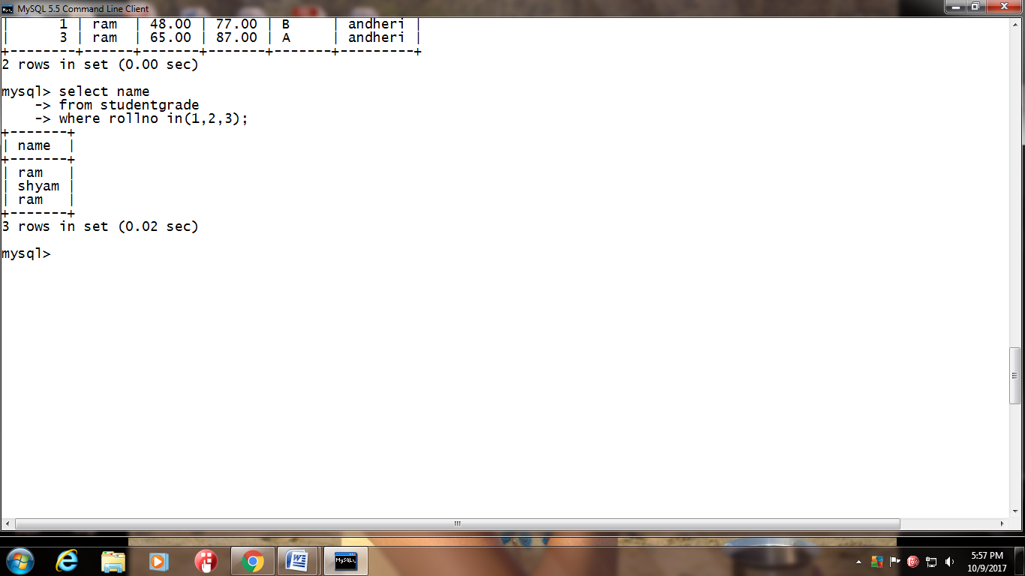

**14)Display the name of the student who’s marks in any of the 2 subject is 10,20,30,40,50,60,70,80,90100(use IN phrase)**

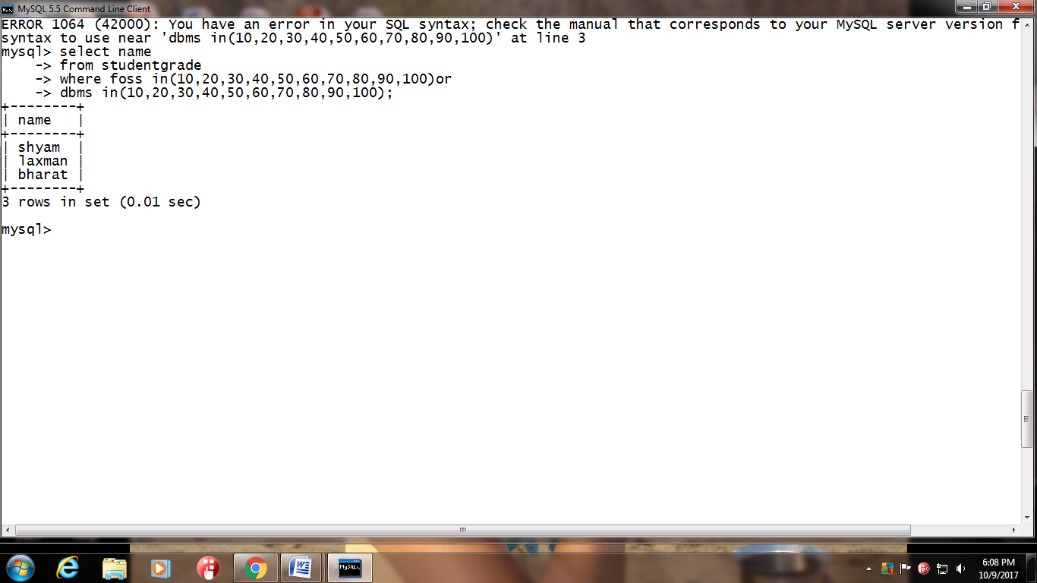

**15)Display the name of the student scoring marks between 40 to 100 in foss(use BETWEEN phrase)**

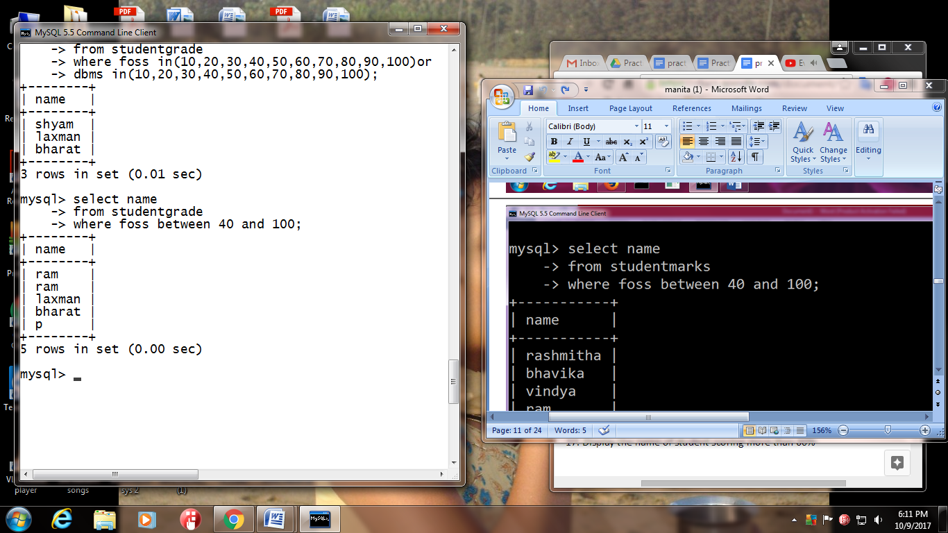

**16)Display the rollno and percentage(calculated column) for any student.**

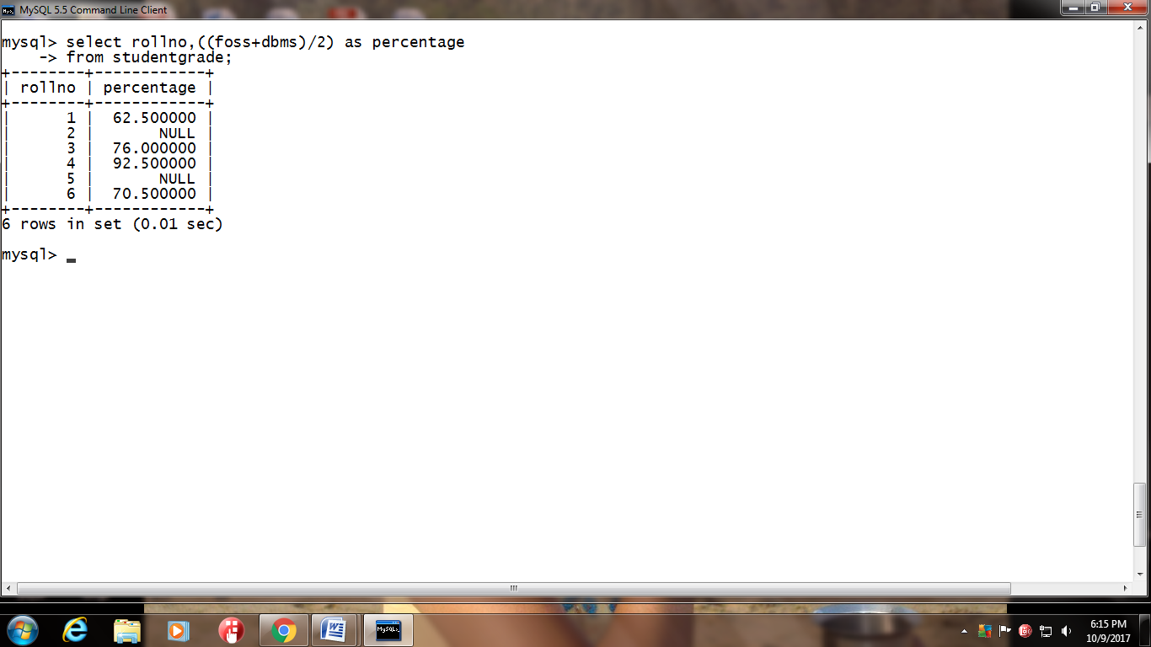

**17)Display the name of student scoring more than 60%**

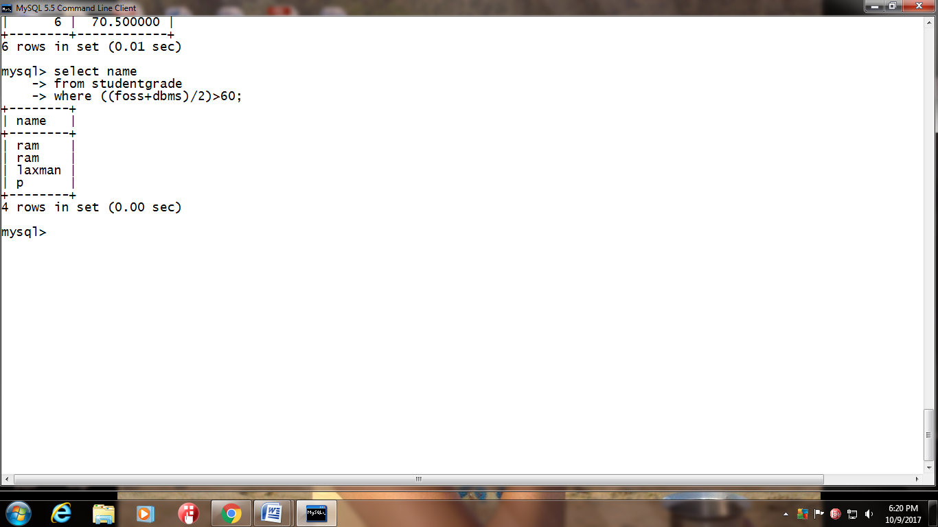

**Q1)** **Solve the following queries using LIKE operator on StudentGrade table:**

**1)** Display the rollno of the student who’s name starts with ‘s’

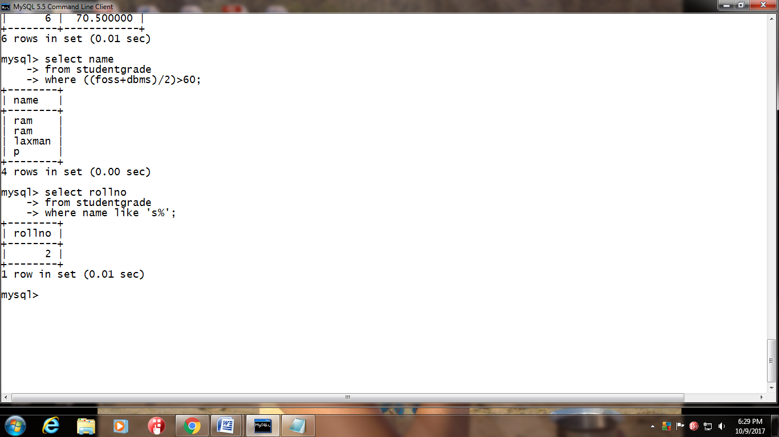

2) Display the name,rollno of the student who’s address starts with ‘a’ and ends with ‘i’

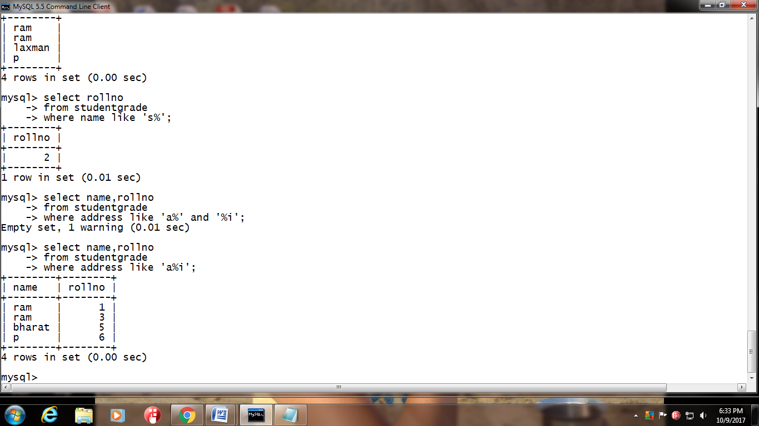

3) Find the grade of the student who’s name ends with ‘m’

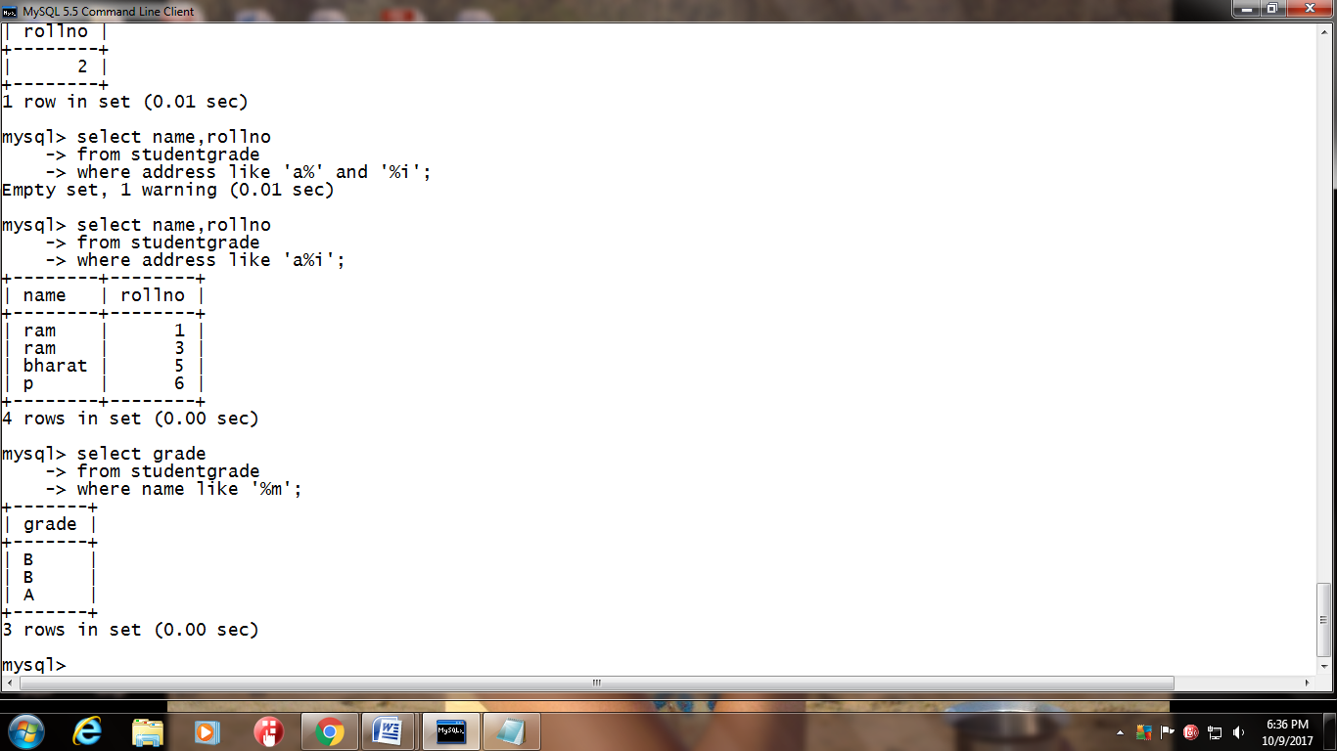

4) Display the rollno, grade  of the student who’s name comprises of 3 alphabet’s only.

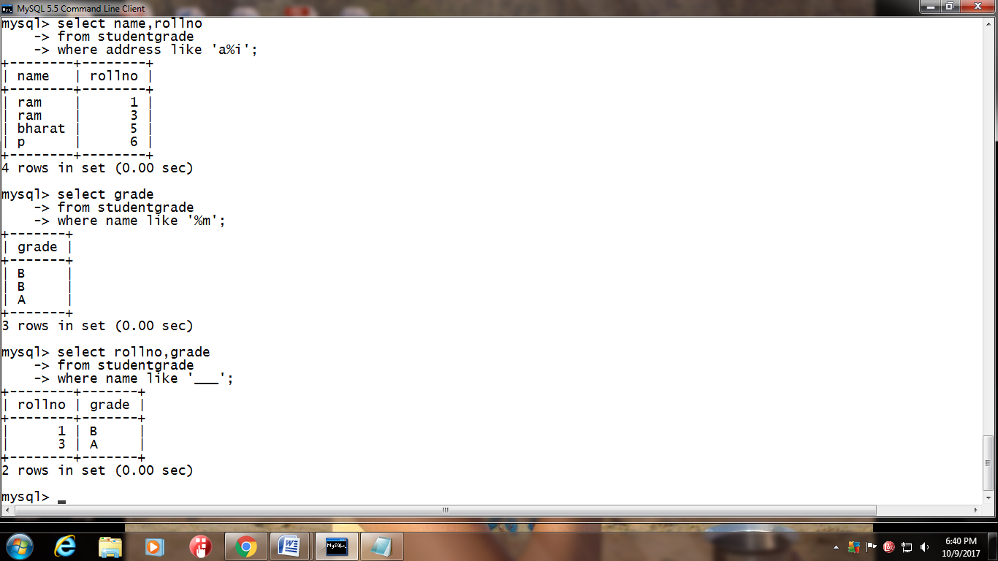

5) Display the rollno,name  of the student who’s address comprises of alphabet ‘ L‘ in it.

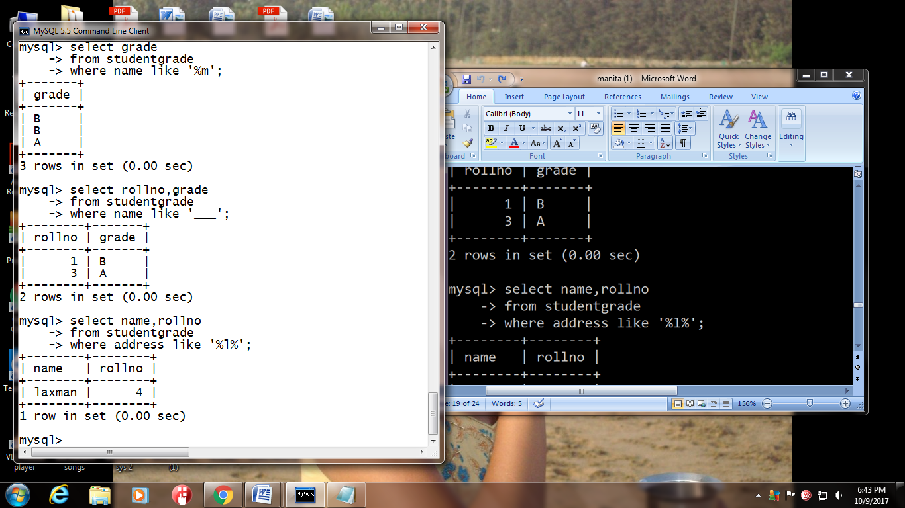

**Q2. Solve the following queries using REGEXP operator on StudentGrade table**:

1. 1) Display the rollno,name  of the student who’s address comprises of pattern ‘an’ in the beginning

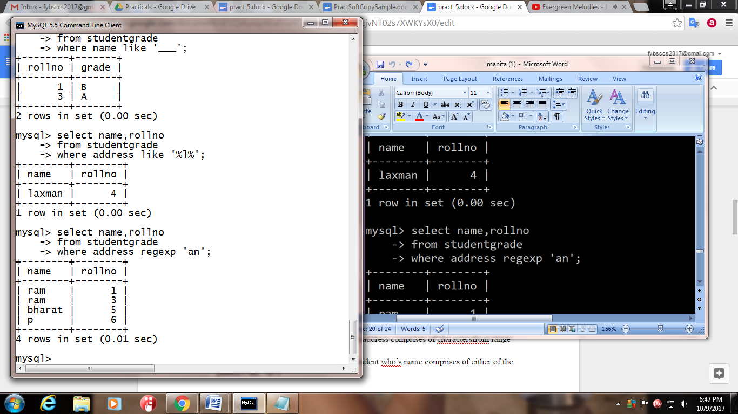

2) Display the rollno,grade,foss,dbms  of the student who’s address comprises of pattern ‘rar’ at the end

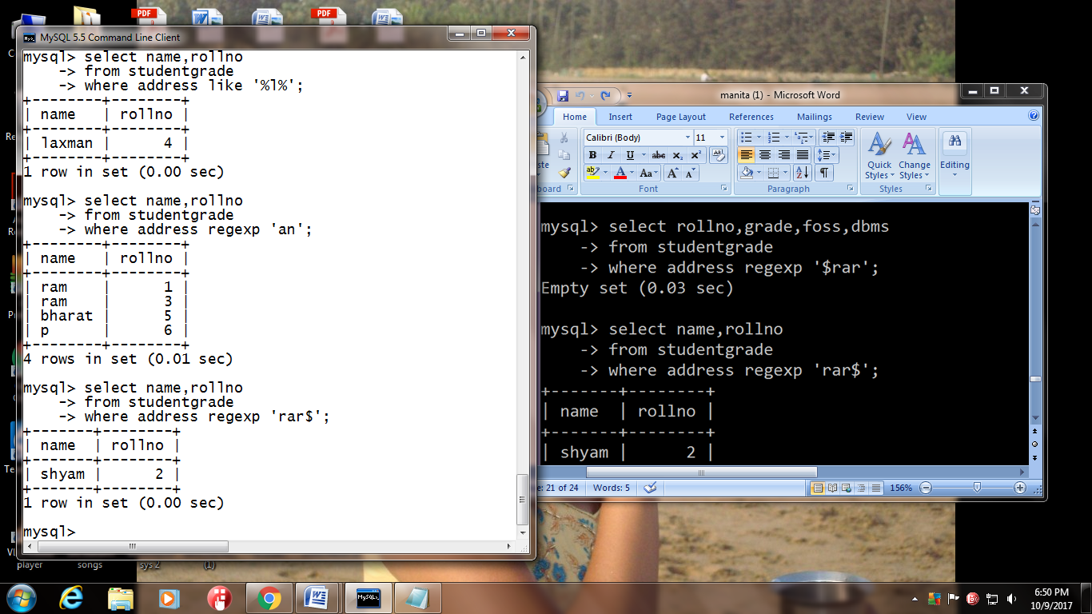

3) Find the rollno of the student who’s name comprises of single character

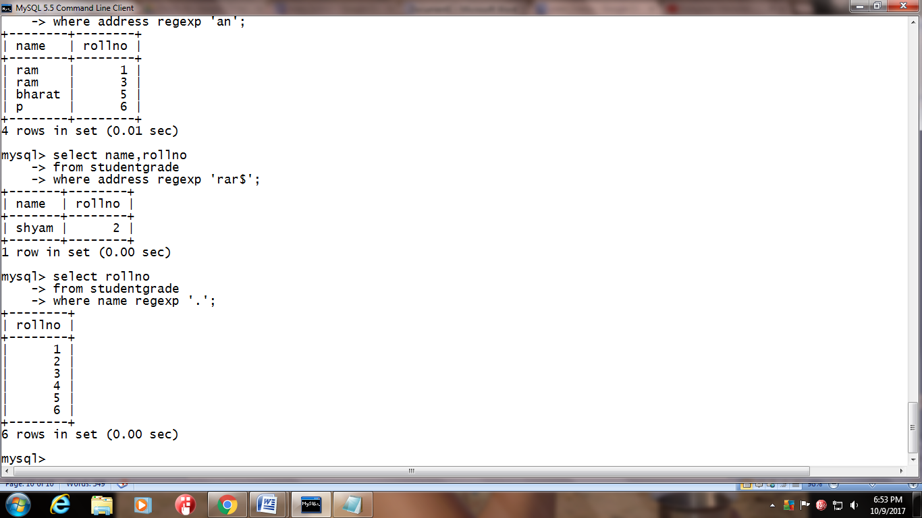

4) Find the grade,roll,dbms of the student who’s name comprises of any character from list(x,u,v)

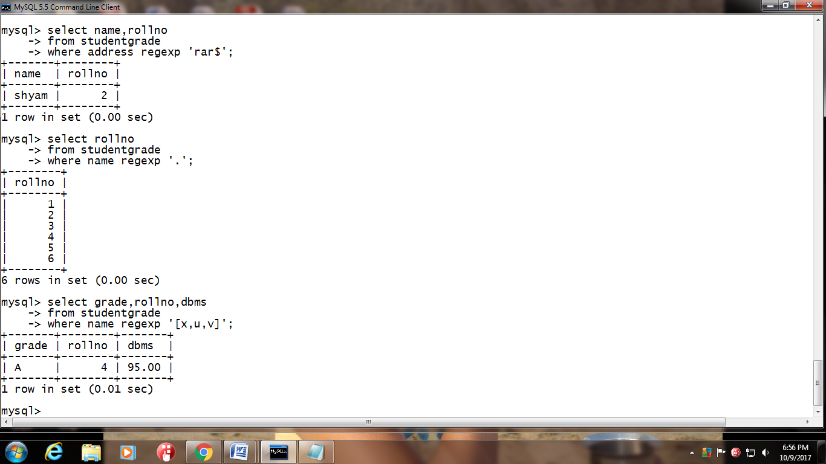

5) Find the rollno,name of the student who’s address comprises of charactersfrom range [A-P]

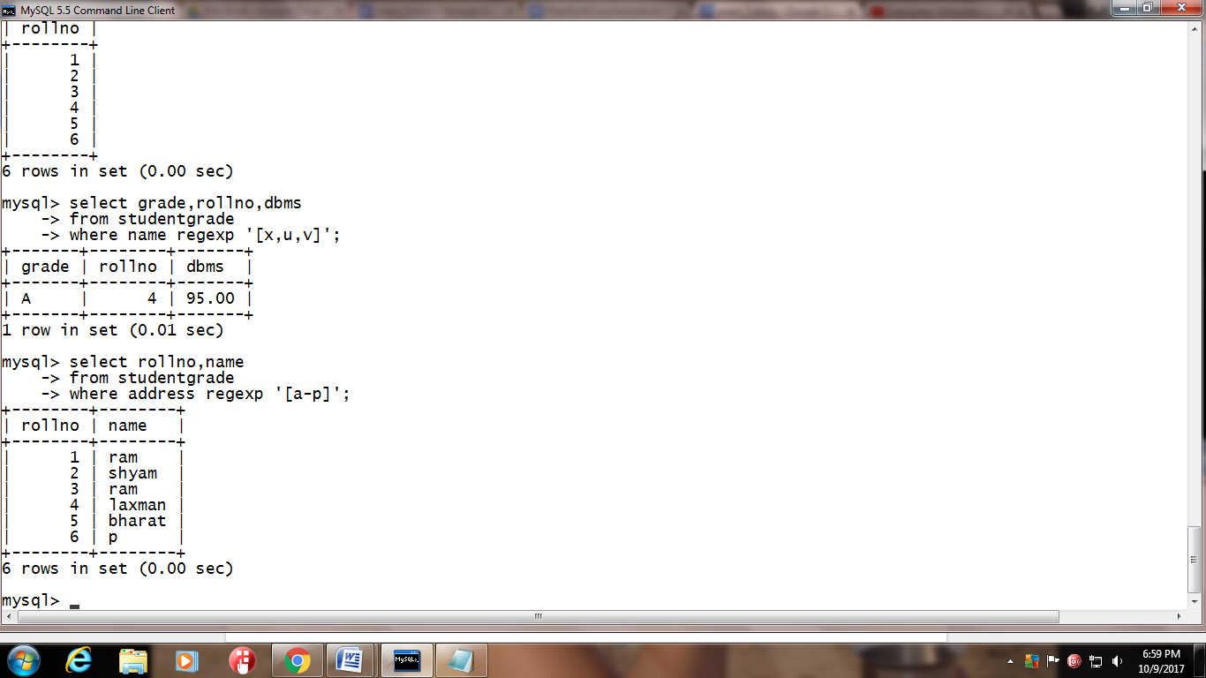

6) Display the rollno,name,address  of the student who’s name comprises of either of the pattern (‘am’,’at’).

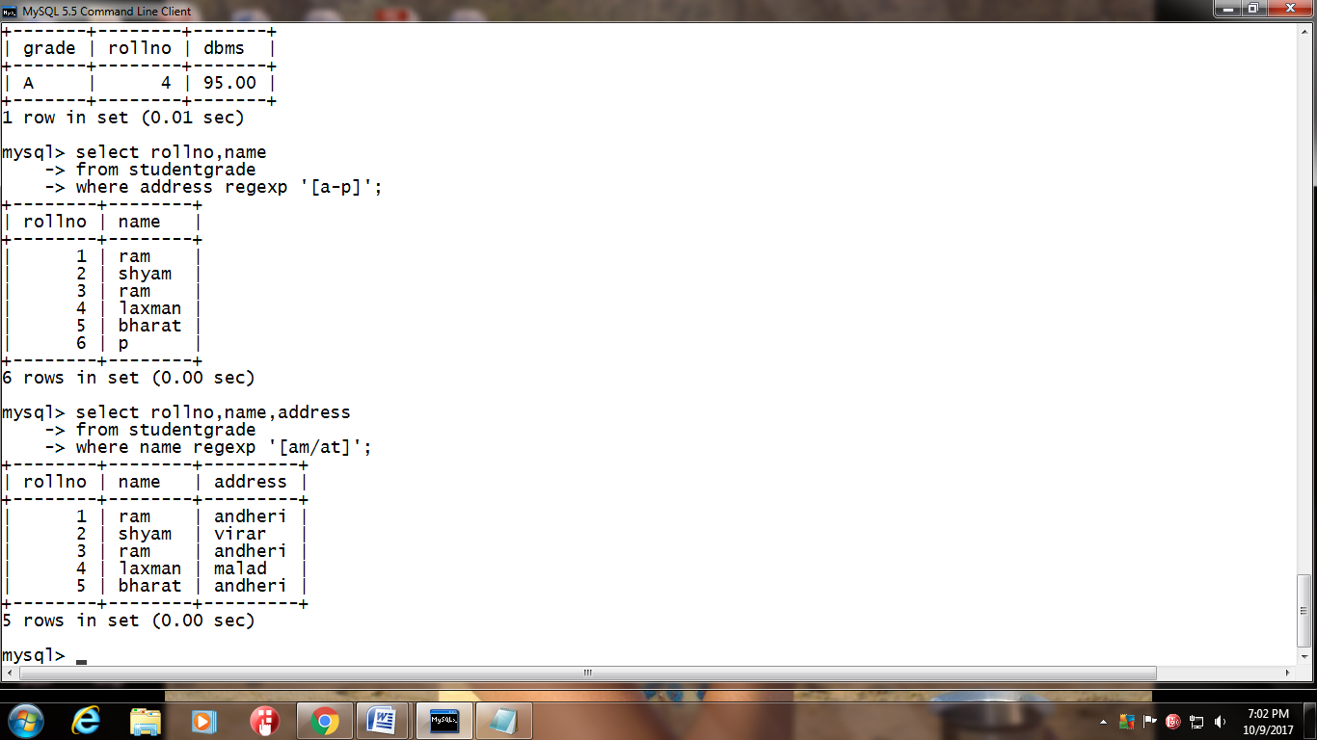

**5.2 Simple Queries with Aggregate functions**

Solve the following queries using Aggregate functions on StudentGrade table:

1)Return the total number of students in StudentGrade table

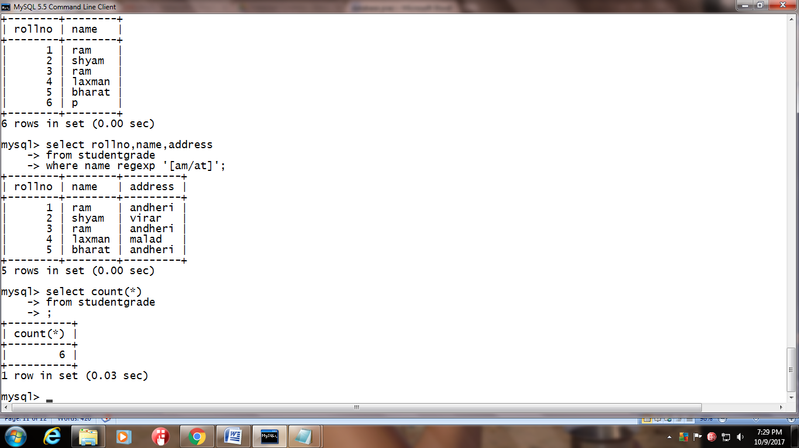

2) What is the highest marks scored in dbms subject

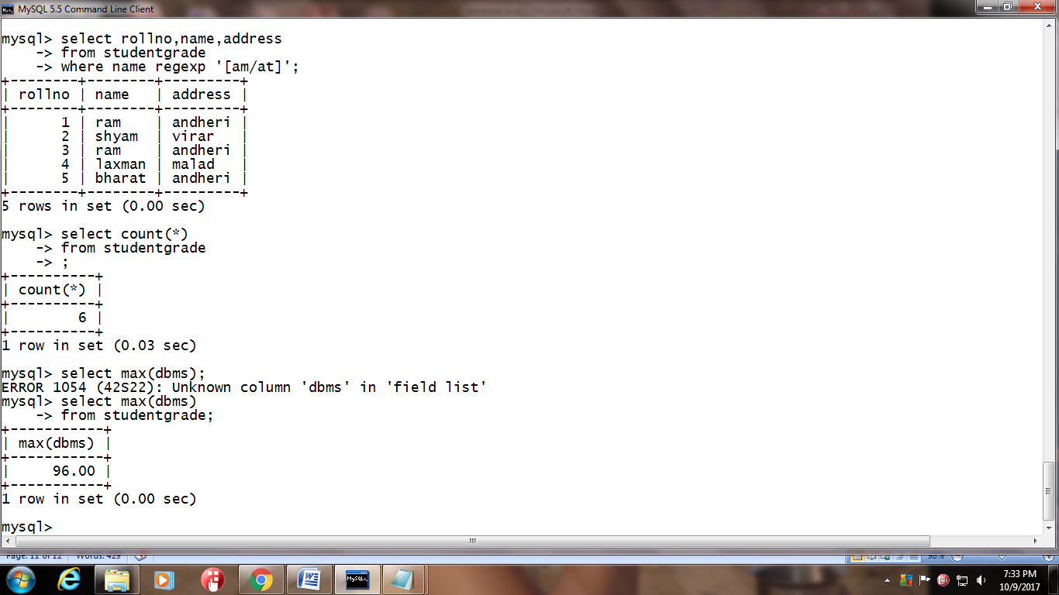

3)Find the number of students having unique names

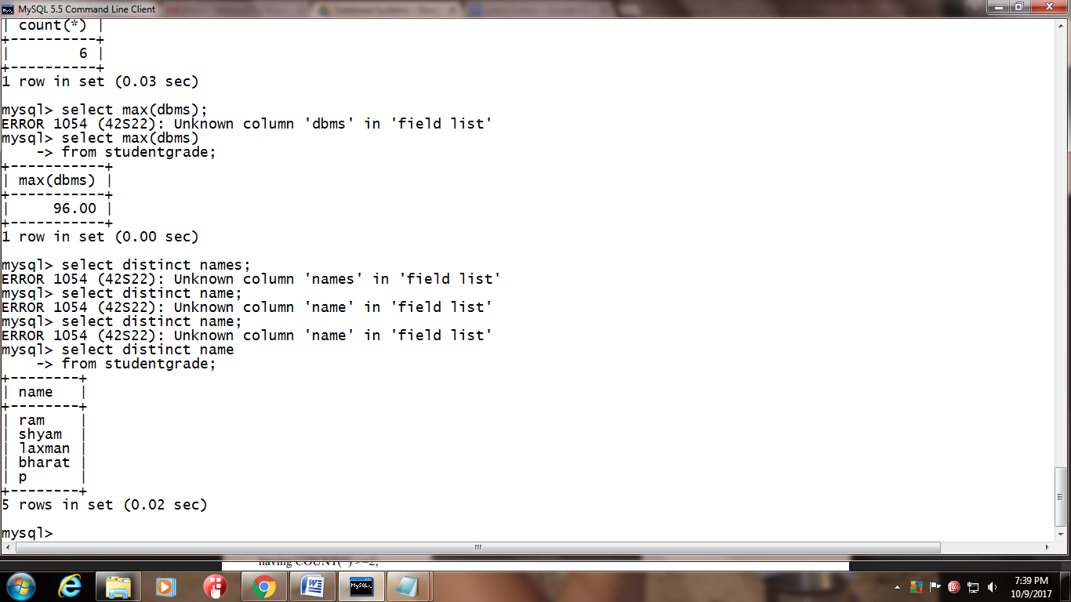

4) Display the count of students having foss marks as not null.

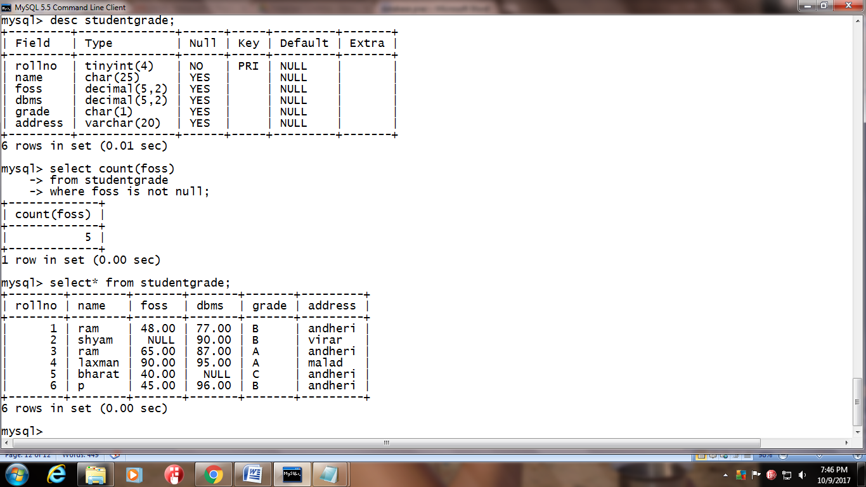

5) Find the name and grade of student scoring highest marks in foss.

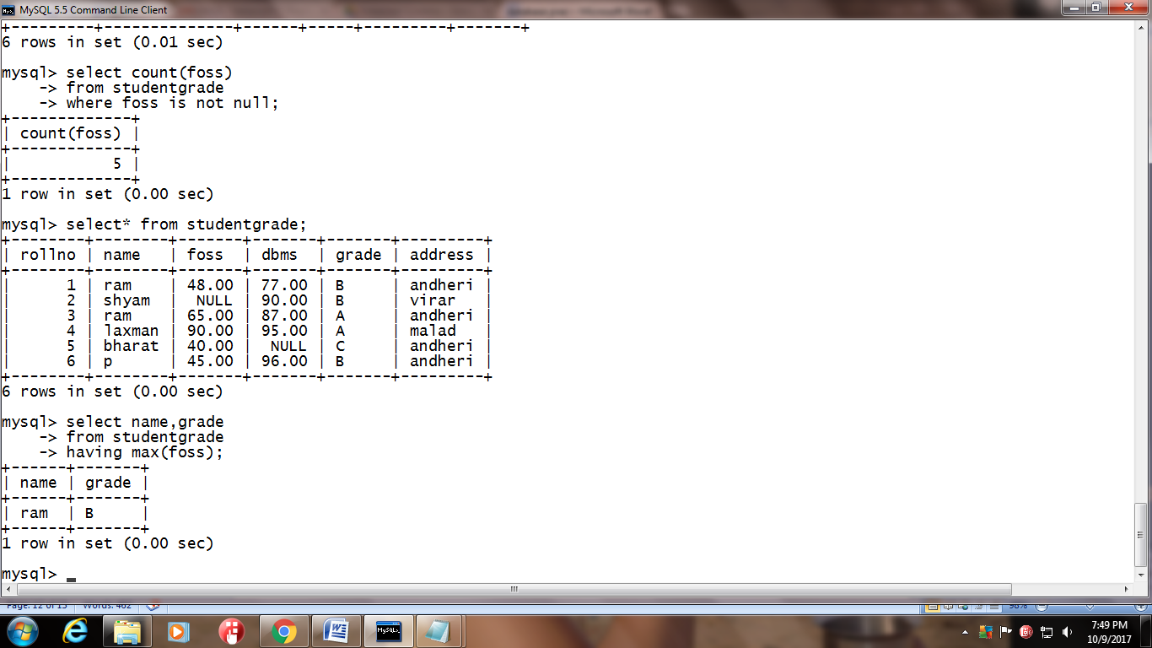

6) Display total marks scored by all students in dbms

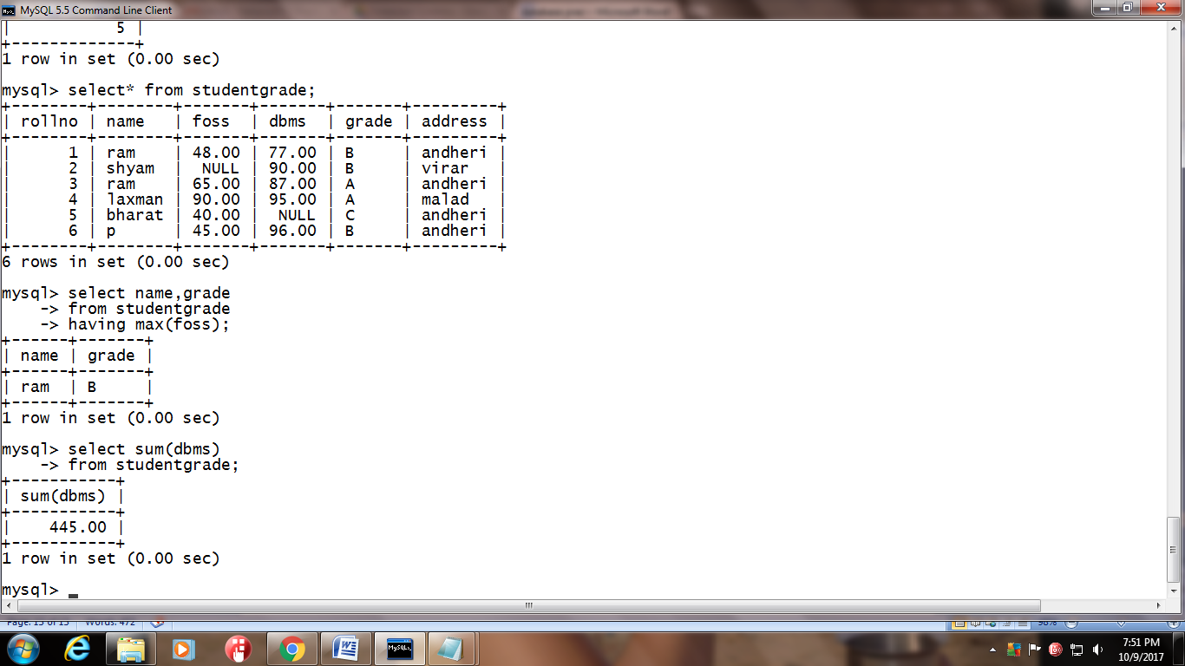

7) Display minimum marks scored in dbms

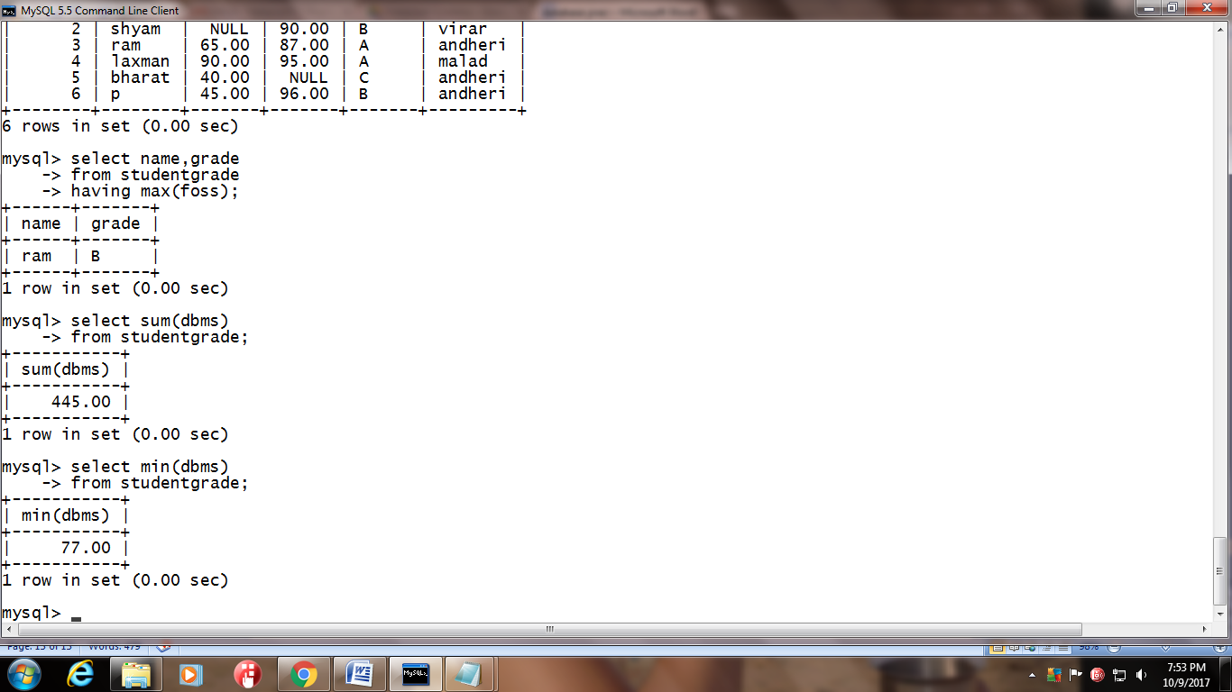

8) Display maximum marks scored in dbms



9) Count the number of students failing in foss subject

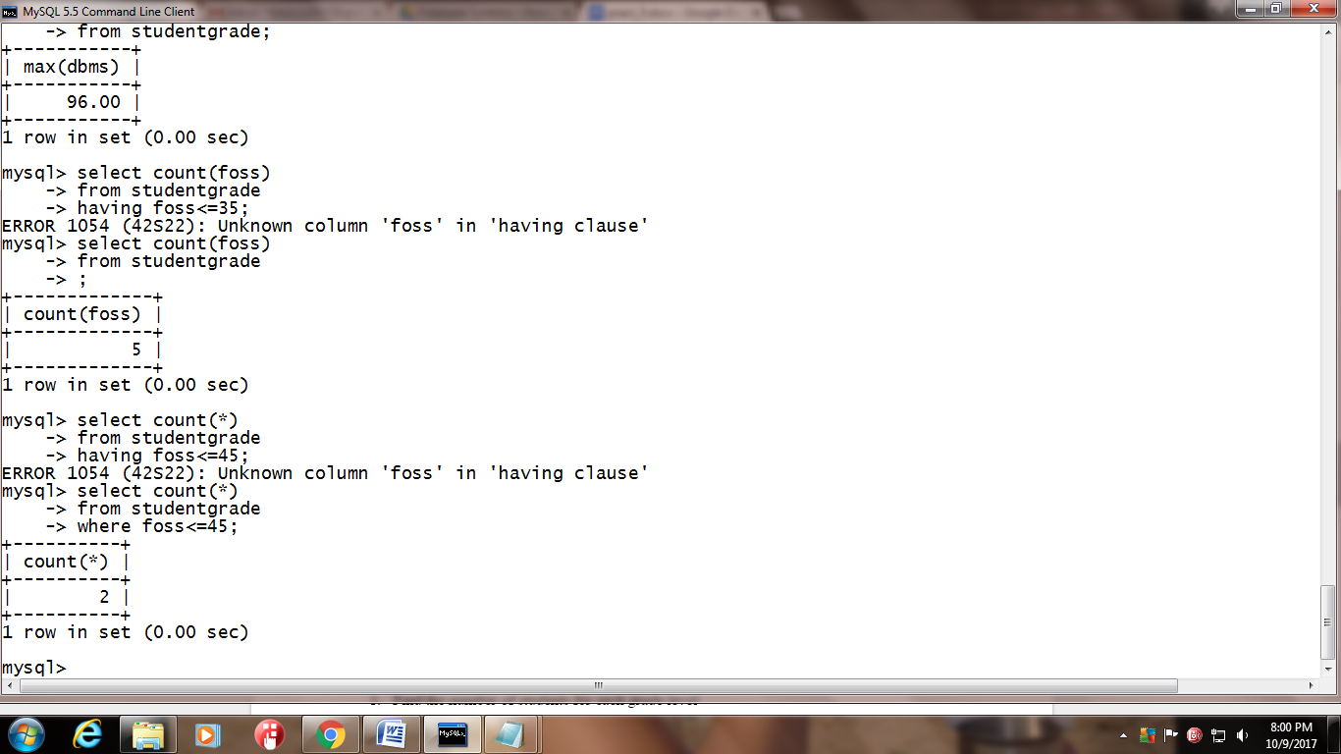

10) Count the number of students failing in either of foss or dbms subject

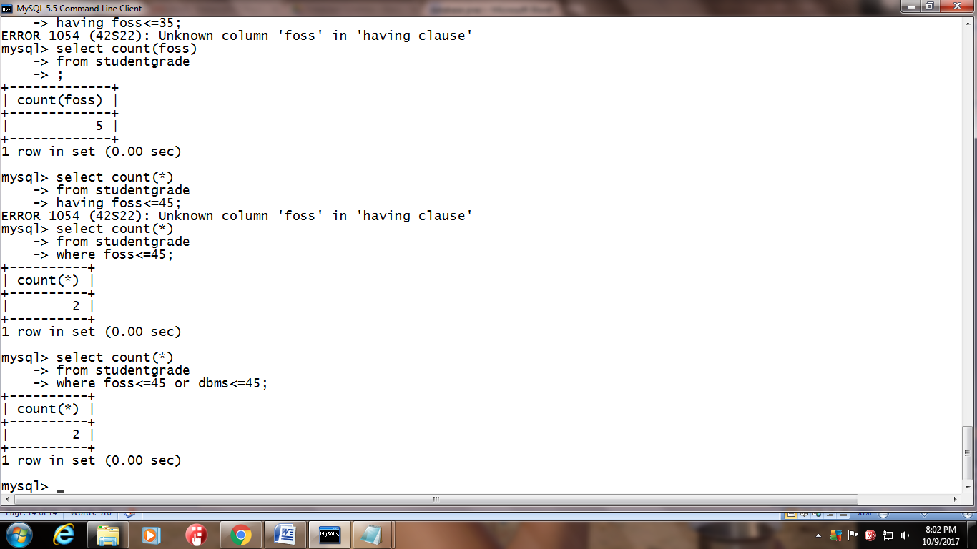

**5.3 Queries with Aggregate functions (group by and having clause)**

5.3.1 Solve the following queries using groupby and having clauses on StudentGrade table:

1) Find the number of students for each grade level

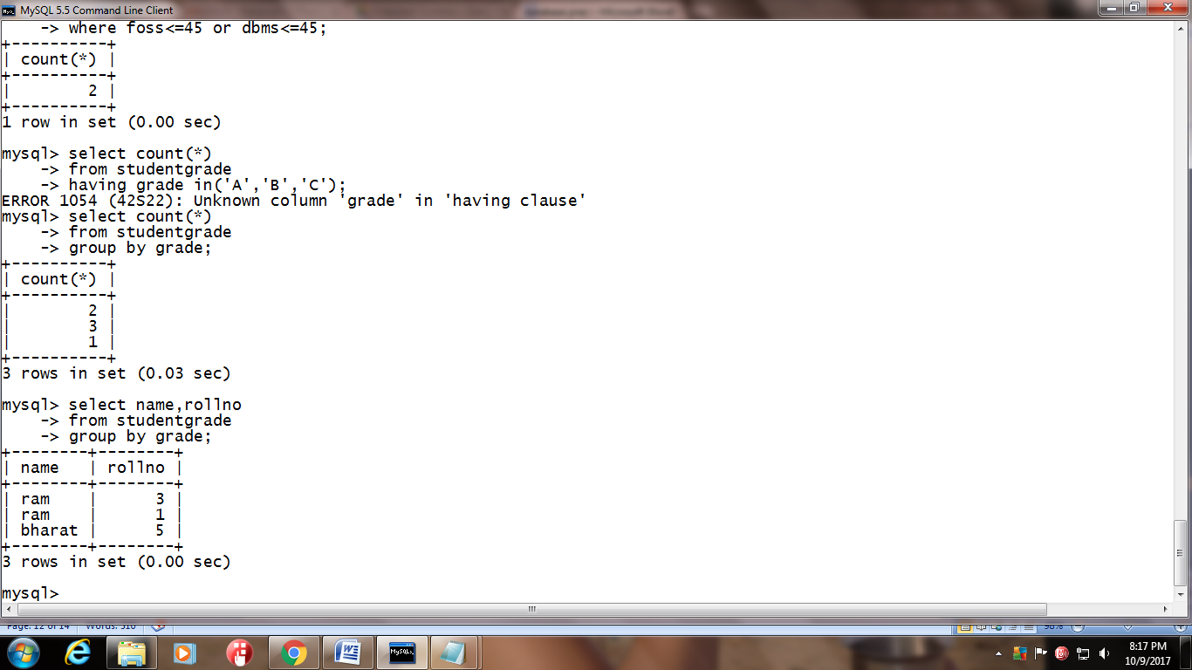

2) For each grade level find the average marks in dbms



3) Find the name,rollno of the student at each grade level having highest marks in foss.

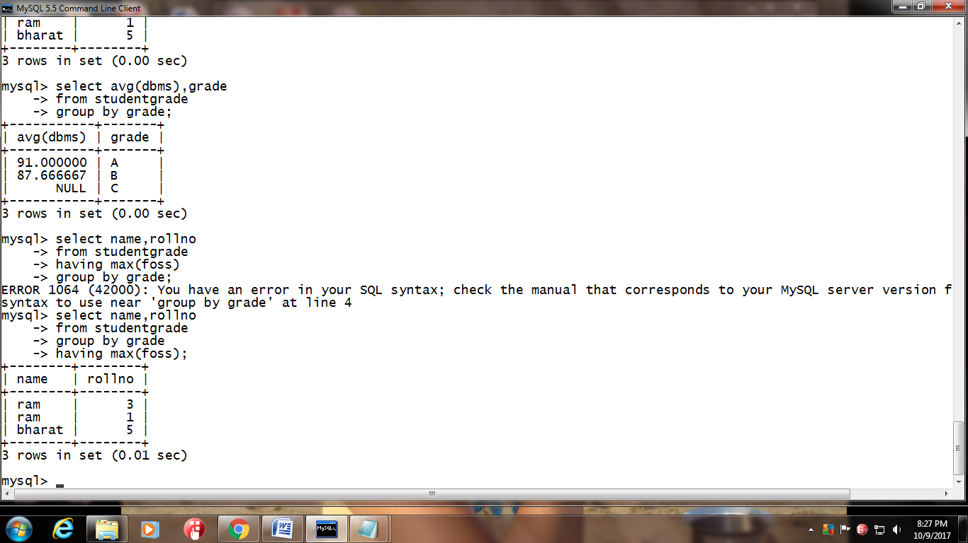

4) Display the highest percentage scored by the student in each grade level

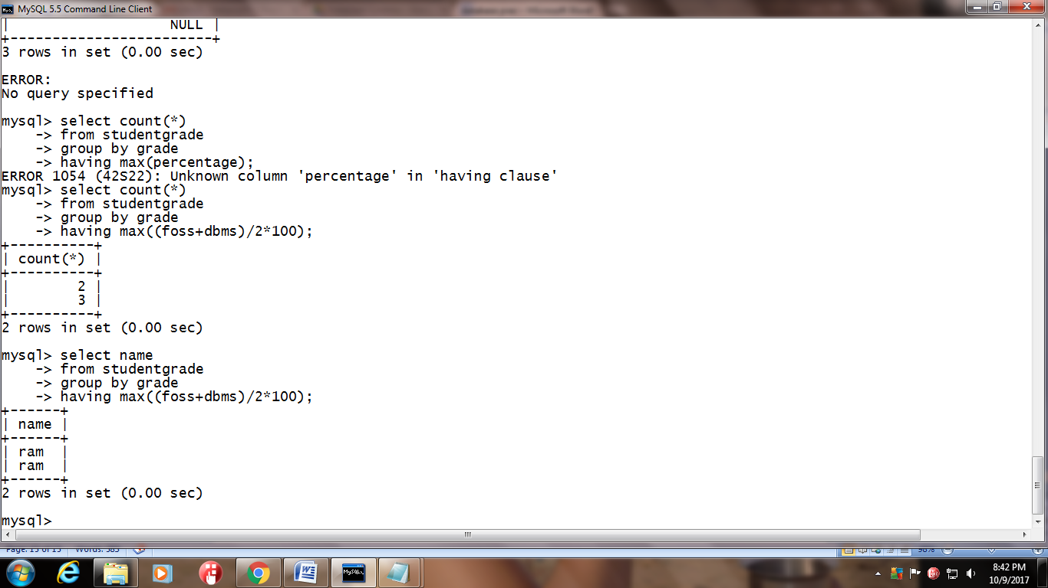

5) Display the name of the student scoring highest marks in foss.



6) Display the name of the student for each grade level scoring minimum of 85 marks in dbms.

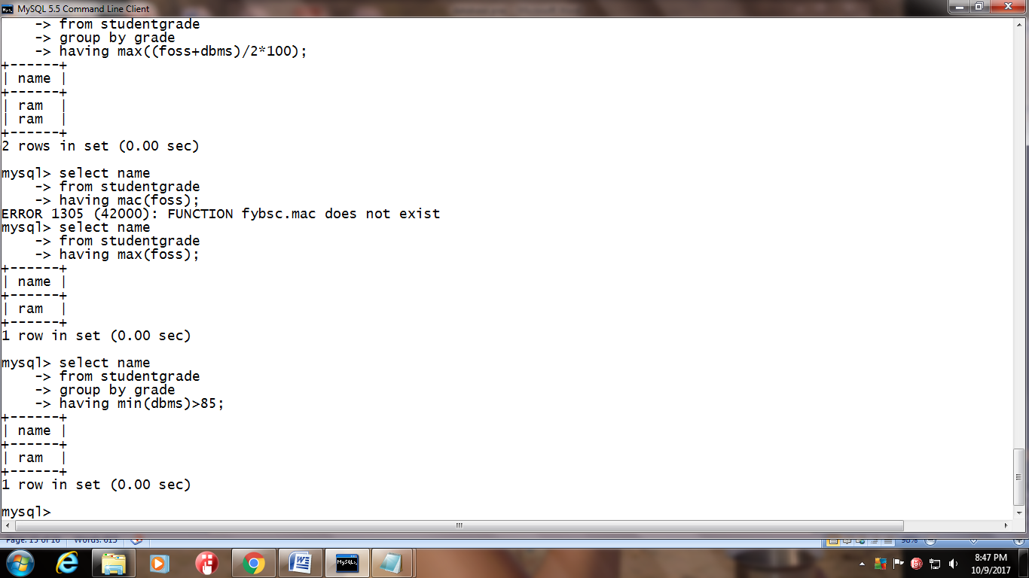

7) Display the grade where NO student is failing in either foss or dbms

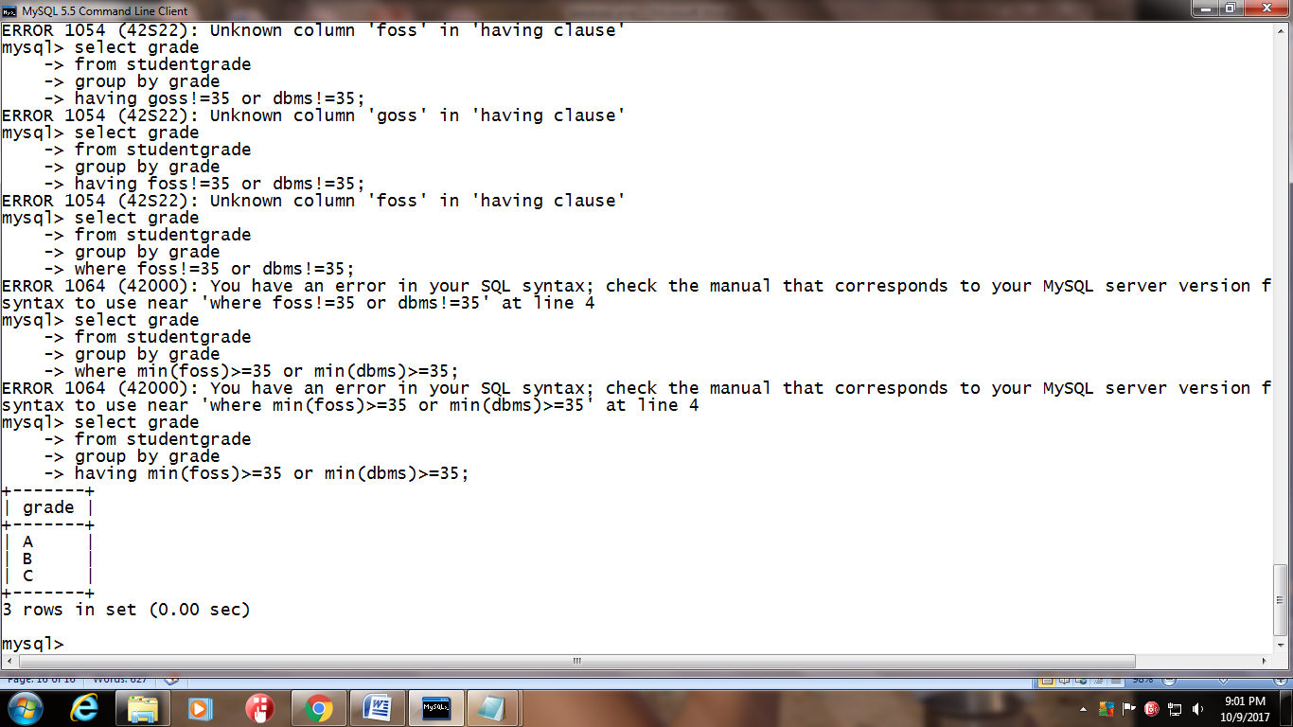

8) From roll 1 to 4 group the students by grade and then count the number of students absent for foss.

**5.3.2**Solve the following queries on Sailors, Boats and reserves table:

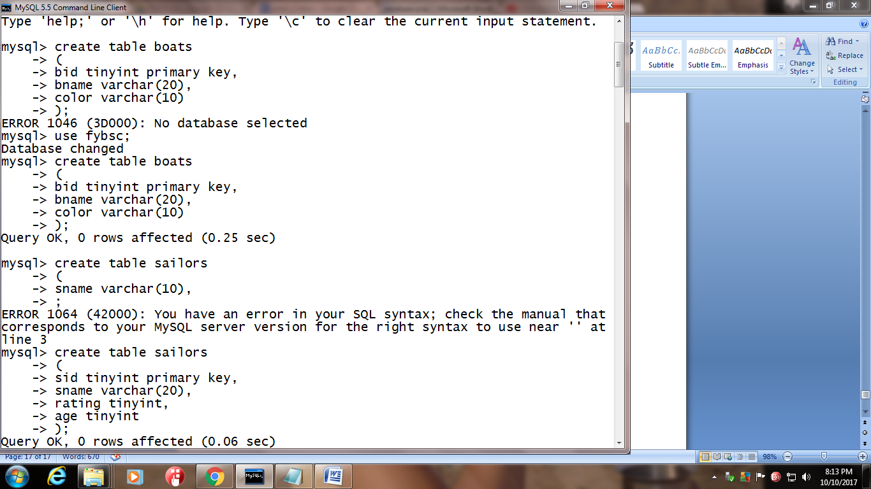

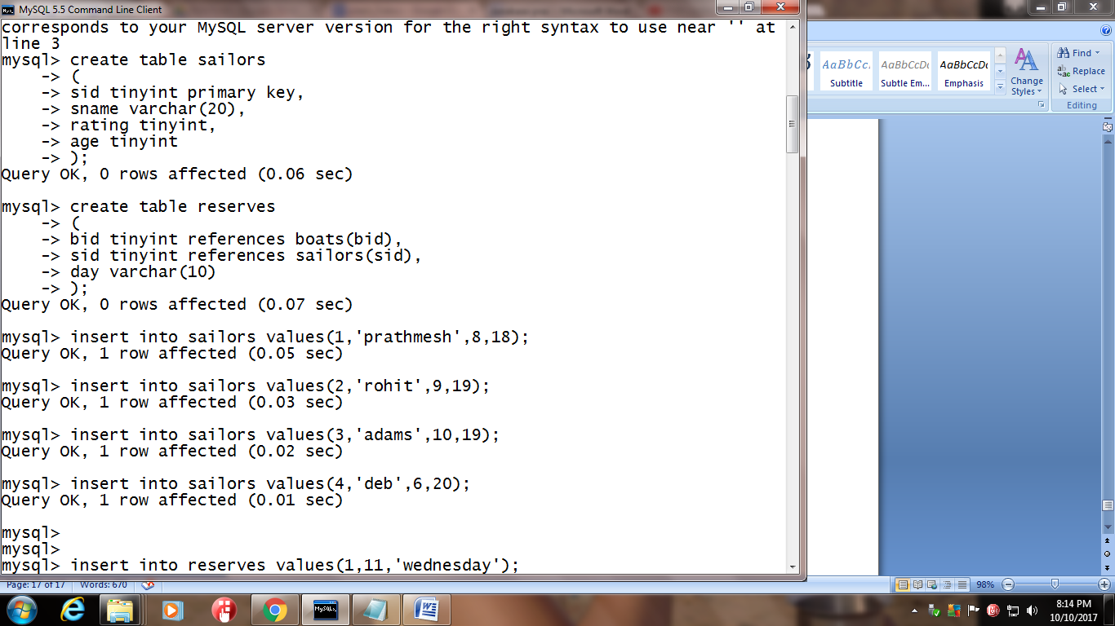

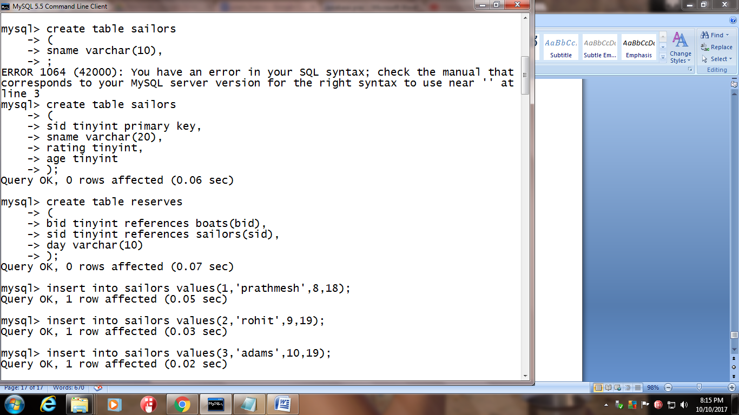

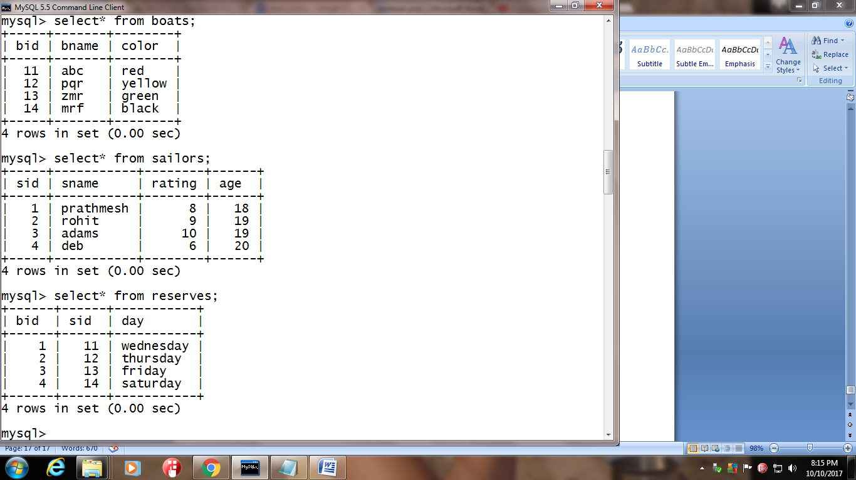

1. Find the age of the youngest sailor for each rating level.

4) Find the average age of all sailor.

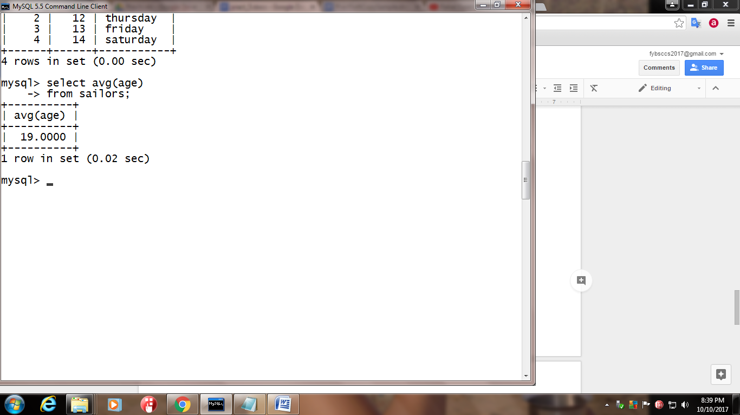

**5)**Find the average age of sailor with the rating of 3.

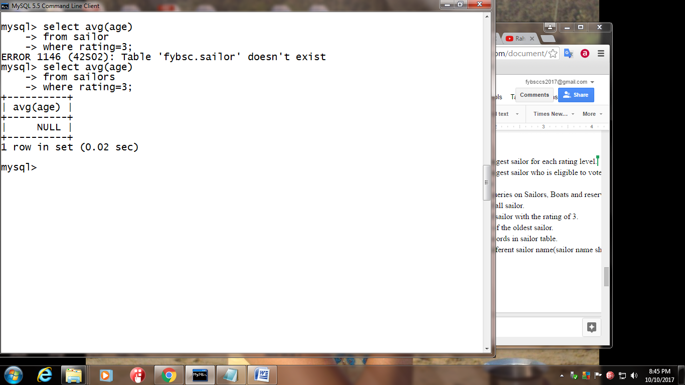

**6)** Find the name and age of the oldest sailor.

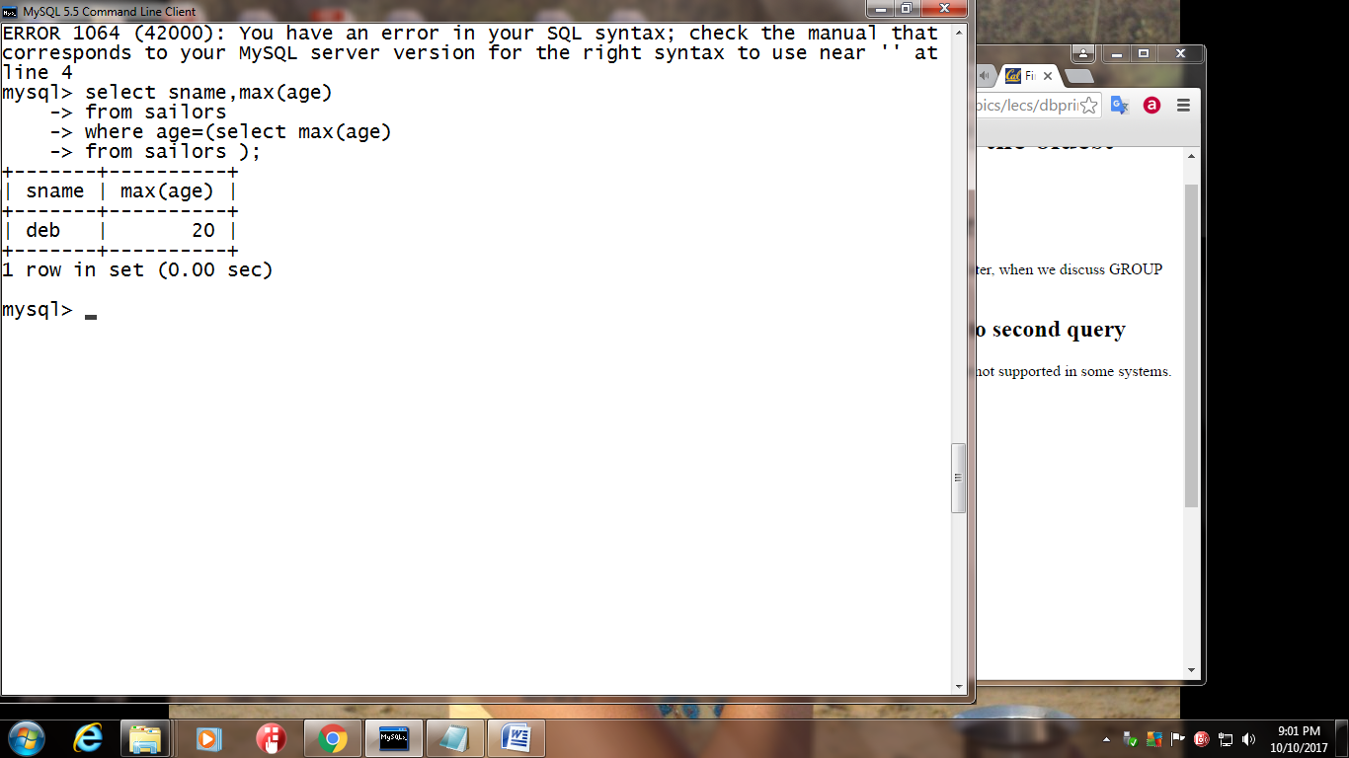

**7)** Count the number of records in sailor table.



**8)** Select the number of different sailor name(sailor name should not repeat)



**9)** Find the name of sailor who are older than the oldest sailor with the rating of 10

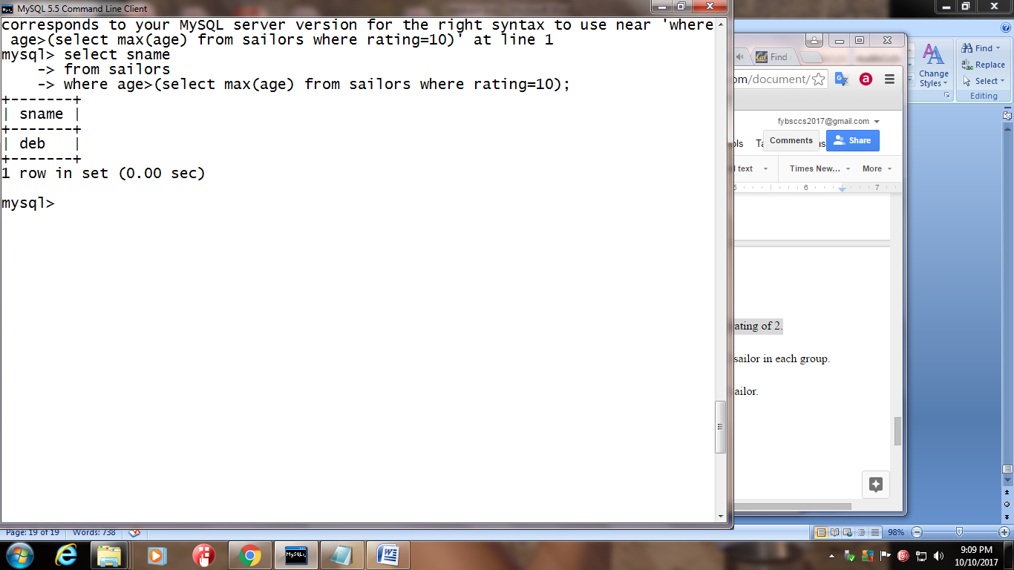

**10)** Find oldest sailor with rating 6

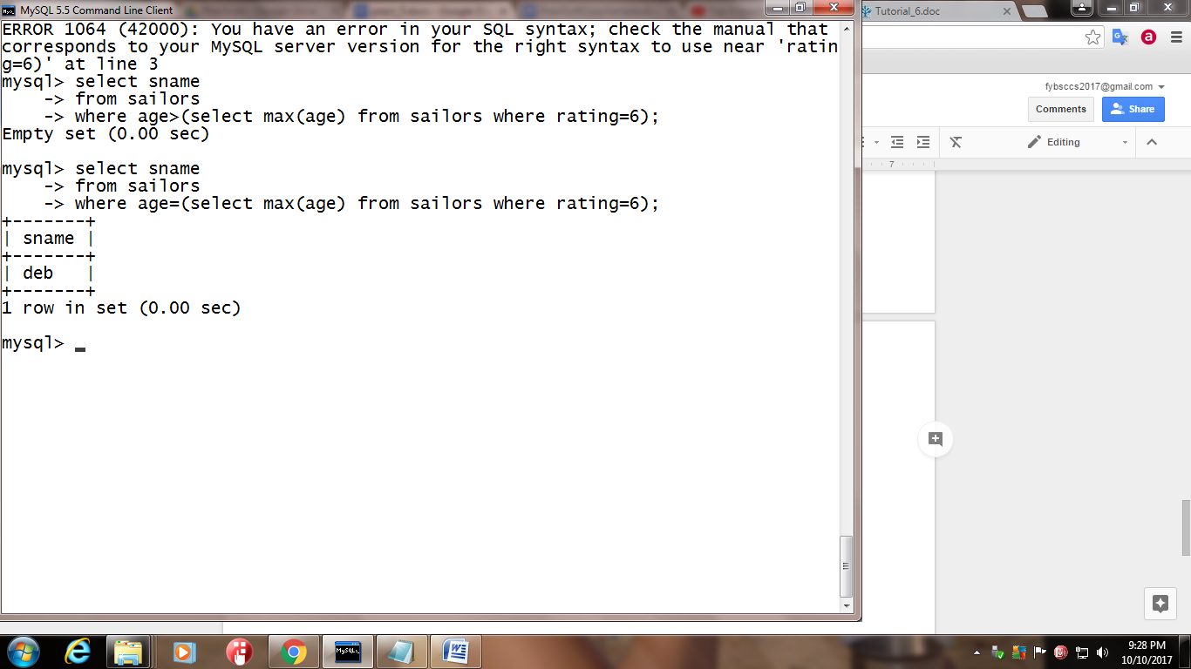

12) Find the average age of sailor for each rating level.

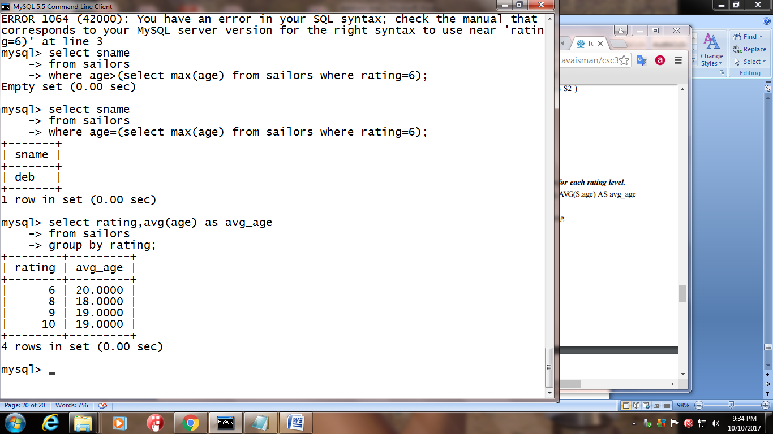

13) Find the average age of sailor for each rating level that has atleast 2 sailor.

Practical 6

1] Ltrim(‘ abc ’)

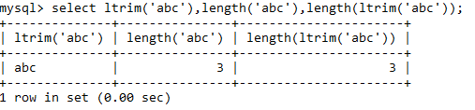

2] Rtrim(‘ abc ’)

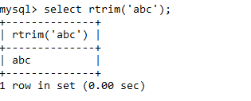

3] Trim(‘abc’)

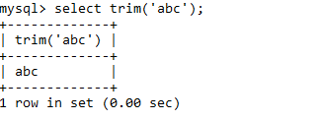

4] Trim(both ‘*’ from ‘*abc*’)

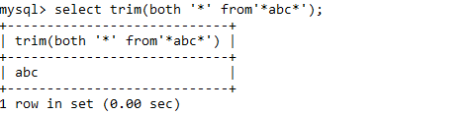

5]Trim(both ‘1’ from ‘11*abc*111’)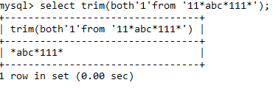

6] Trim(both ‘ab’ from ‘abcab’)

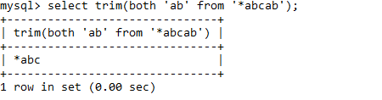

7] Trim(both ‘*’ from ‘pq*abc*pq’)

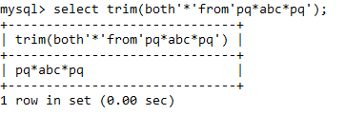

8] Trim(trailing ‘*’ from ‘*abc*’)

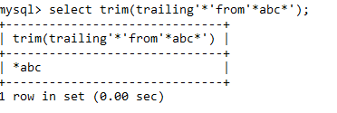

9] Trim(leading ‘*’ from ‘*abc*’)

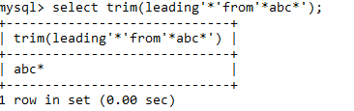

11] ConcatFirst_name and last name column and label the resultant column as FullName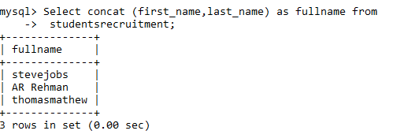

12]ConcatFirst_name and last name column with space saperator and label the resultant column as FullName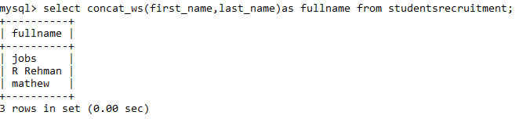

13] ConcatFirst_name and last name column with comma(,)seperator and label the resultant column as FullName

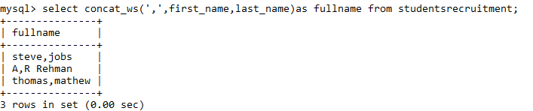

14] Find the length of first name

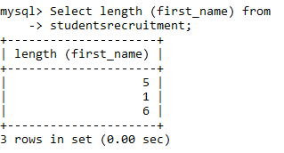

15] Display the name of student whose first name comprise of a single character.

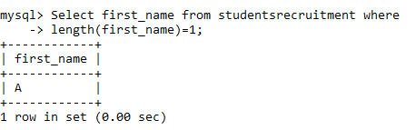

16] Perform Locate ‘e’ in first name whose last name is Jobs

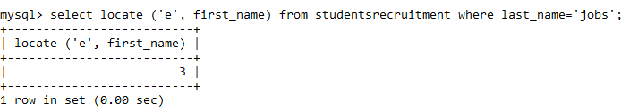

17] Display the domain name (Eg.google.com, rediffmail.com) for email account.

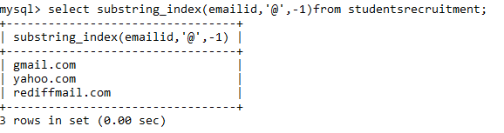

18] Display the Full name(first & last name) in Upper case into a single column output

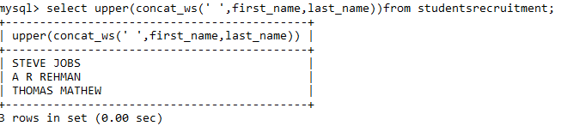

19] Display the Full name(first & last name) in Lower case into a single column output

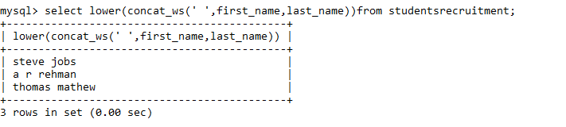

Working with Numeric/Math Functions:

1. Round and truncate the percentage up to 2 decimal place.

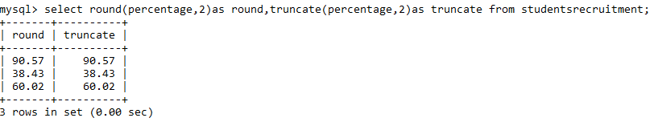

1. Perform ceiling and floor function on percentage column.

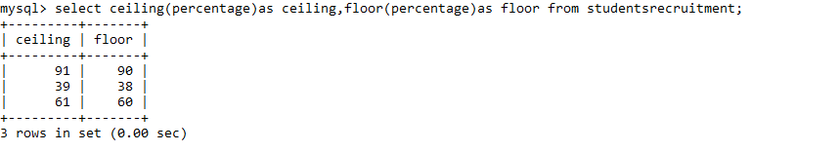

1. Round the percentage to a smallest integer value

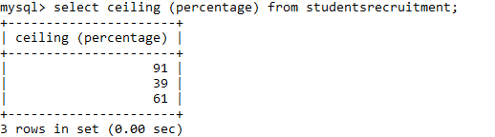

1. Round the percentage to a largest integer value

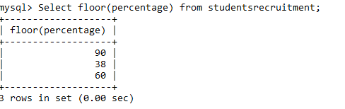

1. Abs(-9),abs(9),sqrt(81),sqrt(-81),power(2,3), power(2,-3), power(-2,-3)

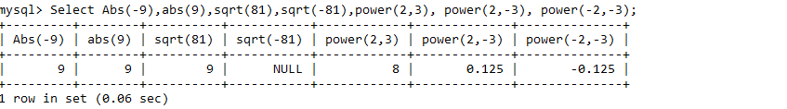

1. Display the name of student whose percentage is greater than 60.1 and less than 90.1



Working with date and time functions

1] Display the current system’s date time

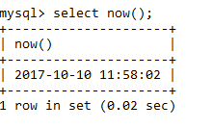

2] Display the current date

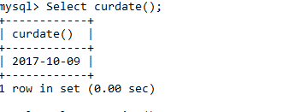

3]Display the current time

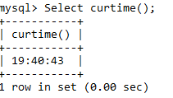

4] Display the day from DOB

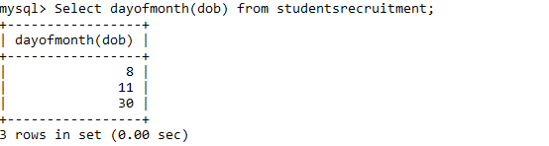

5] Display the name of student born after the year 1984

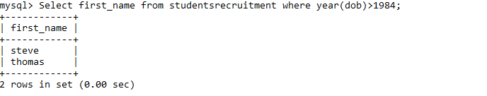

6] Display the interview details for student whose first name consist of letter ‘a’

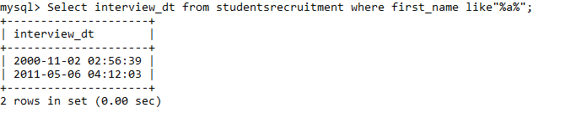

7] Display the next date for DOB

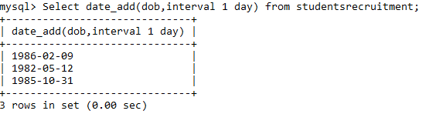

8] Display the age of each student

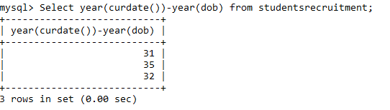

9]Display the details of student born in the month of October

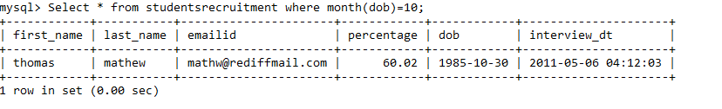

10] Display the first name and interview details of student whose interview was conducted between 2pm to 5pm.

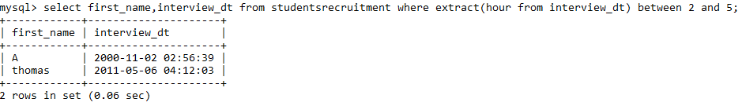

**PRACTICAL NO 7**

**AIM:join tables and processing queries**

**Create table query: -**

Create table supplier

(

Sid tinyint primary key,

Snamechar(15),

Address varchar(30)

);

Table created

Create table parts

(

Pidtinyint primary key,

Pnamechar(15),

Color char(15)

);

Table created

create table catalog

(

Sid tinyint references supplier(sid),

Pidtinyint references parts(pid),

Cost int

);

Table created

**Insert table query:-**

**For supplier table:**

Insert into supplier values(1,’abc’,’andheri’);

1 row created

Insert into supplier values(2,’pqr’,’malad’);

1 row created

Insert into supplier values(3,’xyz’,’virar’);

1 row created

Insert into supplier values(4,’efg’,’kandivali’);

1 row created

**For parts table:**

Insert into parts values(11,’monitor’,’red’);

1 row created

Insert into parts values(12,’keyboard’,’black’);

1 row created

Insert into parts values(13,’mouse’,’red’);

1 row created

Insert into parts values(14,’cpu’,’white’);

1 row created

**For catalog table:**

Insert into catalog values(1,11,1000);

1 row created

Insert into catalog values(1,13,2000);

1 row created

Insert into catalog values(2,12,350);

1 row created

Insert into catalog values(3,13,2200);

1 row created

Select * from supplier;

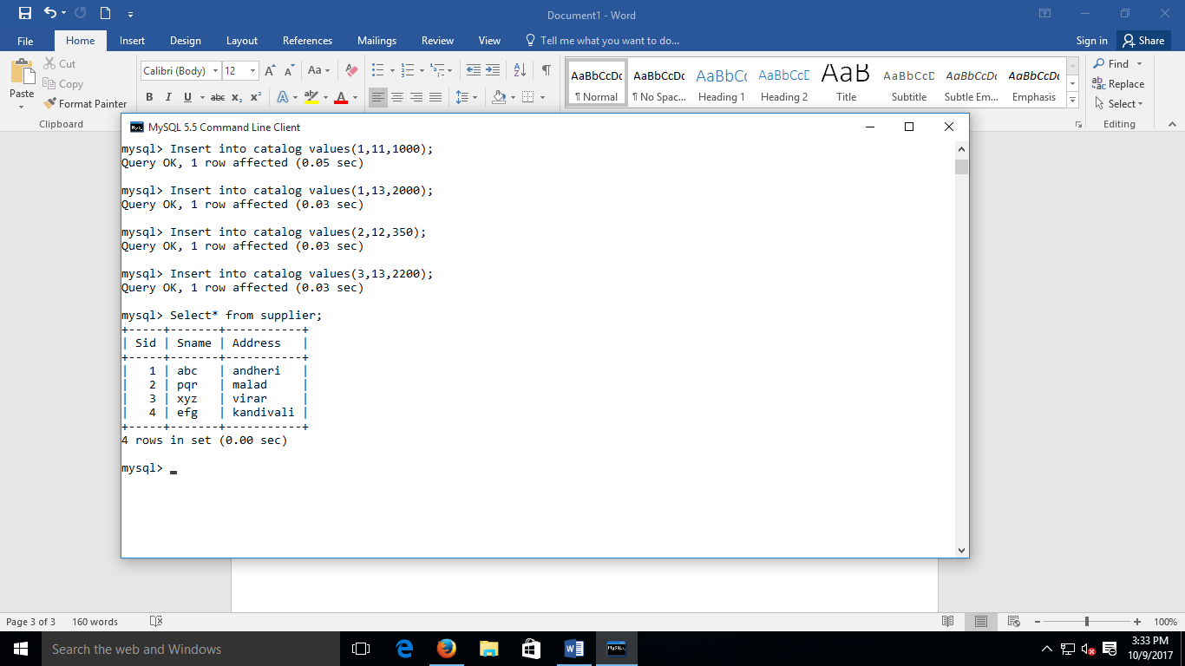

Select * from parts;

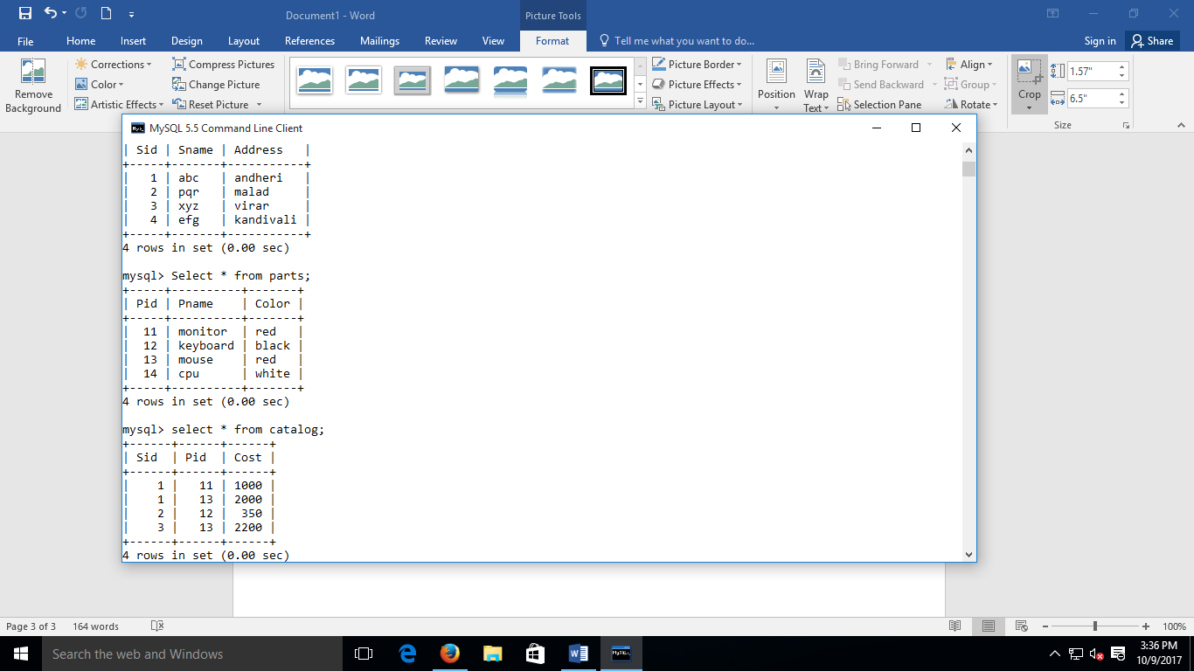

Select * from catalog;

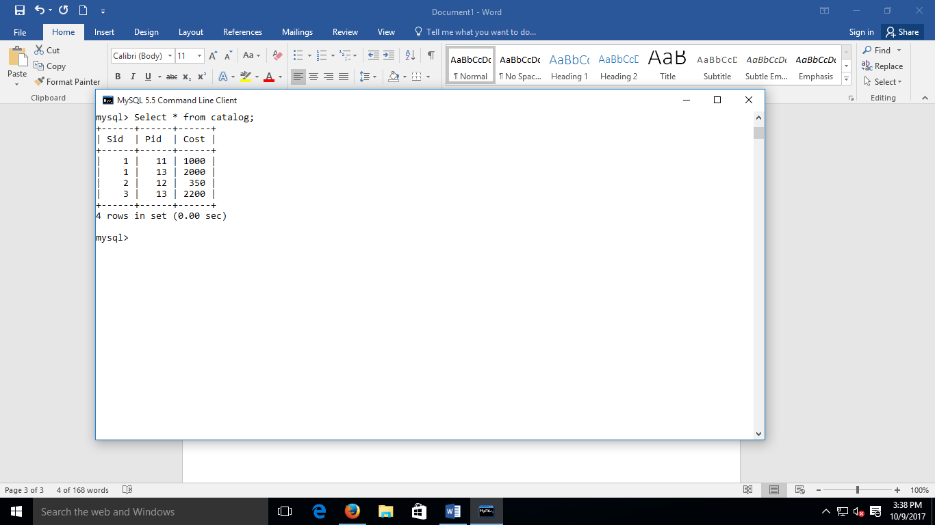

**Queries**

**Q1. Demonstrate Joins concept:**

1. Join Supplier table with Catalog table. (using INNER join)

Select * from supplier

INNER JOIN catalog

ON supplier.sid=catalog.sid;

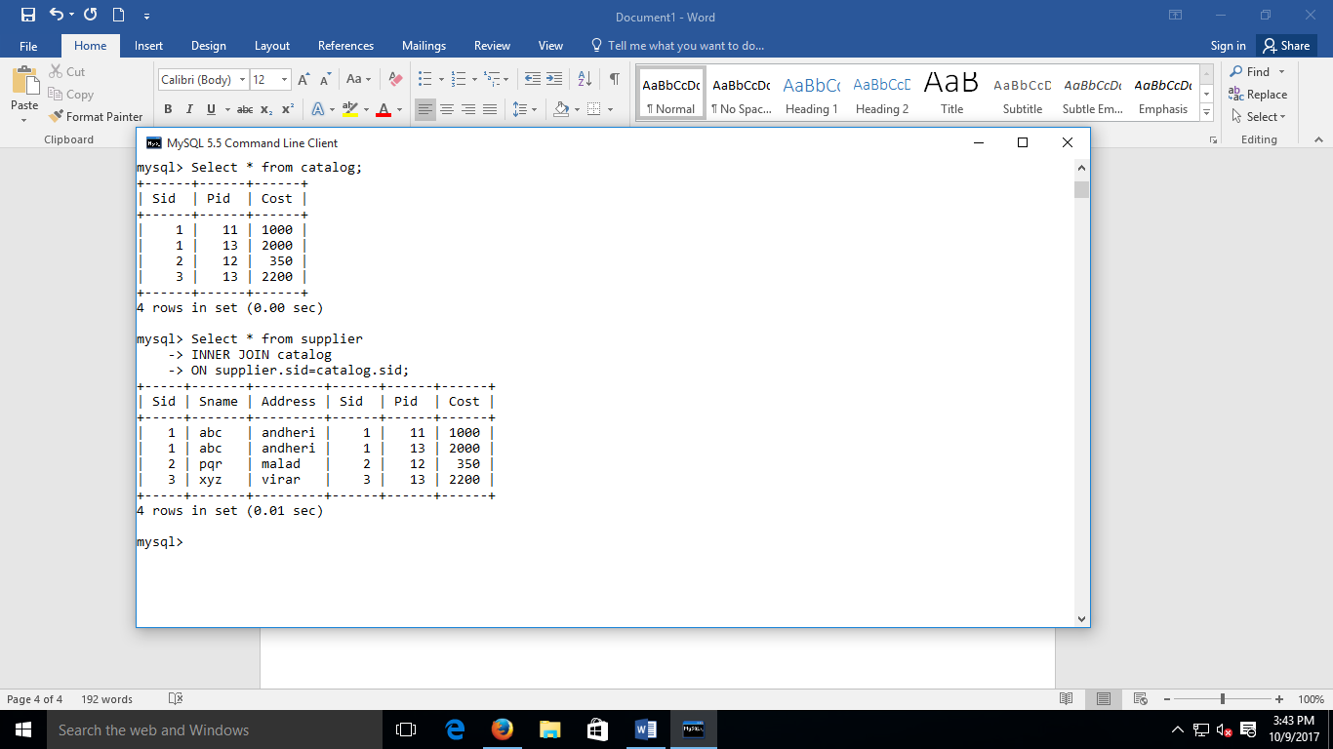

1. Join Parts table with Catalog table. (using INNER join)

Select * from parts

INNER JOIN catalog

ON parts.pid=catalog.pid;

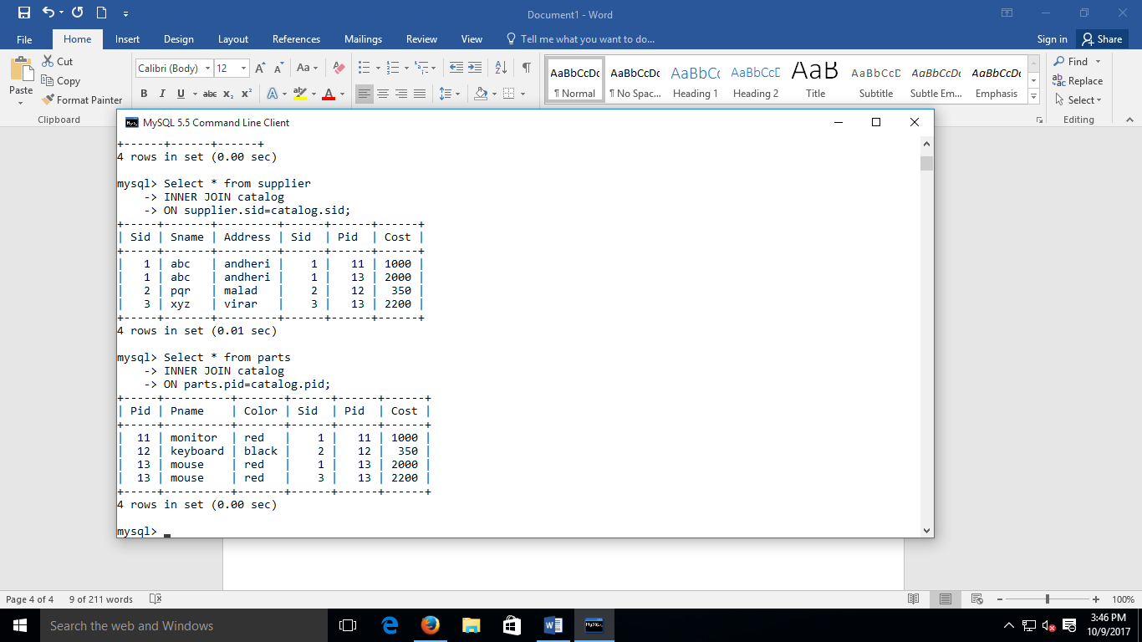

**Practical No 8**

Create table Query:

create table supplier

(

s_id tinyint primary key,

s_name varchar(10) not null,

address varchar(30) not null

);

Table Created

create table parts

(

p_id tinyint primary key,

p_name varchar(20) not null,

colour varchar(10)

);

Table Created

create table catalog

(

s_id tinyint references supplier(s_id),

p_id tinyint references parts(p_id),

cost int

);

Table Created

INSERT VALUE QUERY:

insert into supplier values(1,'abc','221 park avenue');

1 Row Created

insert into supplier values (2,'pqr','Marin lines');

1 Row Created

insert into supplier values(3,'zmr','Link road');

1 Row Created

insert into supplier values(4,'xyz','bp road');

1 Row Created

insert into parts values(11,'Screw','Red');

1 Row Created

insert into parts values(12,'Gpu','Green');

1 Row Created

insert into parts values(13,'ScrewDriver','Blue');

1 Row Created

insert into parts values(14,'Cpu','Yellow');

1 Row Created

insert into catalog values(1,11,100);

1 Row Created

insert into catalog values(1,12,10000);

1 Row Created

insert into catalog values(1,13,200);

1 Row Created

insert into catalog values(1,14,1200);

1 Row Created

insert into catalog values(2,11,105);

1 Row Created

insert into catalog values(2,12,9000);

1 Row Created

insert into catalog values(2,13,190);

1 Row Created

insert into catalog values(3,11,95);

1 Row Created

insert into catalog values(3,12,9500);

1 Row Created

insert into catalog values(4,13,180);

1 Row Created

Query to display All details of Tables.

Select * from supplier;

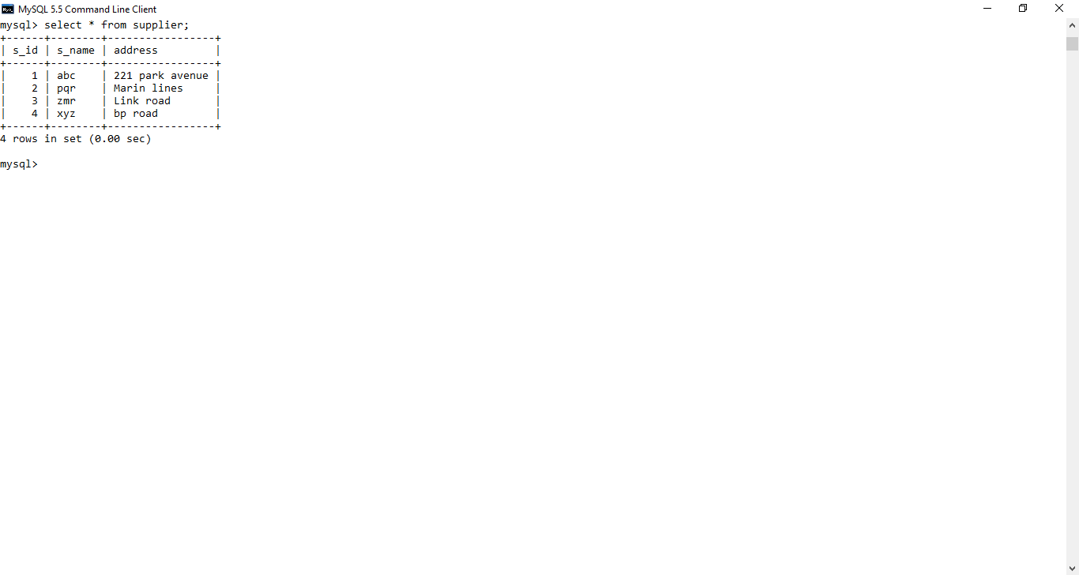

Select * from parts;

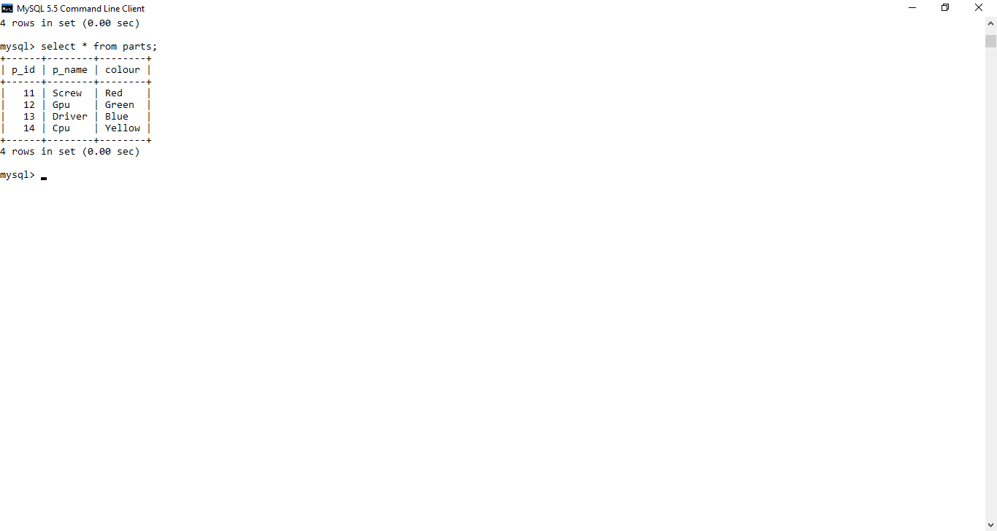

Select * from catalog;

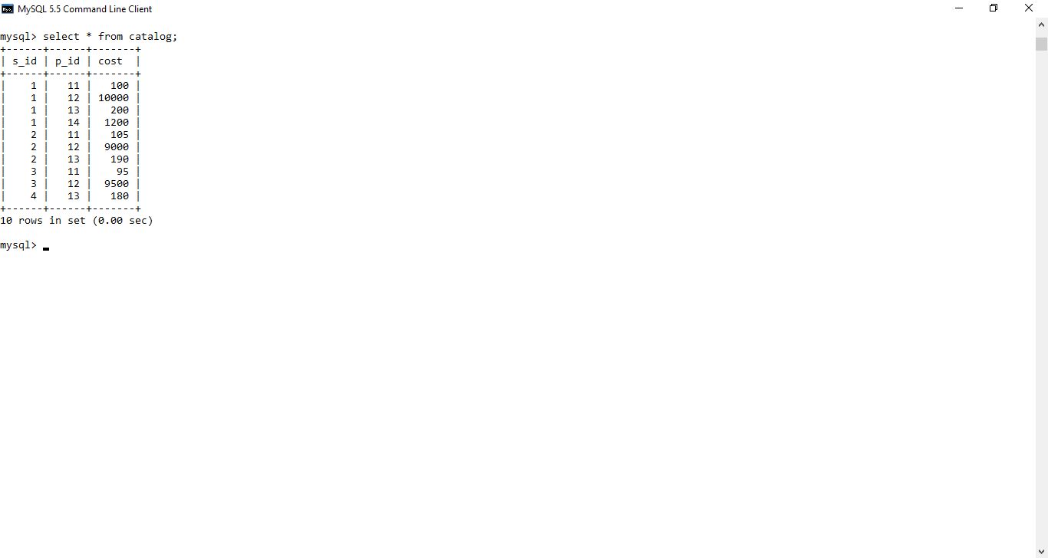

Q. Solve the following questions using SubQueries :

1)Find the name of the supplier who supply some red parts ?

* + select s_name from supplierwhere s_id in (select s_id

from catalogwhere p_id in (select p_id from parts where colour='red'));

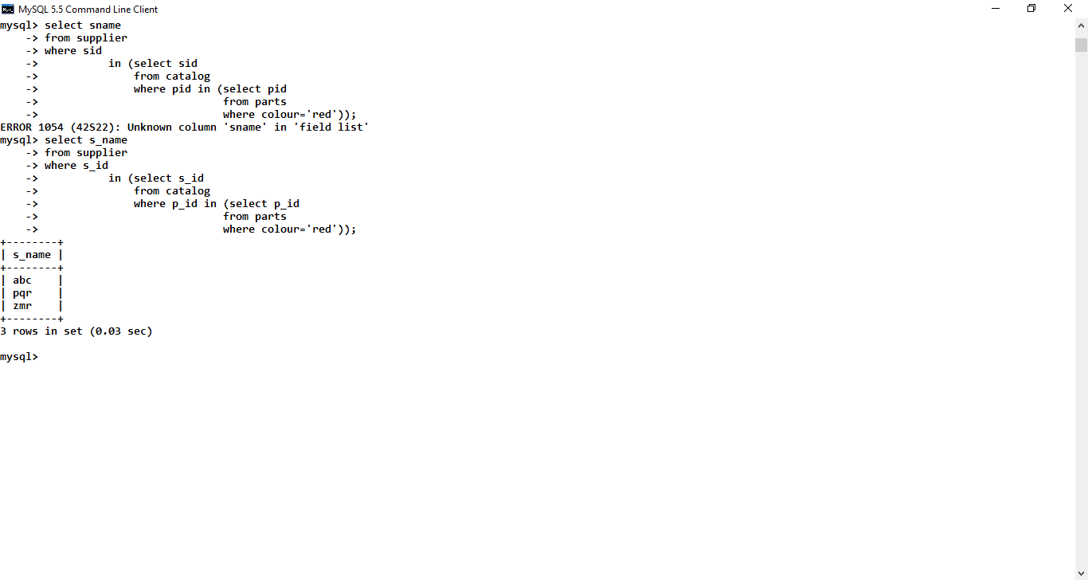

2)Find the s_id of supplier who supplies some red or green parts?

* select distinct s_idfrom catalogwhere p_id in (select p_id

from partswhere colour='red'or colour='green');

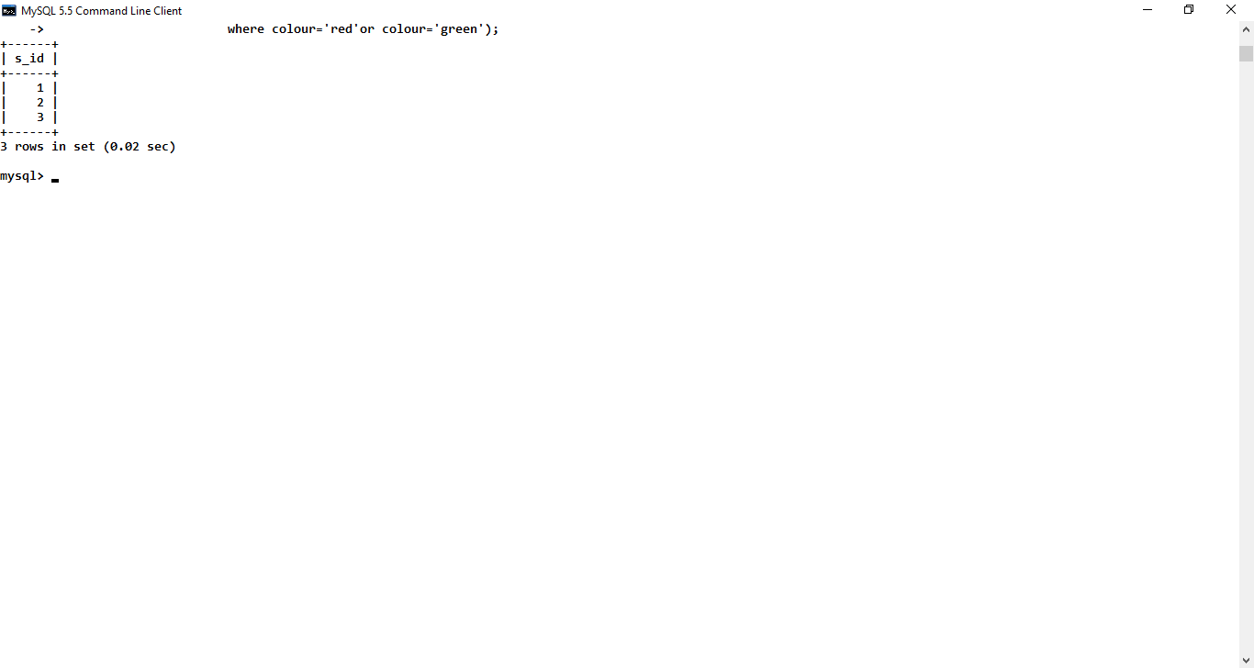

3) Find the s_id of supplier who supplies some red part at 221 Park Avenue?

* select s_idfrom supplierwhere address='221 park avenue' and s_id in (select s_idfrom catalogwhere p_id in (select p_id from parts where colour='red'));

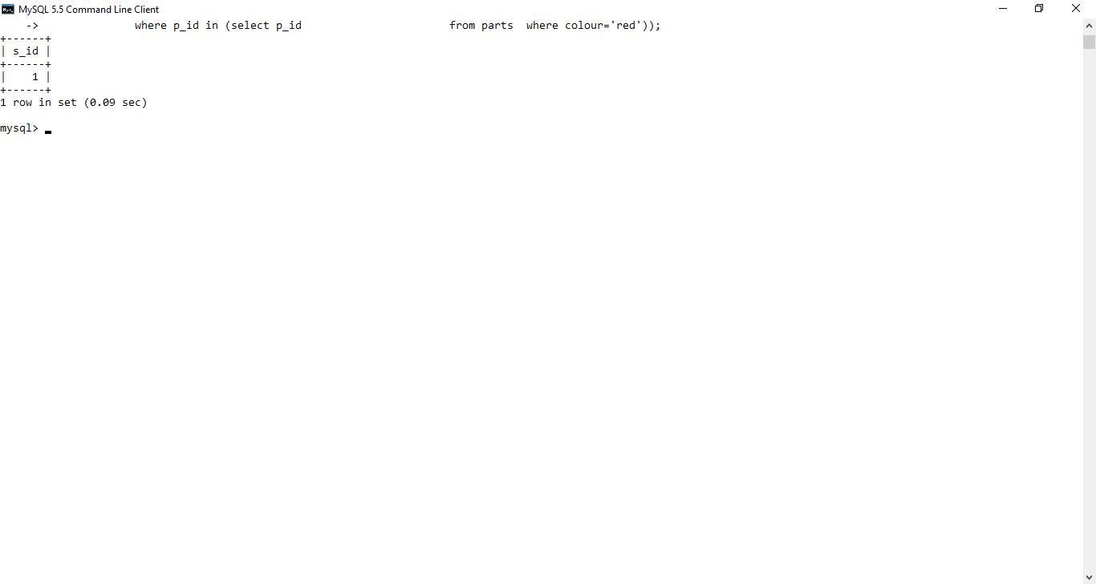

4)Find the name of supplier who supply every red part?

* select s_namefrom supplierwhere s_id IN(select s_id

from catalog where p_id IN(select p_id from part where colour='red'));

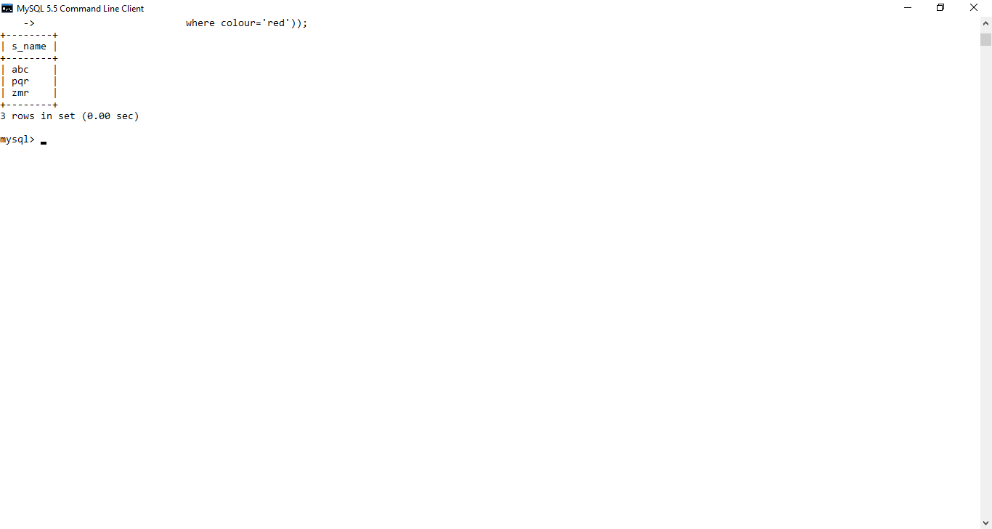

5) Find the s_id of supplier who supply every red or green parts?

* select s_id from supplierwhere s_id IN(select s_id from catalog

where p_id IN(select p_id from parts where colour='red' or colour='green' ));

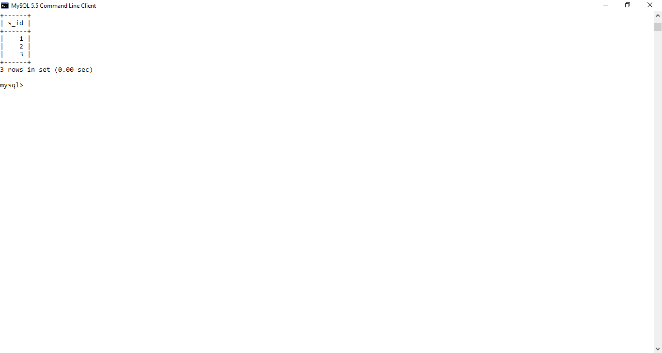

**AIM:- Creating a table ,inserting records in it and firing the subqueries.**

**Creating three tables boats , sailors, and reserves.**

create table boats

(

bid int primary key,

bname char(15),

colour char(10)

);

Table created

create table sailors

(

sid int primary key,

sname char(15),

rating tinyint,

age tinyint

);

Table created

create table reserves

(

sid int references sailors(sid),

bid int references boats(bid),

day char(10)

);

Table created

**Inserting values into the three tables:-**

insert into boats values(11,'prathamesh','red');

1 row created

insert into boats values(12,'rohit','green');

1 row created

insert into boats values(13,'adams','green');

1 row created

insert into boats values(14,'deb','black');

1 row created

insert into sailors values(1,'abc ',8,18);

1 row created

insert into sailors values(2,'pqr ',9,19);

1 row created

insert into sailors values(3,'zmr ',10,19);

1 row created

insert into sailors values(4,'mrf ',6,20);

1 row created

insert into reserves values(1,11,'wednesday');

1 row created

insert into reserves values(2,12,'thursday');

1 row created

insert into reserves values(3,13,'friday');

1 row created

insert into reserves values(3,13,'saturday');

1 row created

**solving the queries:-**

Q) find the names of sailors who have reserved boat 13?

select sname

-> from sailors

-> where sid in (select sid

-> from reserves

-> where bid=13);

Output:-

+-------+

| sname |

+-------+

| zmr |

+-------+

Q2) find the names of sailors who have not reserved boat 13?

select sname

-> from sailors

-> where sid in (select sid

-> from reserves

-> where bid<>13);

Output:-

Q3) find the names of sailors who have reserved a red boat?

select sname

-> from sailors where sid in (select sid

-> from reserves

-> where bid in (select bid

-> from boats

-> where colour='red'));

+-------+

| sname |

+-------+

| abc |

+-------+

Q4) find the names of sailors who have not reserved a red boat?

select sname

-> from sailors where sid in (select sid

-> from reserves

-> where bid in (select bid

-> from boats

-> where colour<>'red'));

+-------+

| sname |

+-------+

| pqr |

| zmr |

+-------+

Q5) find the names of sailors who are older than the oldest sailor with the rating of 10?

select sname

-> from sailors

-> where age=(select age

-> from sailors where rating=10);

+-------+

| sname |

+-------+

| pqr |

| zmr |

+-------+

Q6) Display the color of the boat reserved by sailor ‘ABC’

select colour

-> from boats

-> where bid = (select bid

-> from reserves

-> where sid=(select sid from sailors

-> where sname='abc'));

+--------+

| colour |

+--------+

| red |

+--------+

Q7) Display the age of sailor who have reserved a boat on ‘Thursday’

select age

-> from sailors

-> where sid=(select sid

-> from reserves

-> where day ='thursday');

+------+

| age |

+------+

| 19 |

+------+

Q8) Find the day on which there is no reservation for boat by any sailor.

Q9) Get the name of the boat reserved by the sailor having highest rating.

select bname

-> from boats

-> where bid in (select bid

-> from reserves

-> where sid in(select sid

-> from sailors

-> where rating=(select max(rating) from sailors)));

Output:-

+-------+

| bname |

+-------+

| adams |

+-------+

Q10) Display the names of the boat reserved on either monday,Wednesday or Sunday.

select bname

-> from boats

-> where bid in (select bid

-> from reserves

-> where day in ('monday','wednesday','sunday')

-> );

Output:-

bname

prathamesh

Q11) Display the sid, bid if their exist any reservation on Saturday or Sunday

select sid,bid

-> from sailors,boats

-> where EXISTS (select *

-> from reserves

-> where day in ('saturday','sunday'));

Output:-

sid | bid |

+-----+-----+

| 1 | 11 |

| 2 | 11 |

| 3 | 11 |

| 4 | 11 |

| 1 | 12 |

| 2 | 12 |

| 3 | 12 |

| 4 | 12 |

| 1 | 13 |

| 2 | 13 |

| 3 | 13 |

| 4 | 13 |

| 1 | 14 |

| 2 | 14 |

| 3 | 14 |

| 4 | 14 |

+-----+-----+

Practical No. 9

Views

• Creating Views (with and without check option)

• Dropping views

• Selecting from a view

* **Create the following tables:**

**Create table query:**

Create table vendor

(v_id int primary key,

v_name char(25) ,

v_addr varchar(50),

v_city char(15),

v_state char(15),

v_zipcode int,

v_phone bigint,

v_contact_lastname char(15),

v_contact_first_name char(15)

);

Table created

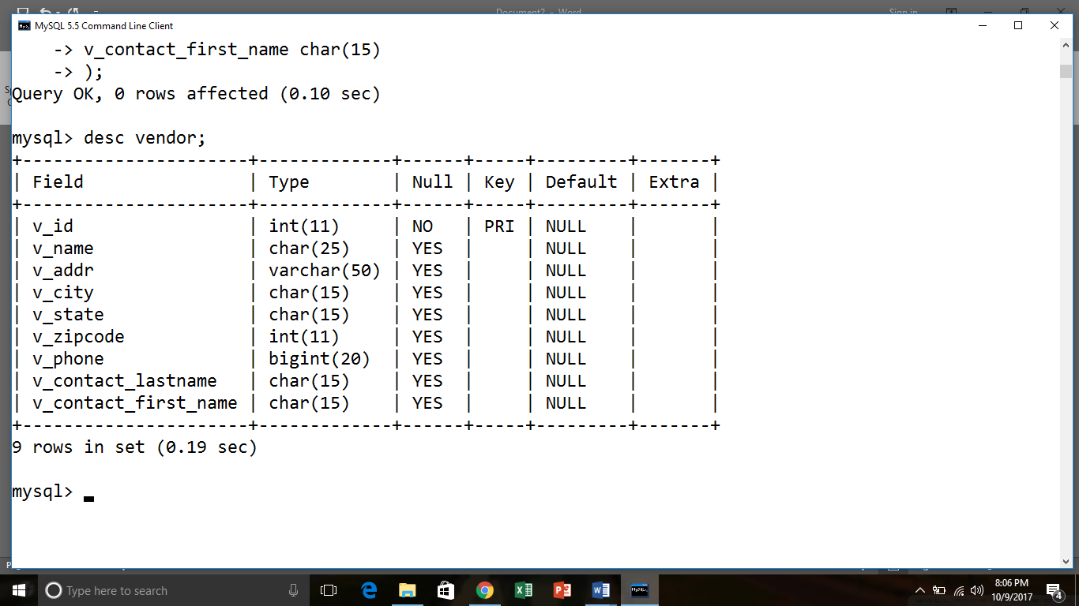

Create table Invoice

(i_id int primary key,

v_id int references vendor(v_id),

i_no int,

i_date date,

i_total decimal,

payment_total decimal,

credit_total decimal,

terms_id varchar(5),

i_due_date date,

payment_date date

);

Table created

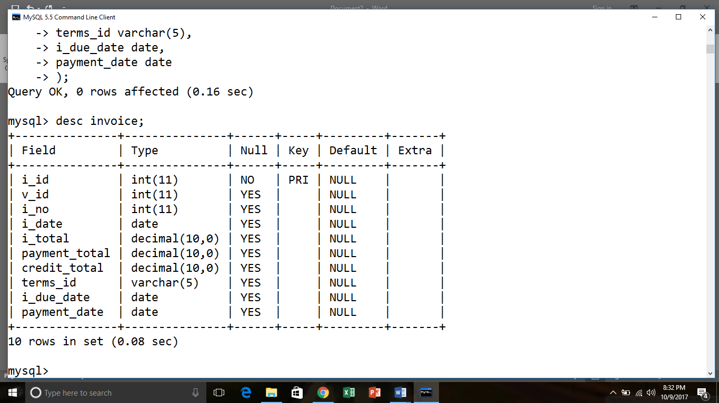

**Insert table query:-**

**For vendor**

insert into vendor value(10,'ITware','Park street','kochi','kerela',25127,3652147896,'Rao','Laxmi');

1 row created

insert into vendor values(11,'Aptech','Lamint on road','mumbai','maharastra',40005,6565658242,'shroff','Dilip');

1 row created

**For invoice**

insert into invoice values(1,11,'122','2000/12/1',2000,1500,0,'AP522','2000/1/1','2000/12/24');

1 row created

insert into invoice values(2,11,'12','2000/5/8',7800,5000,0,'SD868','2000/5/30','2000/5/10');

1 row created

* select* from vendor;

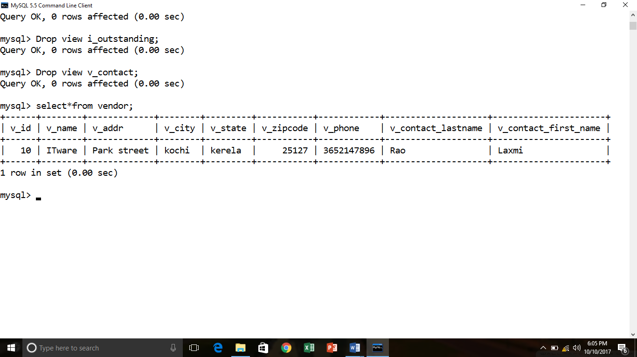

* select* from invoice;

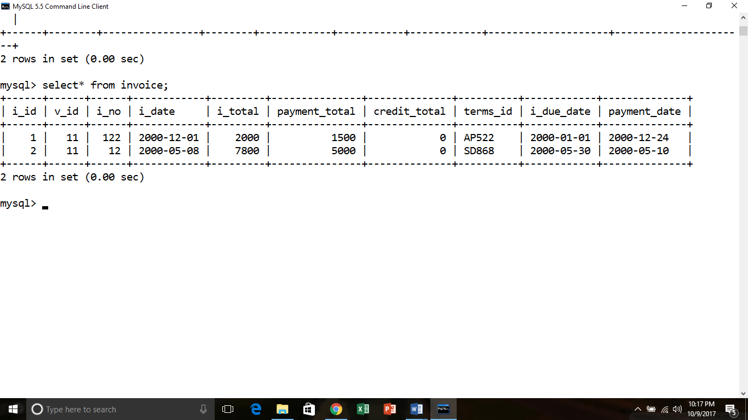

**QUERIES:**

**7.1 Creating Views (with and without check option)**

**1. Create a view named v_basic_info that shows v_id, v_name, v_state, v_phone, v_contact_lastname, v_addr from vendors table.**

* create view v_basis_info as select v_id,v_name,v_state,v_phone,v_contact_lastname,v_addr from vendor;

View created

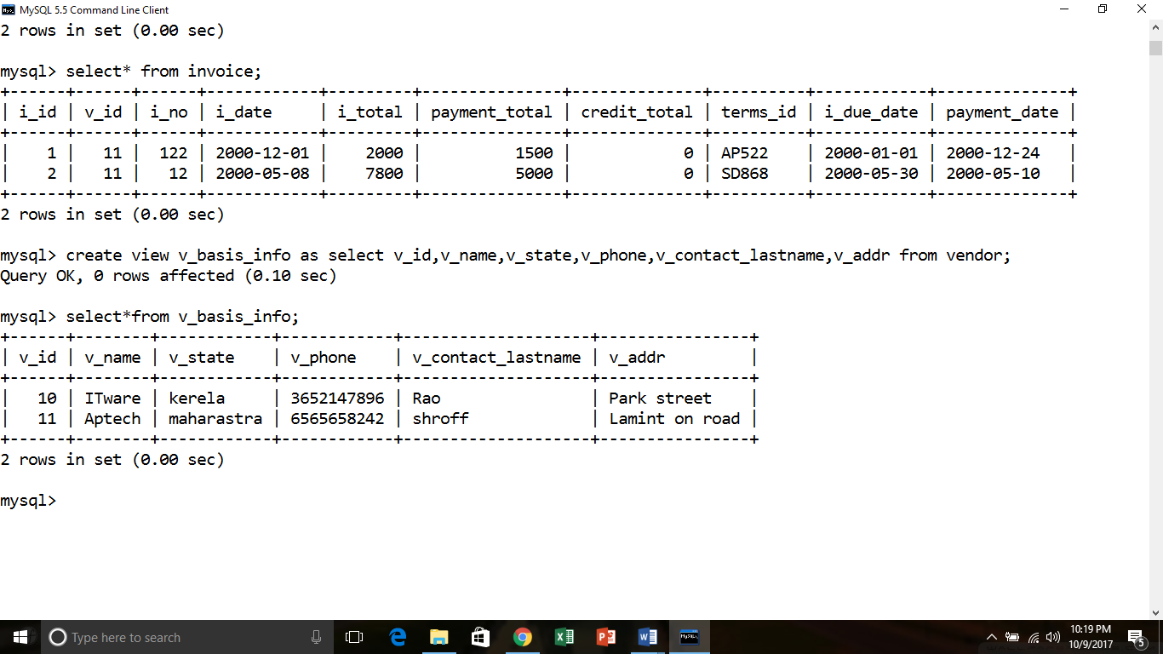

**2. Create a view named vendor_invoice that shows v_name, i_id, i_total from vendors and invoices table.**

* Create view vendor_invoice as select

V_name,i_id,i_total from vendor,invoice;

View created

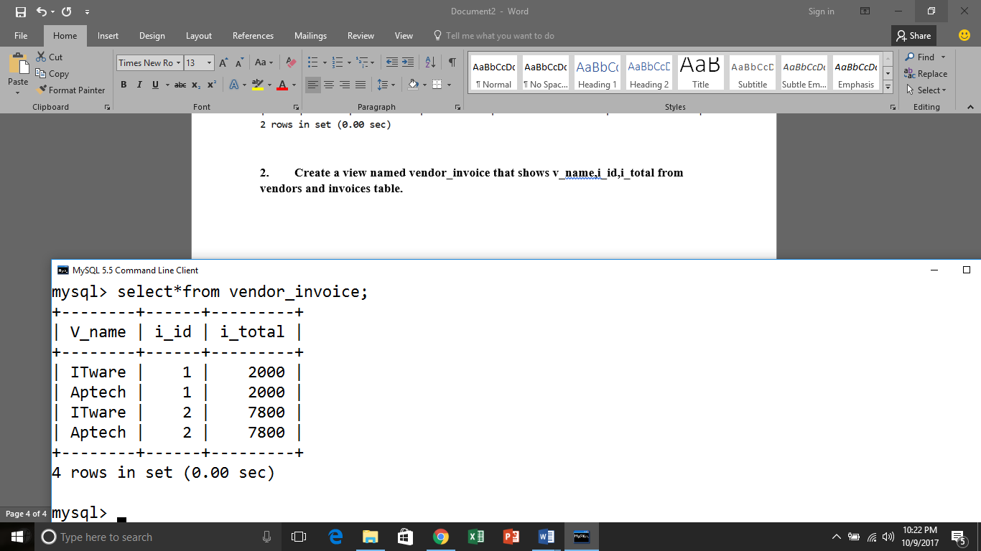

**3. Create a view named bal_info that shows i_number,i_date,i_total and balance(i_total-payment_total).**

* Create view bal_info as select

i_no,i_date,i_total, i_total-payment_total as balance from invoice;

View created

* select*from bal_info;

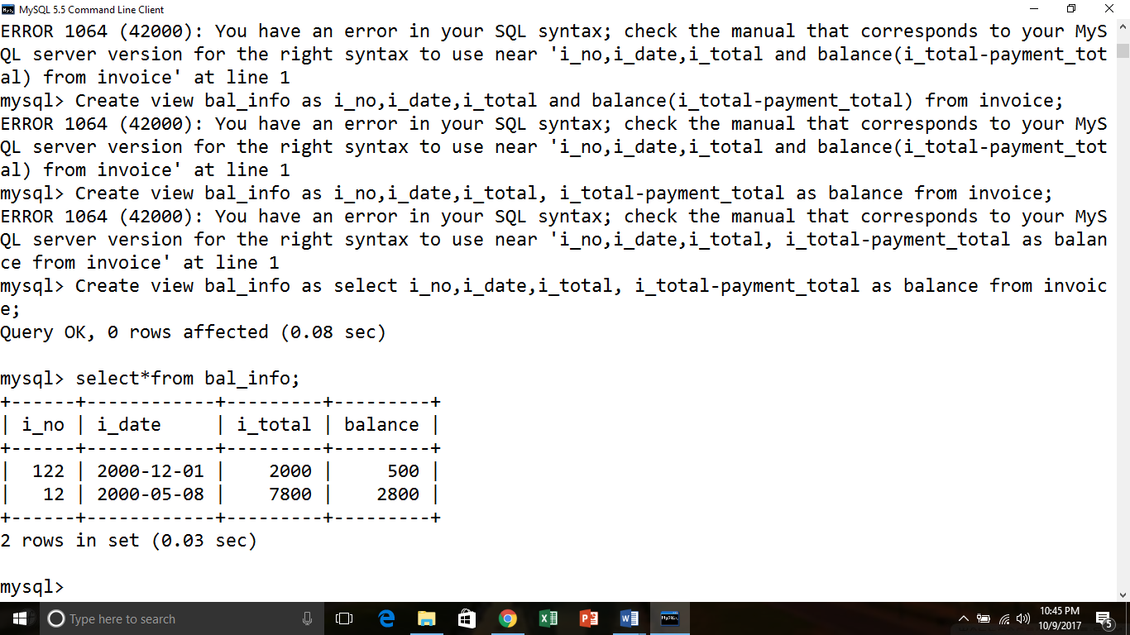

**4. Create a view named i_outstanding that shows i_number,i_date,i_total and balance(i_total-payment_total) for balance amount greater than 1000, with check option.**

* Create view i_outstanding as select

i_no,i_date,i_total, i_total-payment_total as balance from invoice

where i_total-payment_total >1000;

View created

* select*from i_outstanding;

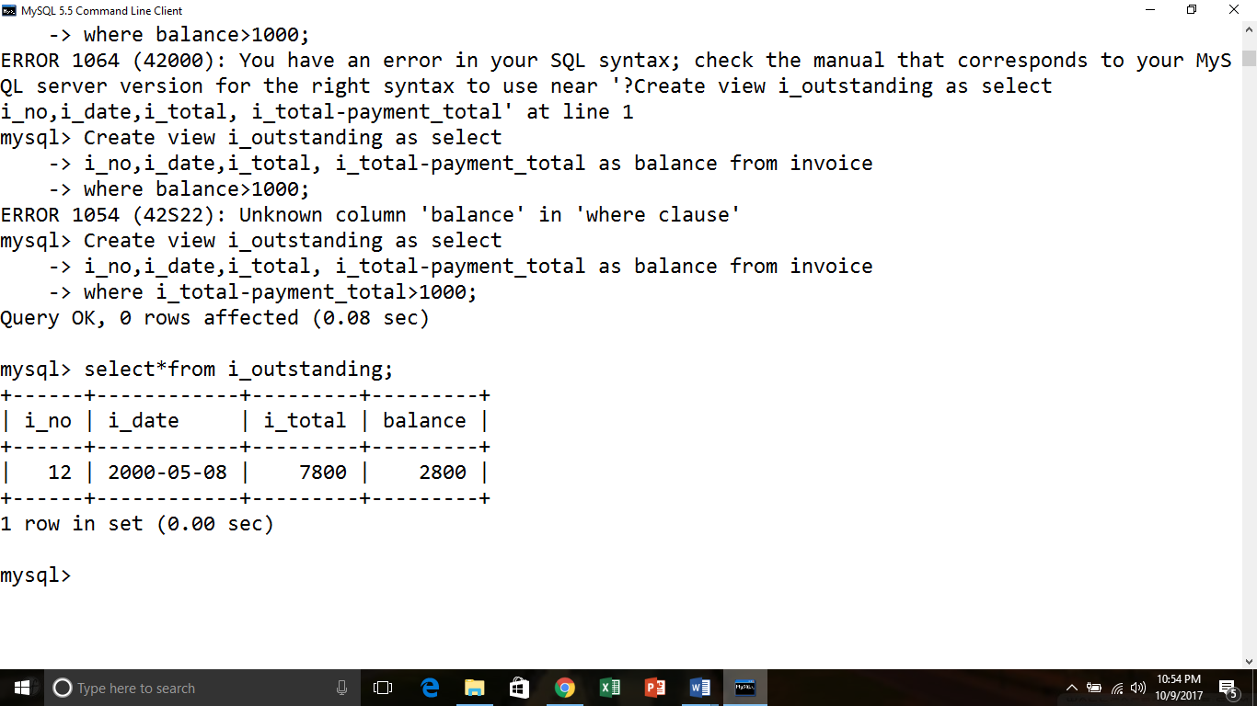

**5. Create a view named v_contact that shows v_name,v_phone from view v_basic_info.**

* Create view v_contact as select v_name,v_phone from v_basis_info;

View created

* select*from v_contact;

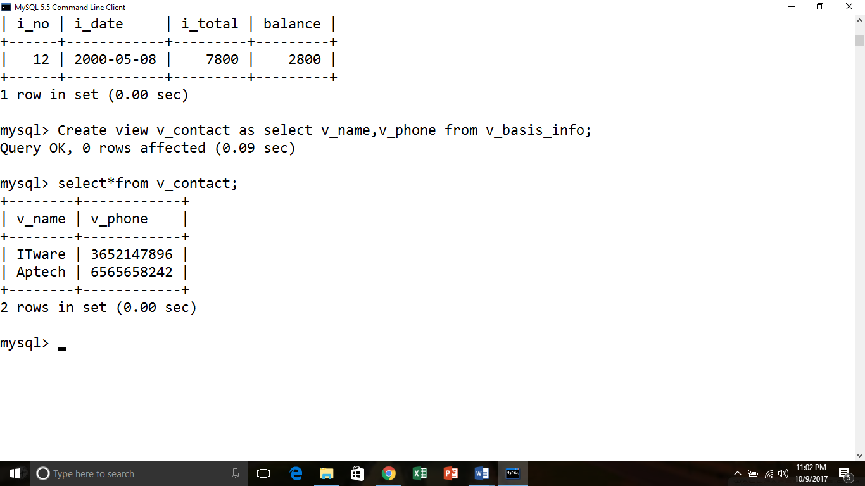

**7.2Selecting from a view**

**1. Display the vendor_name from v_basic_info who’s state is ‘kerela’**

* Select v_name from v_basis_info

Where v_state=’kerela’;

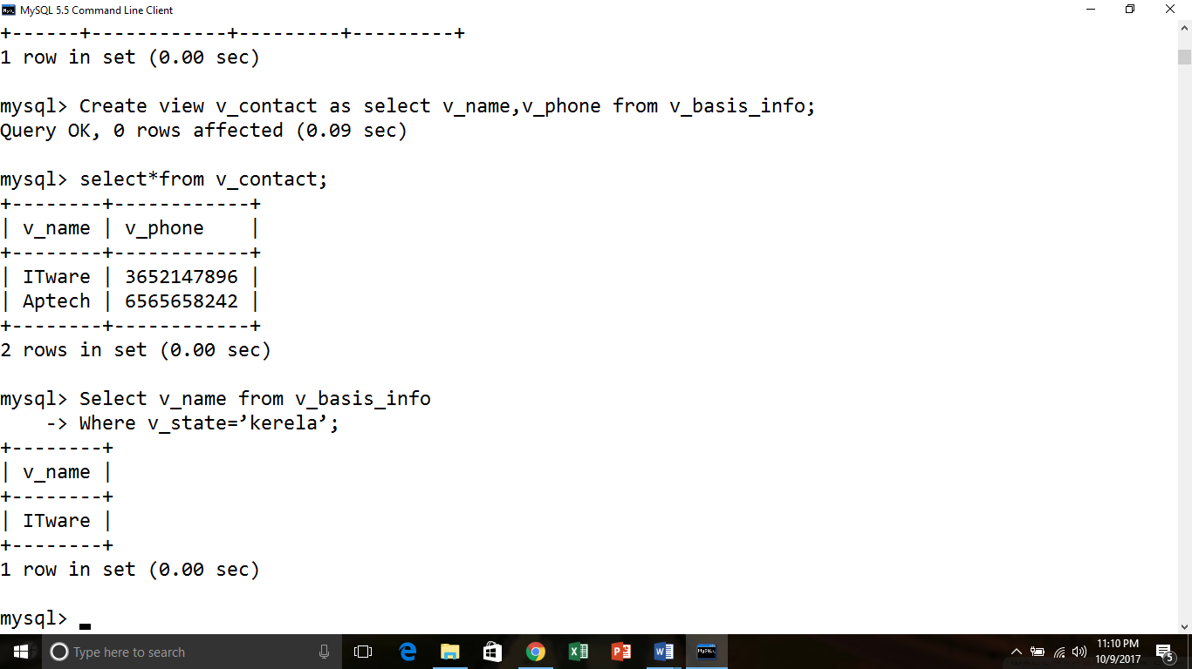

**2. Display the balance amount in view(bal_info) in descending order**

* Select balance from bal_info order by balance desc;

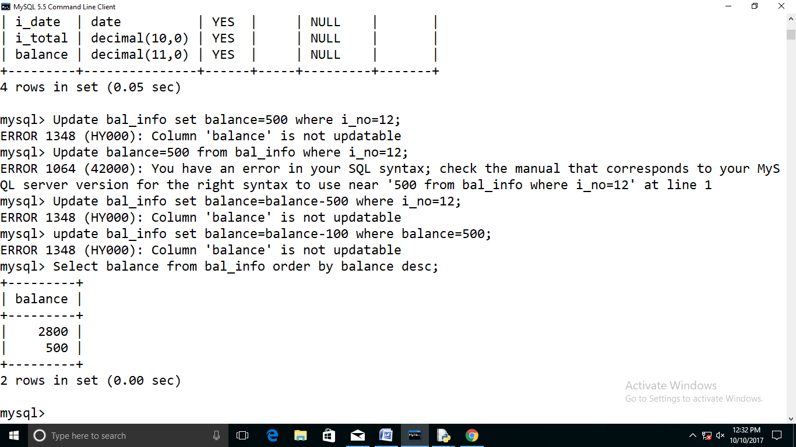

**3. Display the 2 highest balance amount from bal_info**

**Select balance from bal_info where max(balance) limit 2;**

* Select balance from bal_info order by balance desc limit 2;

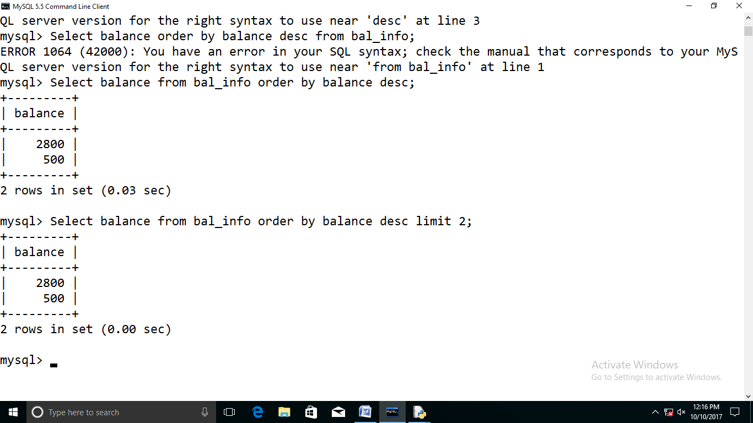

**4. Set the new balance amount to 500 where i_nois 12.**

* Update bal_info set i_total-payment_total=500 where i_no=12;

Column 'balance' is not updatable

**5. Deduce the balance amount by 100 for existing balance amount =500.**

* update bal_info set balance=balance-100 where balance=500;

Column 'balance' is not updatable

**6. Delete a record from v_basic_info where v_name is ‘Aptech’**

* Delete from v_basis_info where v_name=’Aptech’;

select*from v_basis_info;

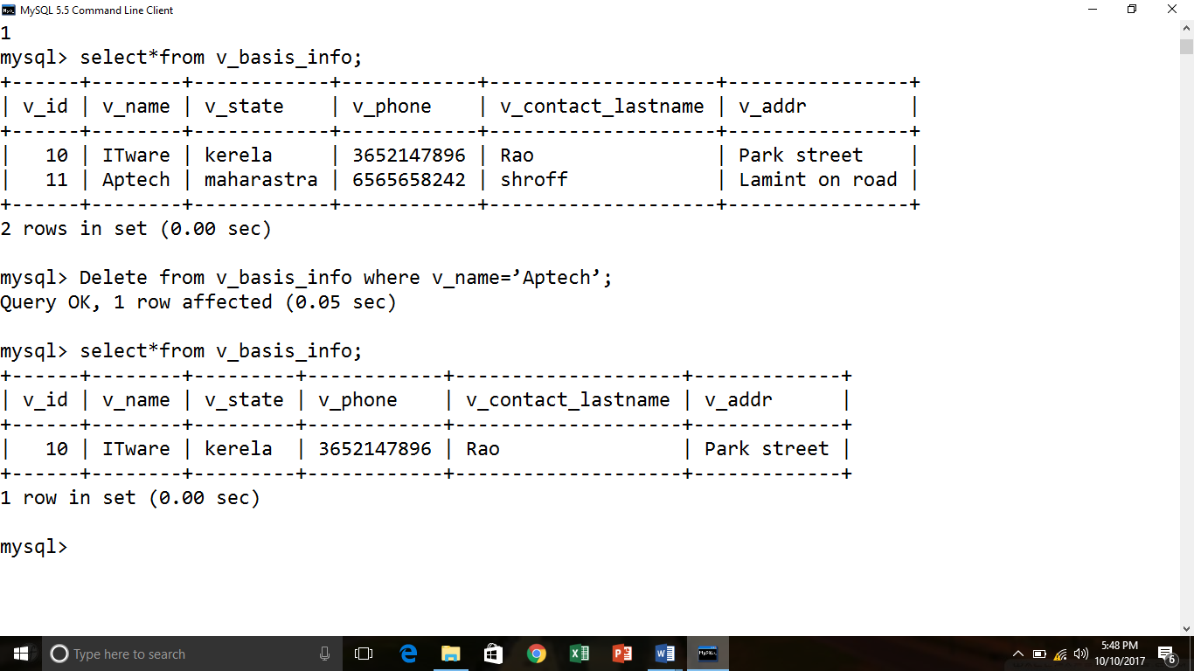

**7.3 Dropping views**

**1. Remove the view bal_info from database.**

* Drop view bal_info;

View droped

**2. Drop view v_basic_info, vendor_invoice, i_outstanding and v_contact.**

* Drop view v_basis_info;

View droped

* Drop view vendor_invoice;

View droped

* Drop view i_outstanding;

View droped

* Drop view v_contact;

View droped

**PRACTICAL NO. 10**

**CREATING USERS AND GRANTING PRIVILEGES**

1.Create user ‘user1’ from any host and assign it password as ‘password1’

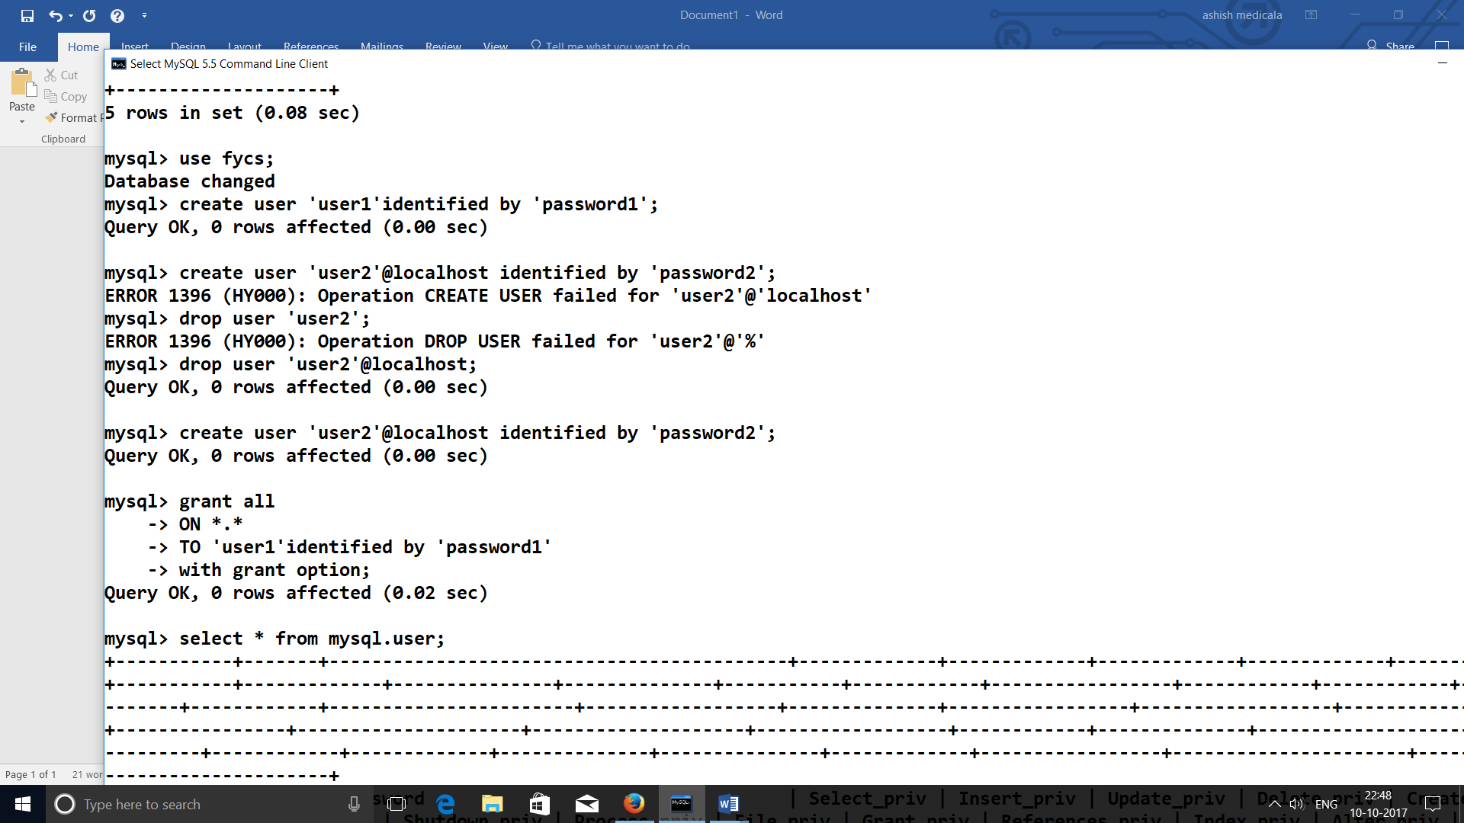

2. Create user ‘user2’ from localhost and assign it password as ‘password2’

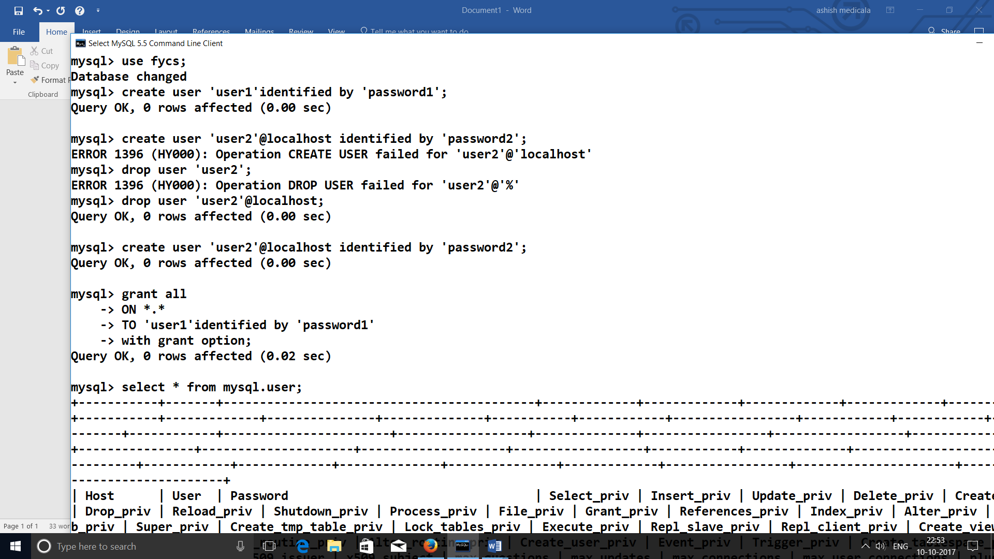

3. Display the list of all users of dbms

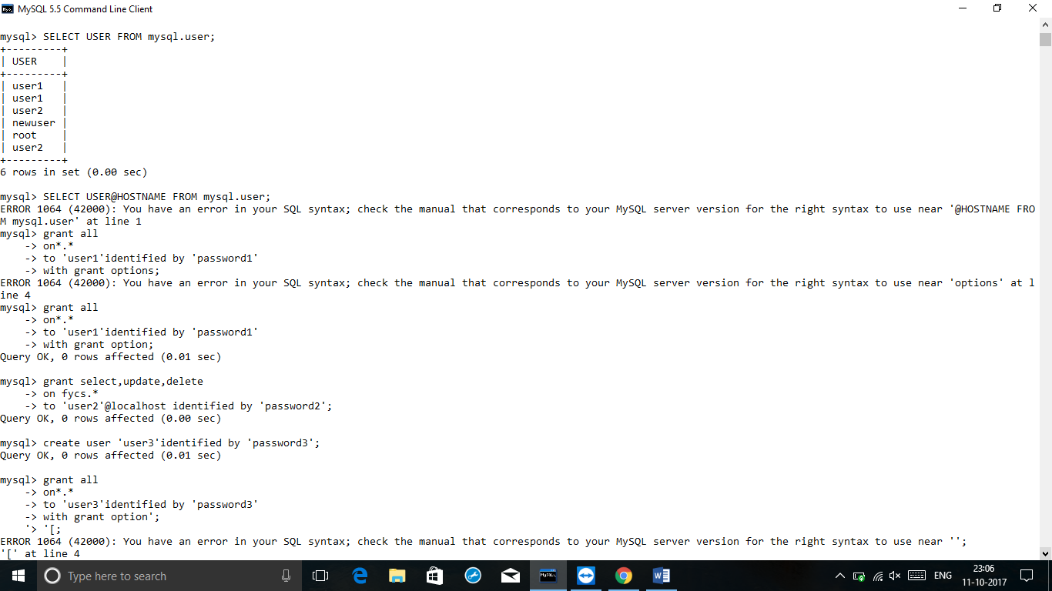

4. Display the list of all users of dbms along with their hostname

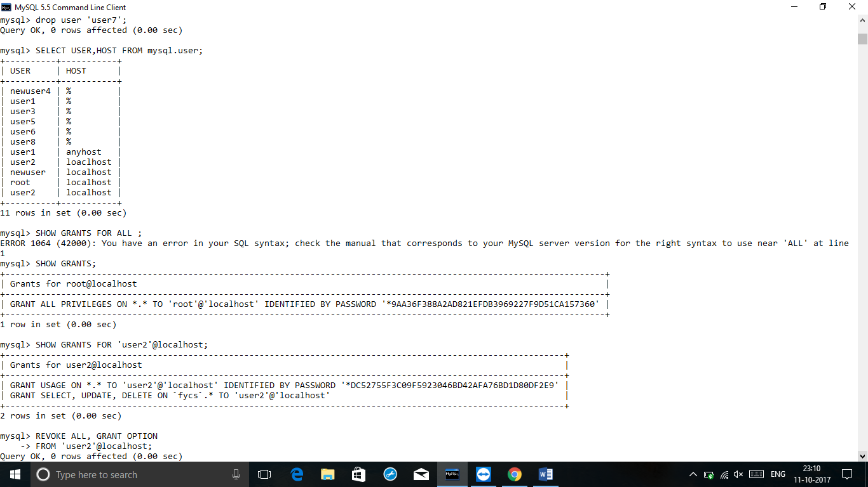

5. Grant all (global)privileges to user ‘user1’

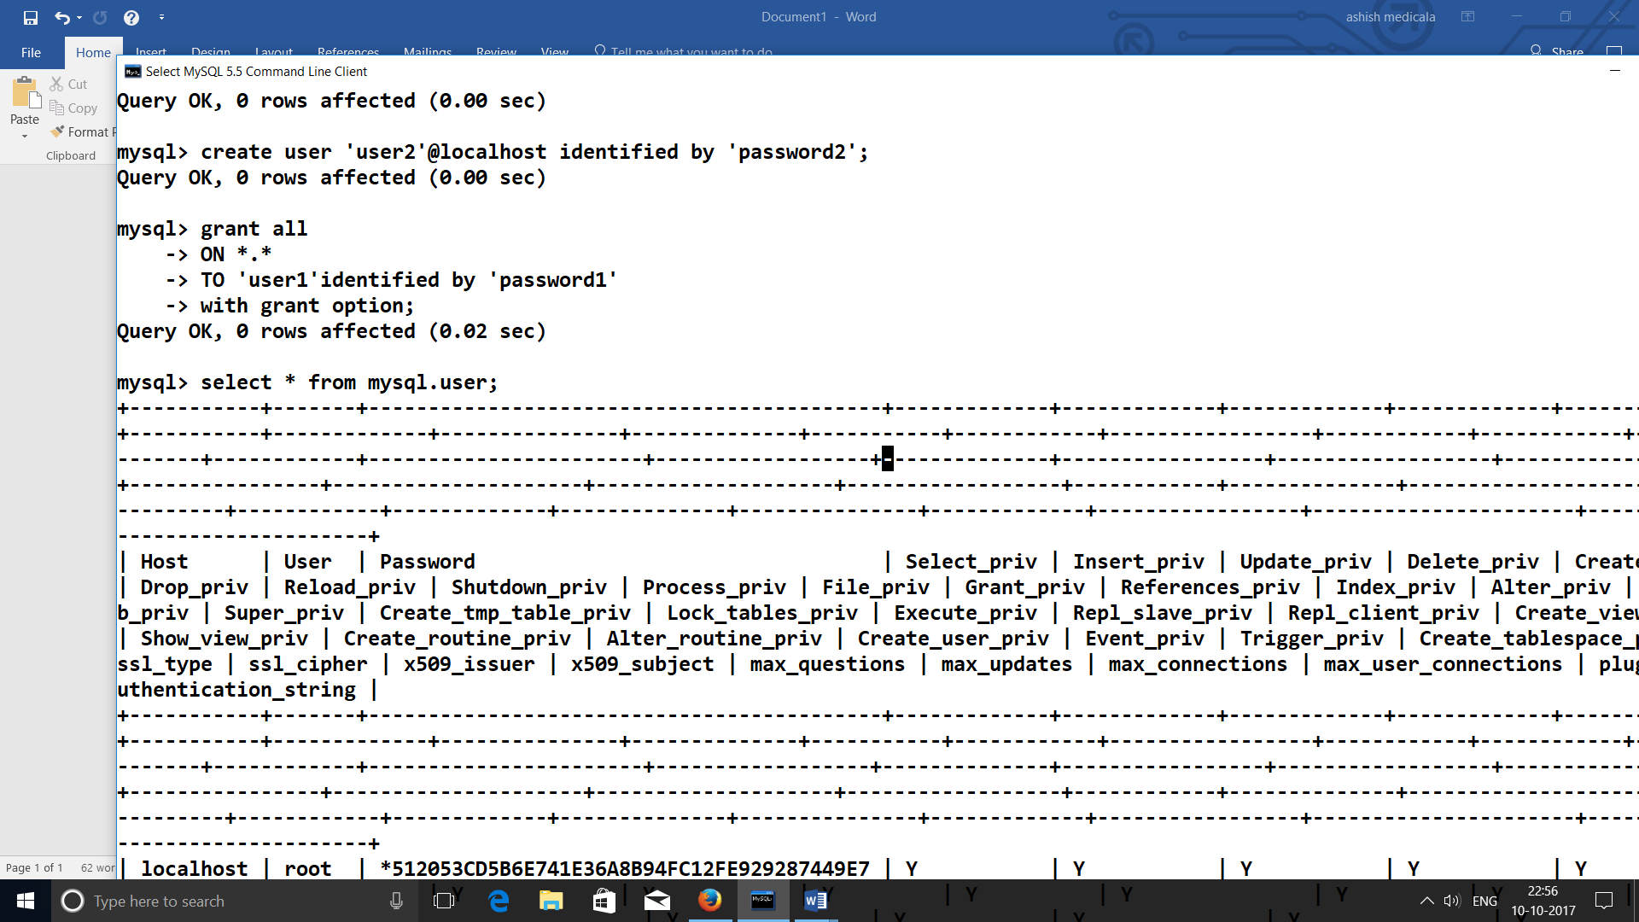

6. Grant database privileges to user ‘user2’

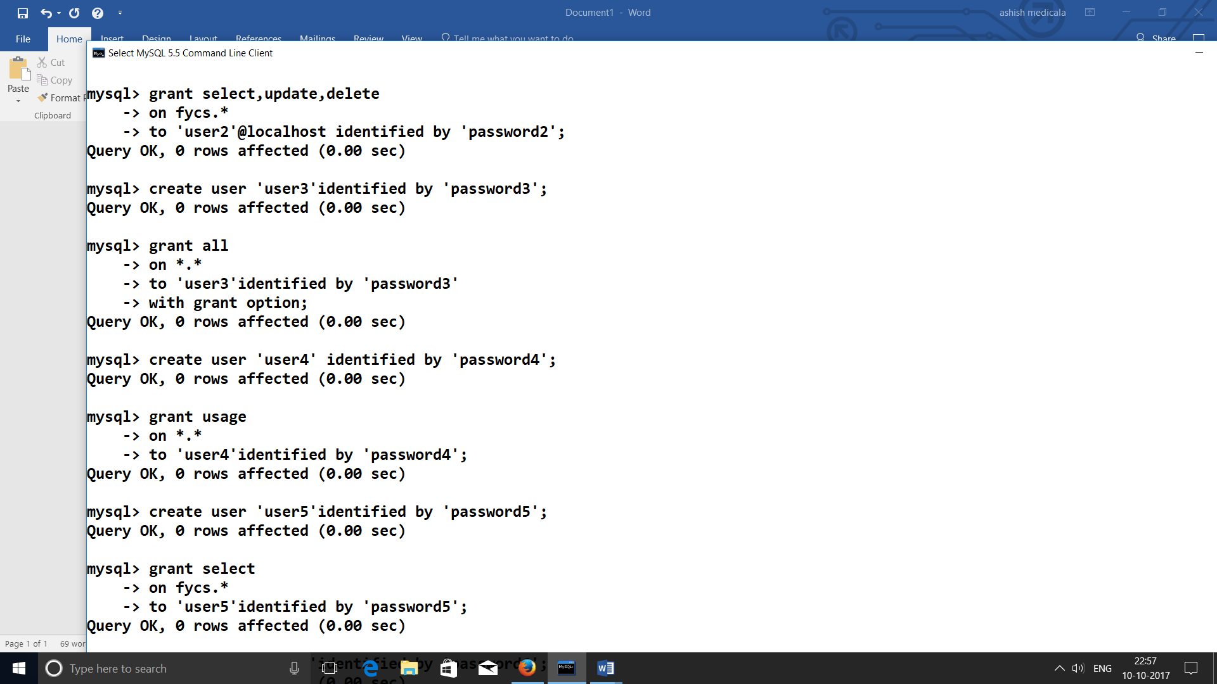

7. Create a user ‘user3’ with global privileges

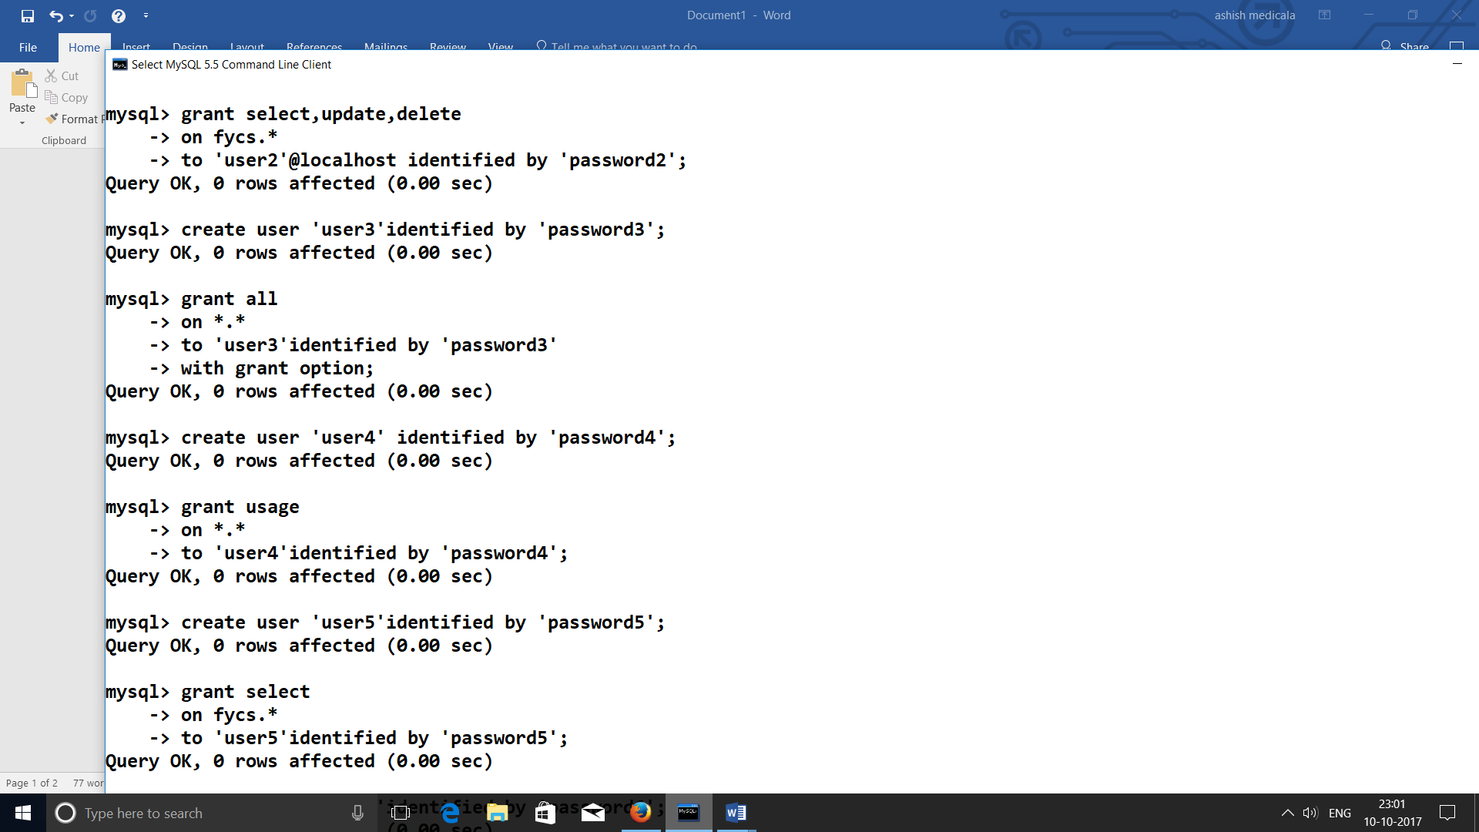

8.Create a user ‘user4’ with no privileges

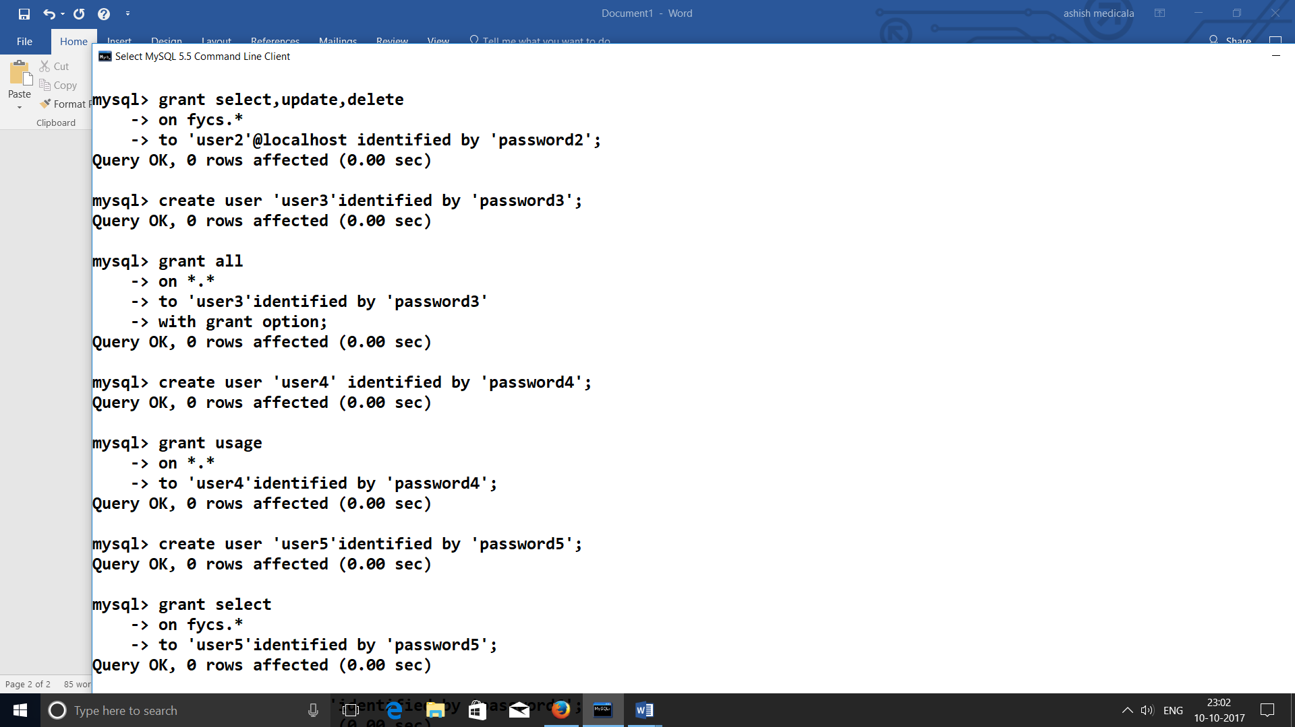

9. Create user ‘user5’and Grant only ‘select ‘operation privilege

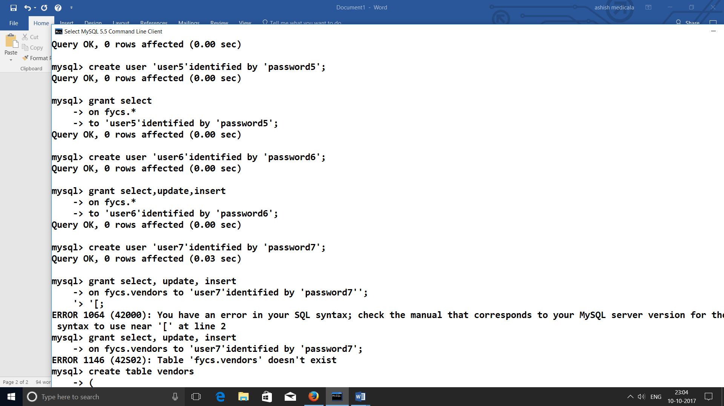

10. Create user ‘user6’and Grantselect,update,insert operation privilege

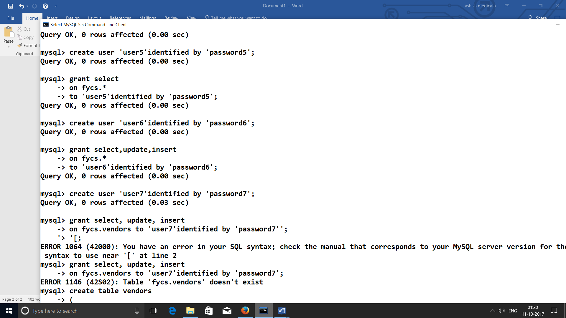

11. Create a user ‘user7’ with table privileges

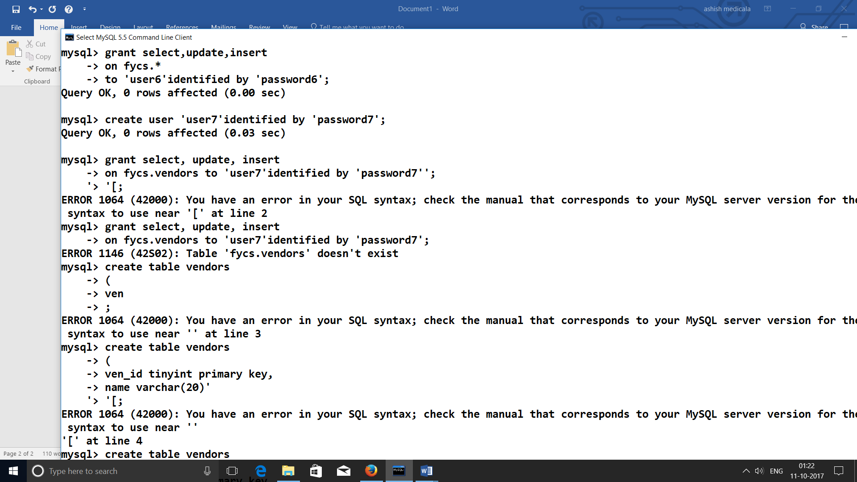

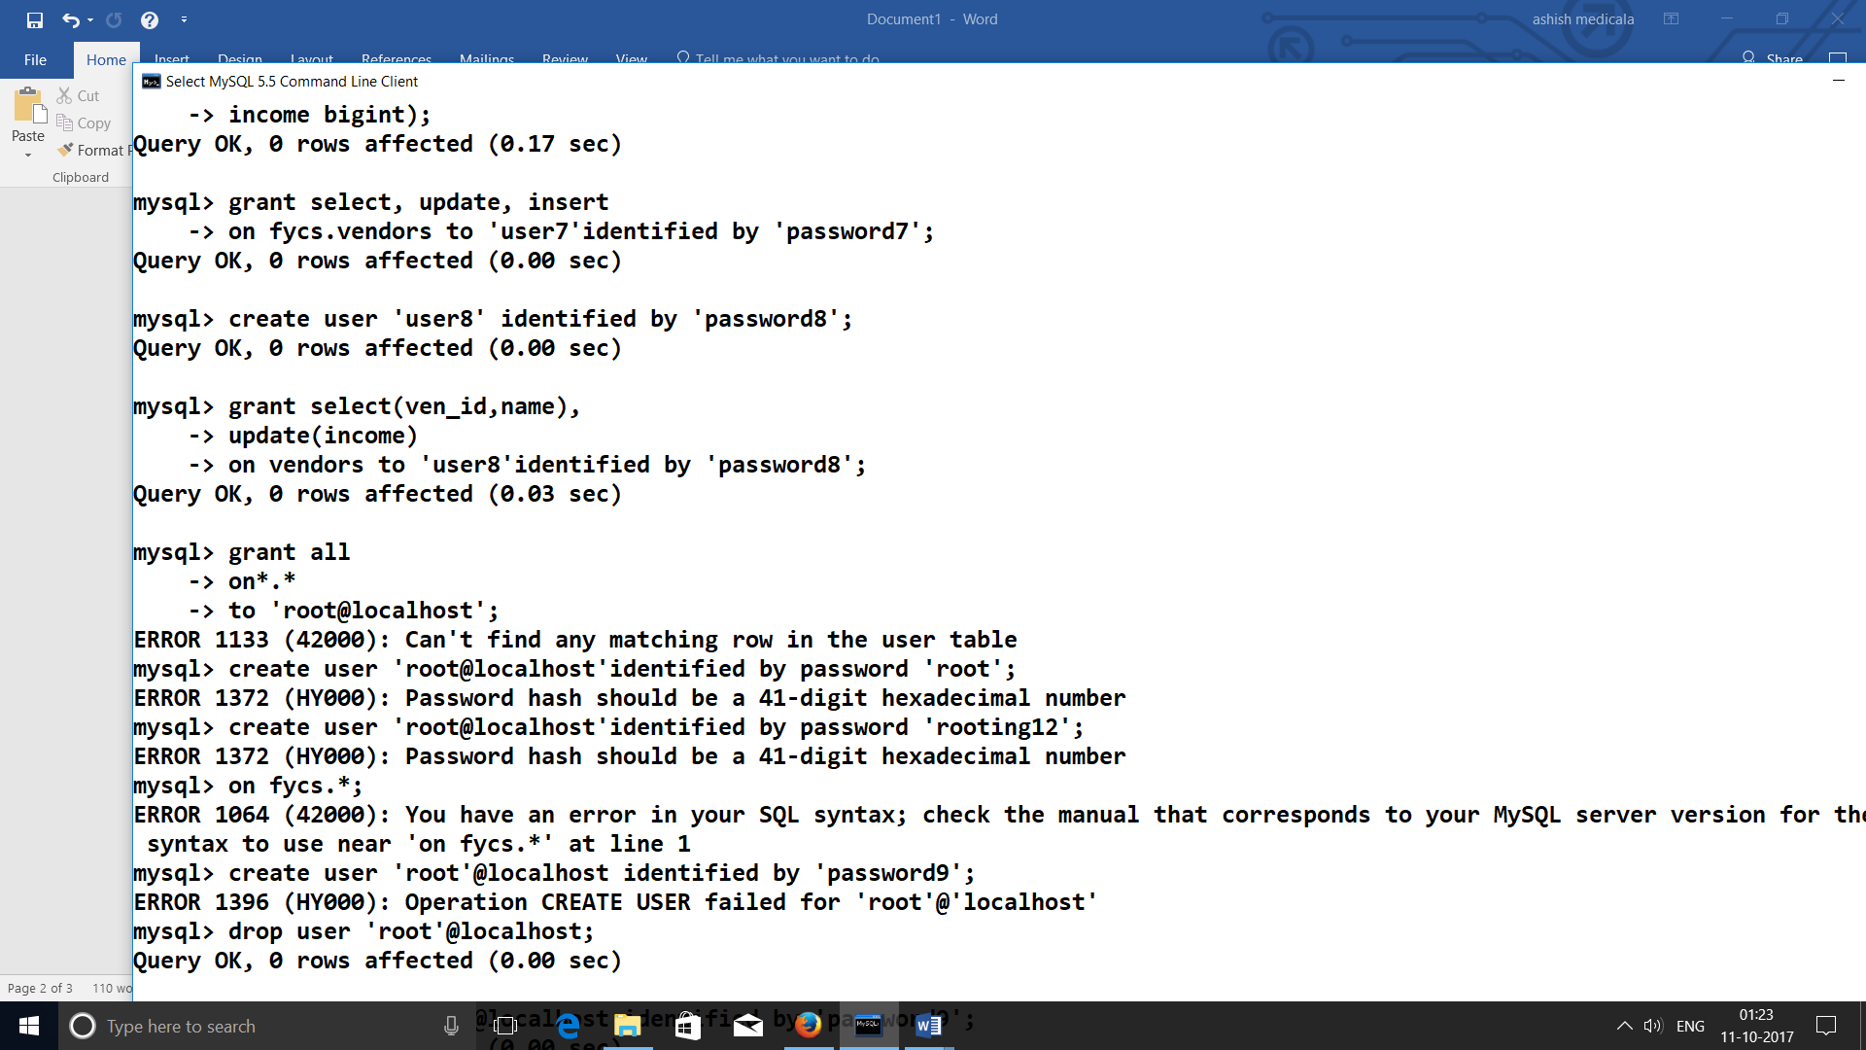

12. Create a user ‘user8’ with column privileges

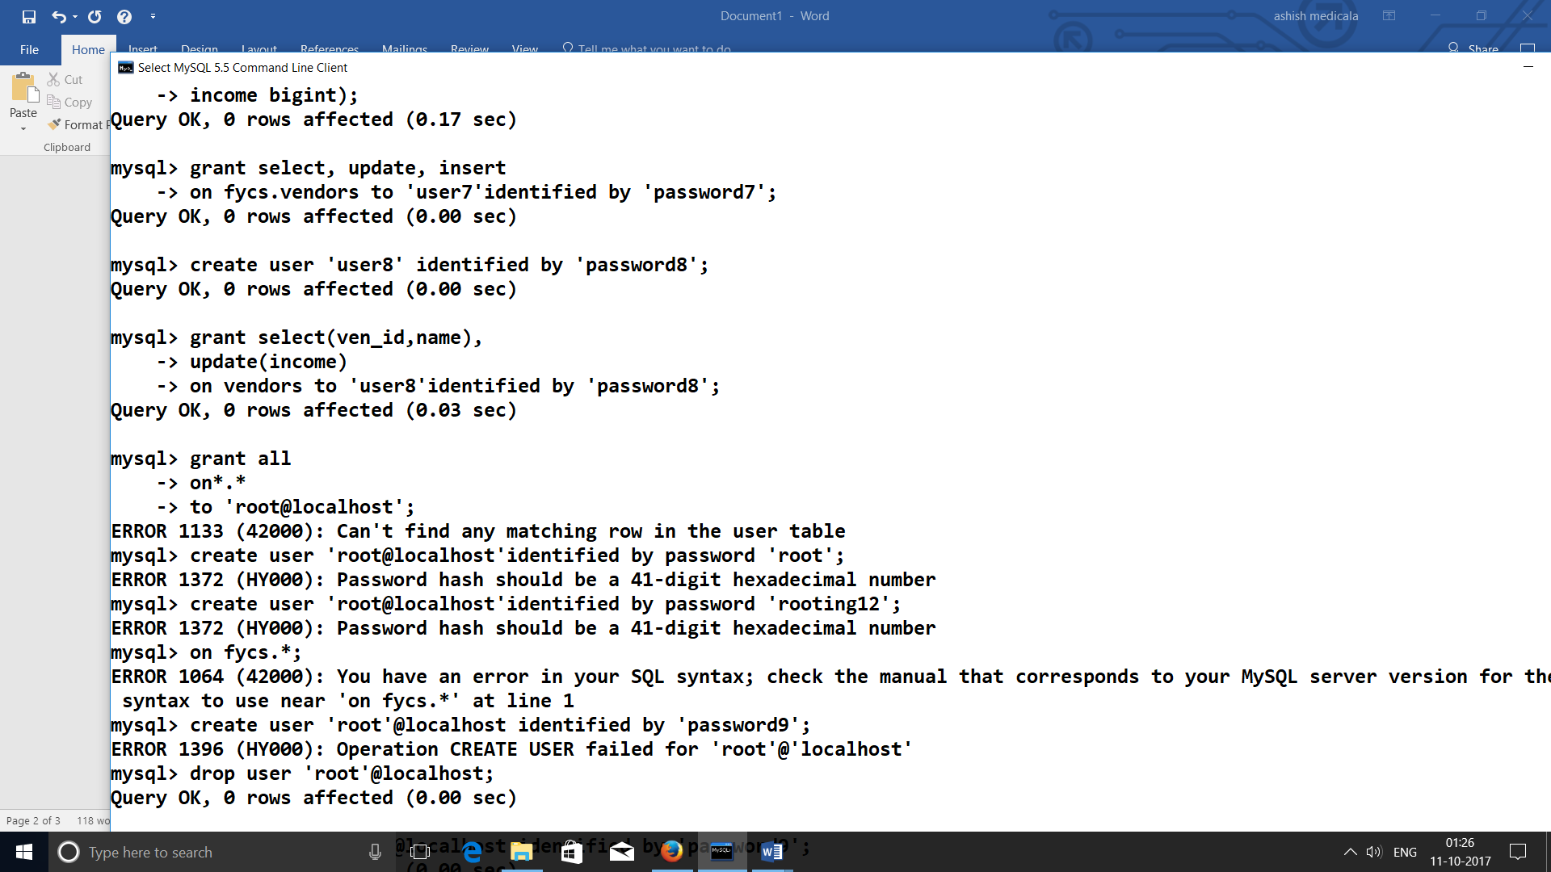

13. Grant global privileges to ‘root@localhost’ user

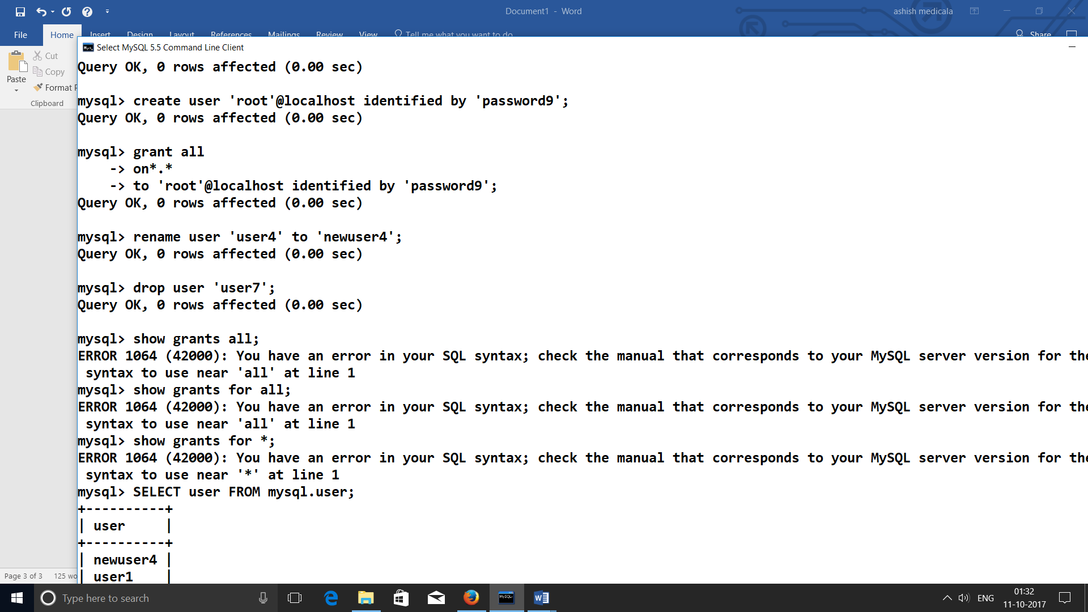

14. Rename user ‘user4’ to ‘newuser4’

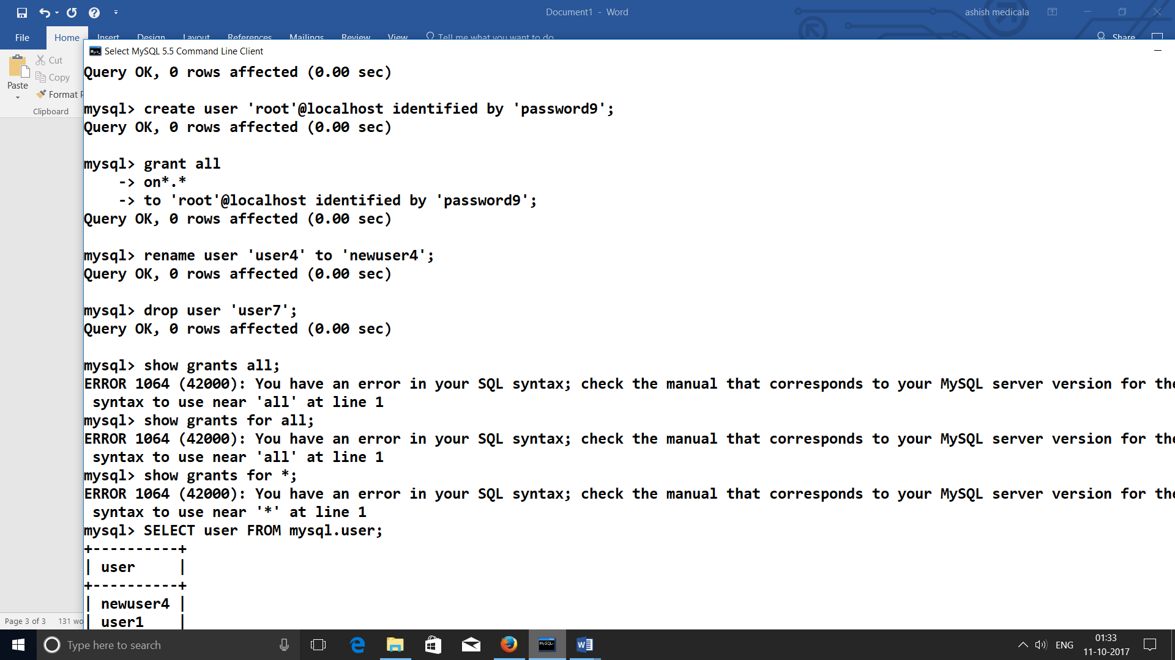

15. Drop user ‘user7’

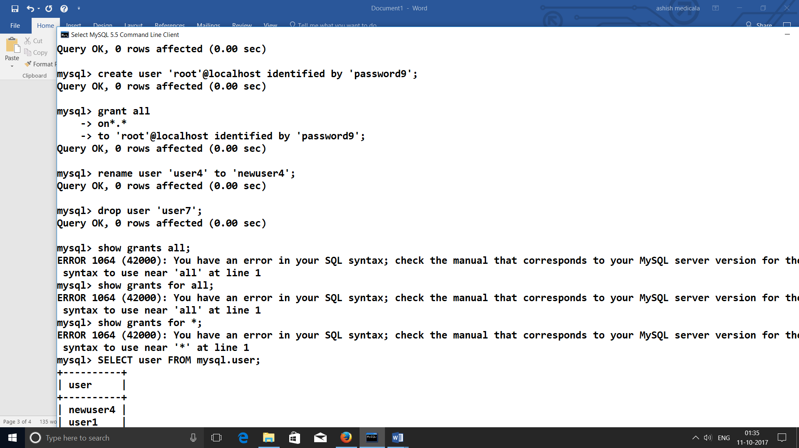

16. Show the privileges for all users from any host

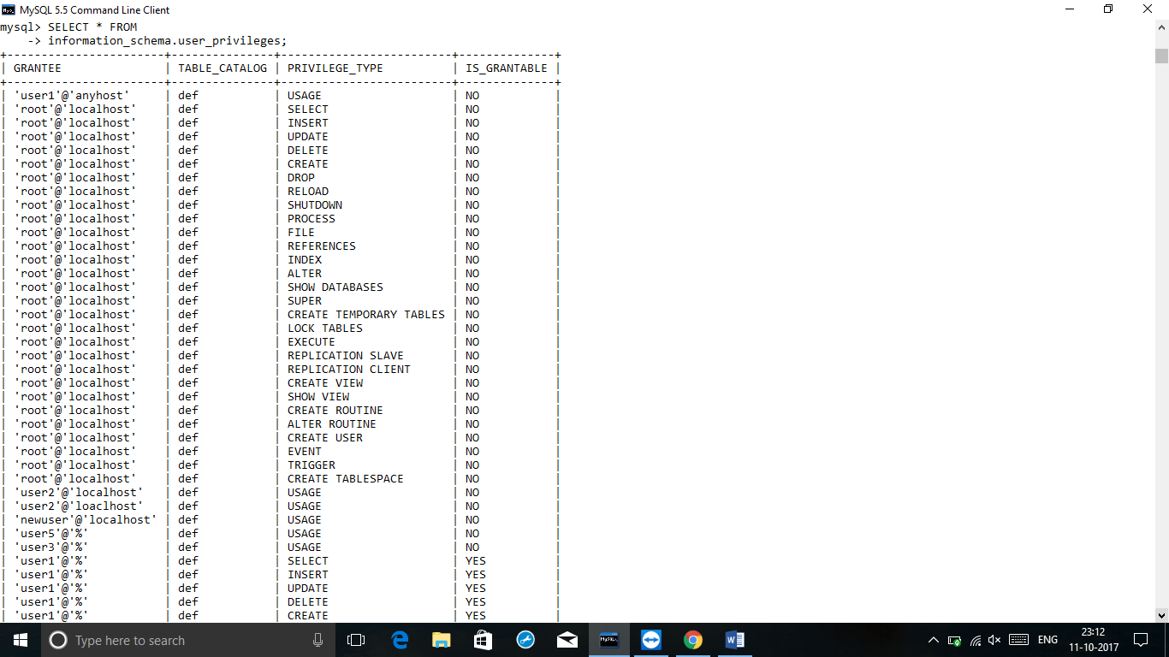

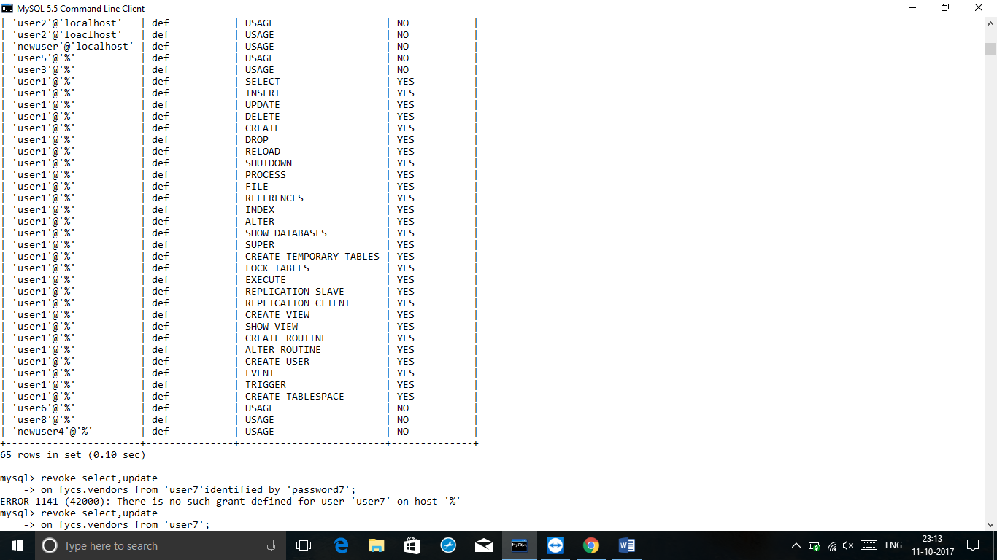

17.Show the privileges for all users from a specific host



18.Show the privileges for the current user



**Revoking privileges from user:**

1.Revoke all privileges from ‘user2’[GRANT OPTION]



2.Revoke all privileges from multiple users(user3,user6,user8)[GRANT OPTION]

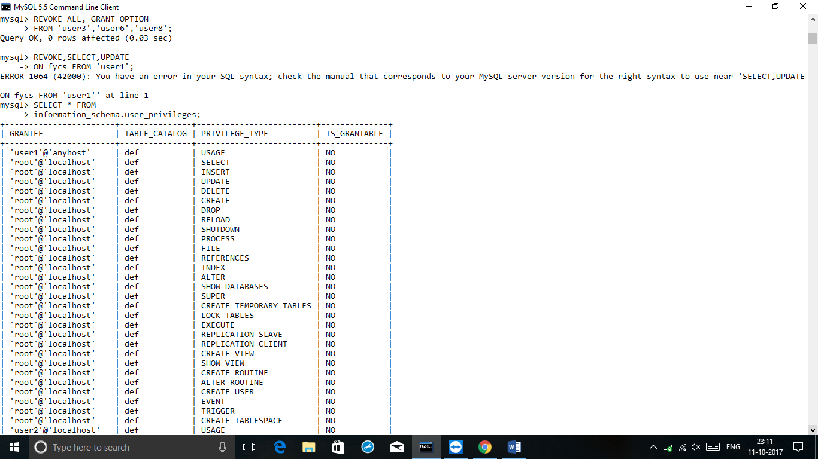

3.Revoke specific privileges from ‘user6’[GRANT OPTION]

